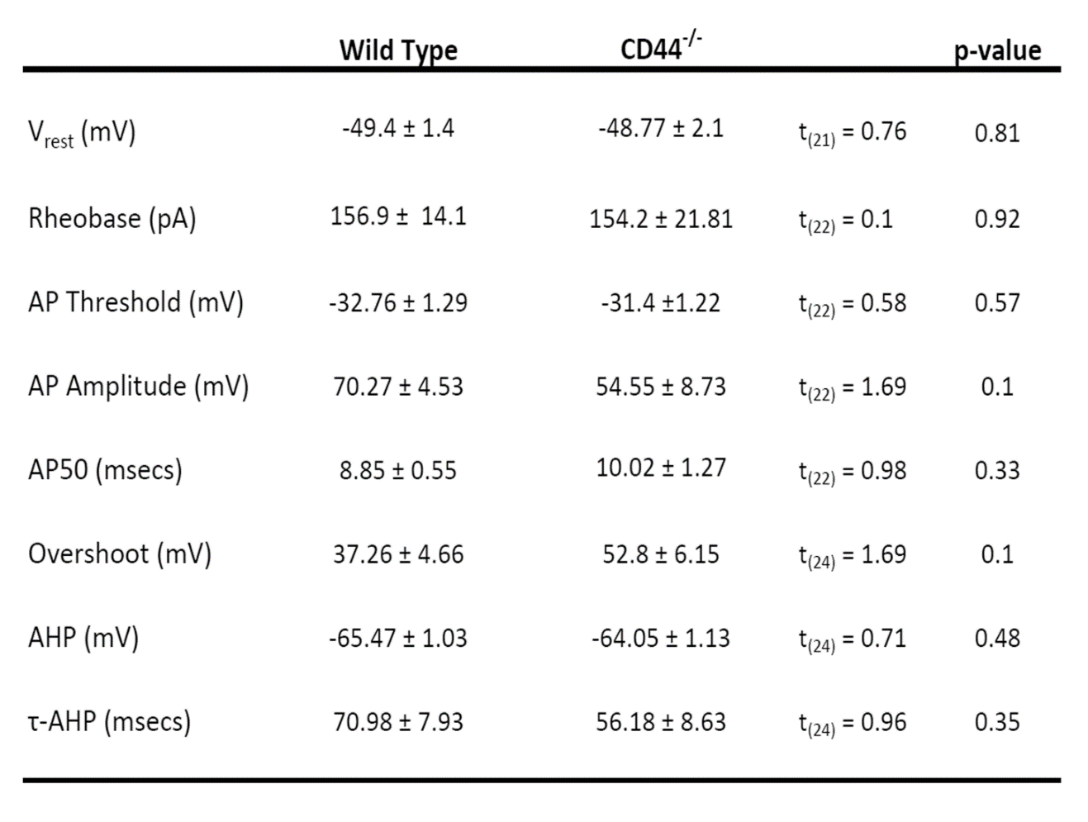
Supplementary File 1. The measures of intrinsic membrane properties of small-diameter DRG neurons in WT and CD44 KO mice. Knocking out of CD44 did not significantly alter the intrinsic membrane property of DRG neurons, as compared to that in WT mice.

