Supplementary File 1A. IC₅₀ of the caffeic acid and its derivate on TcdB-mediated cell-rounding.
Compound | Structure | IC₅₀ (μg/mL)
Caffeic acid | 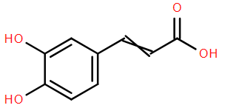 | 527.5
Ethyl caffeate | 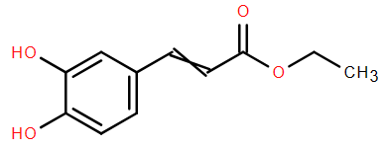 | 5.9
CAPE | 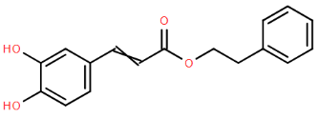 | 3.0
Echinacoside | 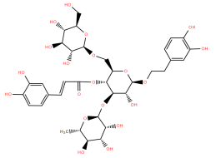 | 5.1
Rosmarinic acid | 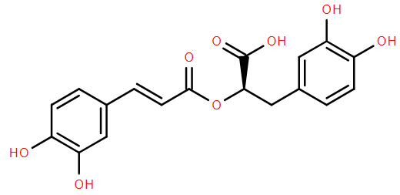 | 198.1
Salvianolic acid | 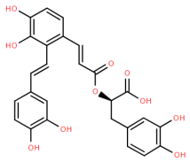 | 3.4
Verbascoside | 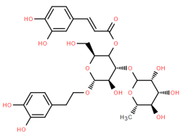 | 5.4

Supplementary File 1B. Primers used in this study.
Primers | Sequences | Notes
YG101 | ctgGGATCCATGAGTTTAGTTAATAG | gtd BamHI-F
YG102 | ctgGTCGACCTAAAGAGAACCTTCAA |  | gtd SalI-R
YG103 | CAGAAGCAGCAGCTGCATTCCACCTTTCTACCAACTCTTGTTC |  | gtd_{L265A} -F
YG104 | GAACAAGAGTTGGTAGAAAGGTGGAATGCAGCTGCTGCTTCTG |  | gtd_{L265A} -R
YG105 | GTATTCCTGGTAACATATCAACAGCTAAATACATACCACCAATTTCT |  | gtd_{D286A} -F
YG106 | AGAAATTGGTGGTATGTATTTAGCTGTTGATATGTTACCAGGAATAC |  | gtd_{D286A} -R
YG107 | CAGGGCCACTTAAGTTAATAGCAGTTTTAACATCTGGGAAGAA |  | gtd_{T465A}-F
YG108 | TTCTTCCCAGATGTTAAAACTGCTATTAACTTAAGTGGCCCTG |  | gtd_{T465A}-R
YG109 | TGCTTCAGGGCCACTTAAGTTAGCAGTAGTTTTAACATCTGGGAAG |  | gtd_{I466A}-F
YG110 | CTTCCCAGATGTTAAAACTACTGCTAACTTAAGTGGCCCTGAAGCA |  | gtd_{I466A}-R
YG111 | CTTGCATCGTCAAATGACCATGCGCTAGCCATTTCTTGTTCAGT |  | gtd_{L519} -F
YG112 | ACTGAACAAGAAATGGCTAGCGCATGGTCATTTGACGATGCAAG |  | gtd_{L519A} -R
YG113 | CTCTTGCATCGTCAAATGACGCTAAGCTAGCCATTTCTTGTTC |  | gtd_{W520A} -F
YG114 | GAACAAGAAATGGCTAGCTTAGCGTCATTTGACGATGCAAGAG |  | gtd_{W520A}-R

Supplementary File 1C. Sequence of primers used for Reverse transcriptase PCR (RT-PCR) analysis.

Gene | Primer | Sequence (5’-3’)
tcdB | Forward | TAGCAAGAAGTTCAGAGAGAGGAT
 | Reverse | CTTGTATTTCACCATCTCCAGGA
16S | Forward | GCGTAGGCGGTCTTTCAAG
 | Reverse | TCGCAACTGGTGTTCCTCC

