Supplementary Table 4. Binding affinities of Compounds with 5'UTR-SL5 in the PEDV genome.
Compounds | Names | structural formula | Binding affinities
1 | 1-(2-methylpyrimidin-4-yl)piperidin-4-amine | 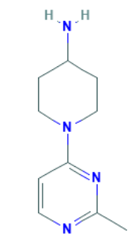 | 4.75 μM
2 | 3,4-Dimethoxybenzylamine | 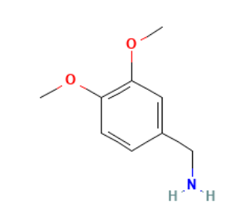 | 0.11 mM
3 | N-ethyl-1-(pyridin-4-yl)piperidin-4-amine | 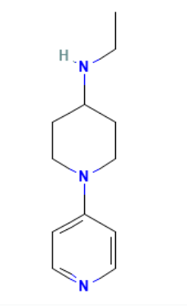 | 18.8 μM
4 | 4-(4-Chlorophenyl)pyrimidin-2-amine | 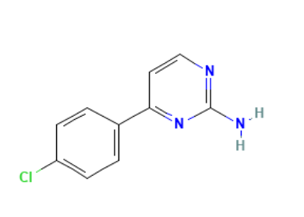 | 1.86 μM
5 | 5-Methoxybenzo[d]thiazol-2-amine | 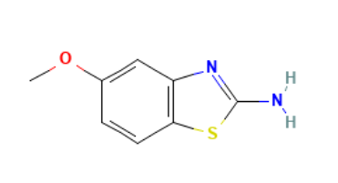 | --
6 | N-3-pyridinylpyrazolo[1,5-a]pyrimidine-3-carboxamide | 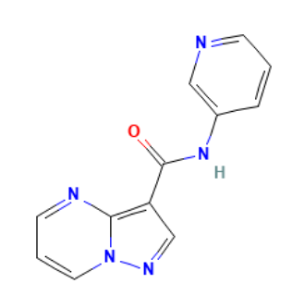 | 1.10 mM
7 | N-methyl-1-(1-phenylpyrazol-4-yl)methanamine | 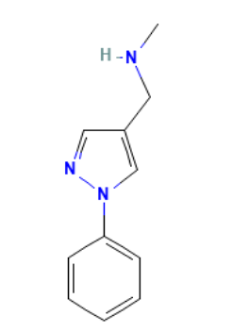 | 13.3 μM

