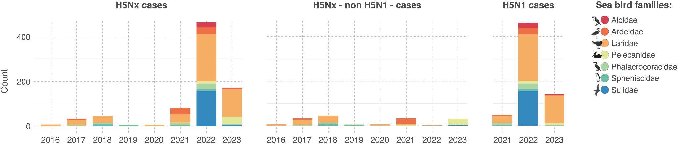
Distribution of H5Nx and H5N1 occurrence records in sea birds from 2015 to 2023, categorised by bird family. The three panels successively show the total occurrence records for all H5Nx subtypes, occurrence records for non-H5N1 H5Nx subtypes, and all H5N1 occurrence records.

