Supplementary ﬁle 1. Summary statistics of the measures of ental health in the baseline. Med = Median IQR = interquartile range; CV = Coefficient of variation; CBCL = Child Behavioural Checklist, reflecting children’s emotional and behavioural problems; UPPS-P = Urgency, Premeditation, Perseverance, Sensation seeking and Positive urgency Impulsive Behaviour Scale; BAS = Behavioural Activation System. Under the variable names, there are information about the method to compute these variables and the original variables names in ABCD data dictionary.
No | Variable | Stats / Values | Graph | Valid
1 | Anxious/Depressed CBCL  [numeric]  CBCL_SCR_SYN_ANXDEP_R | Mean (sd) : 2.5 (3.1)  min < med < max:  0 < 1 < 26  IQR (CV) : 4 (1.2) | 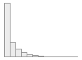 | 11754  (99.9%)
2 | Withdrawn CBCL  [numeric]  CBCL_SCR_SYN_WITHDEP_R | Mean (sd) : 1 (1.7)  min < med < max:  0 < 0 < 15  IQR (CV) : 1 (1.7) | 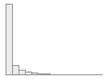 | 11754  (99.9%)
3 | Somatic CBCL  [numeric]  CBCL_SCR_SYN_SOMATIC_R | Mean (sd) : 1.5 (2)  min < med < max:  0 < 1 < 16  IQR (CV) : 2 (1.3) | 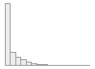 | 11754  (99.9%)
4 | Social CBCL  [numeric]  CBCL_SCR_SYN_SOCIAL_R | Mean (sd) : 1.6 (2.3)  min < med < max:  0 < 1 < 18  IQR (CV) : 2 (1.4) | 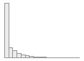 | 11754  (99.9%)
5 | Thought CBCL  [numeric]  CBCL_SCR_SYN_THOUGHT_R | Mean (sd) : 1.6 (2.2)  min < med < max:  0 < 1 < 18  IQR (CV) : 2 (1.4) | 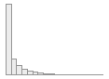 | 11754  (99.9%)
6 | Attention CBCL  [numeric]  CBCL_SCR_SYN_ATTENTION_R | Mean (sd) : 3 (3.5)  min < med < max:  0 < 2 < 20  IQR (CV) : 5 (1.2) | 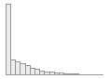 | 11754  (99.9%)
7 | Rule-Breaking CBCL  [numeric]  CBCL_SCR_SYN_RULEBREAK_R | Mean (sd) : 1.2 (1.9)  min < med < max:  0 < 0 < 20  IQR (CV) : 2 (1.6) | 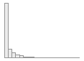 | 11754  (99.9%)
8 | Aggressive CBCL  [numeric]  CBCL_SCR_SYN_AGGRESSIVE_R | Mean (sd) : 3.3 (4.4)  min < med < max:  0 < 2 < 36  IQR (CV) : 5 (1.3) | 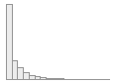 | 11754  (99.9%)
9 | Negative Urgency UPSS  [numeric]  UPPS_Y_SS_NEGATIVE_URGENCY | Mean (sd) : 8.5 (2.6)  min < med < max:  4 < 8 < 16  IQR (CV) : 3 (0.3) | 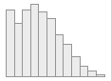 | 11739  (99.8%)
10 | Lack of Planning UPSS  [numeric]  UPPS_Y_SS_LACK_OF_PLANNING | Mean (sd) : 7.7 (2.4)  min < med < max:  4 < 8 < 16  IQR (CV) : 3 (0.3) | 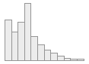 | 11739  (99.8%)
11 | Sensation Seeking UPSS  [numeric]  UPPS_Y_SS_SENSATION_SEEKING | Mean (sd) : 9.8 (2.7)  min < med < max:  4 < 10 < 16  IQR (CV) : 4 (0.3) | 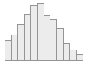 | 11739  (99.8%)
12 | Positive Urgency UPSS  [numeric]  UPPS_Y_SS_POSITIVE_URGENCY | Mean (sd) : 8 (3)  min < med < max:  4 < 8 < 16  IQR (CV) : 4 (0.4) | 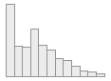 | 11739  (99.8%)
13 | Lack of Perseverance UPSS  [numeric]  UPPS_Y_SS_LACK_OF_PERSEVERANCE | Mean (sd) : 7 (2.3)  min < med < max:  4 < 7 < 16  IQR (CV) : 3 (0.3) | 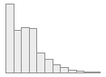 | 11739  (99.8%)
14 | Behavioural Inhibition System  [numeric]  Mean of  (BISBAS2_Y,  BISBAS3_Y,  BISBAS4_Y,  BISBAS6_Y) | Mean (sd) : 1.4 (0.7)  min < med < max:  0 < 1.2 < 3  IQR (CV) : 1.2 (0.5) | 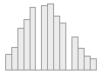 | 11740  (99.8%)
15 | BAS Reward Responsiveness  [numeric]  Mean of  (BISBAS8_Y,  BISBAS10_Y,  BISBAS11_Y,  BISBAS12_Y) | Mean (sd) : 2.2 (0.6)  min < med < max:  0 < 2.2 < 3  IQR (CV) : 1 (0.3) | 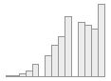 | 11739  (99.8%)
16 | BAS Drive  [numeric]  Mean of  (BISBAS13_Y,  BISBAS14_Y,  BISBAS15_Y,  BISBAS16_Y) | Mean (sd) : 1 (0.8)  min < med < max:  0 < 1 < 3  IQR (CV) : 1 (0.7) | 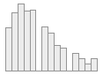 | 11739  (99.8%)
17 | BAS Fun  [numeric]  Means of  (BISBAS17_Y,  BISBAS18_Y,  BISBAS19_Y,  BISBAS20_Y) | Mean (sd) : 1.4 (0.7)  min < med < max:  0 < 1.5 < 3  IQR (CV) : 0.8 (0.5) | 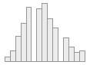 | 11739  (99.8%)

