Supplementary ﬁle 2. Summary statistics of the measures of mental health in the follow up. Med = Median IQR = interquartile range; CV = Coefficient of variation; CBCL = Child Behavioural Checklist, reflecting children’s emotional and behavioural problems; UPPS-P = Urgency, Premeditation, Perseverance, Sensation seeking and Positive urgency Impulsive Behaviour Scale; BAS = Behavioural Activation System. Under the variable names, there are information about the method to compute these variables and the original variables names in ABCD data dictionary.
No | Variable | Stats / Values | Graph | Valid
1 | Anxious/Depressed CBCL  [numeric]  CBCL_SCR_SYN_ANXDEP_R | Mean (sd) : 2.3 (3)  min < med < max:  0 < 1 < 24  IQR (CV) : 3 (1.3) | 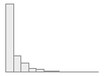 | 10827  (99.9%)
2 | Withdrawn CBCL  [numeric]  CBCL_SCR_SYN_WITHDEP_R | Mean (sd) : 1.3 (2)  min < med < max:  0 < 0 < 16  IQR (CV) : 2 (1.6) | 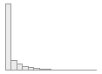 | 10827  (99.9%)
3 | Somatic CBCL  [numeric]  CBCL_SCR_SYN_SOMATIC_R | Mean (sd) : 1.4 (1.9)  min < med < max:  0 < 1 < 16  IQR (CV) : 2 (1.4) | 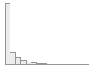 | 10827  (99.9%)
4 | Social CBCL  [numeric]  CBCL_SCR_SYN_SOCIAL_R | Mean (sd) : 1.3 (2.1)  min < med < max:  0 < 0 < 17  IQR (CV) : 2 (1.6) | 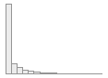 | 10827  (99.9%)
5 | Thought CBCL  [numeric]  CBCL_SCR_SYN_THOUGHT_R | Mean (sd) : 1.4 (2.1)  min < med < max:  0 < 1 < 22  IQR (CV) : 2 (1.5) | 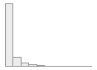 | 10827  (99.9%)
6 | Attention CBCL  [numeric]  CBCL_SCR_SYN_ATTENTION_R | Mean (sd) : 2.7 (3.3)  min < med < max:  0 < 1 < 19  IQR (CV) : 4 (1.2) | 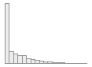 | 10827  (99.9%)
7 | Rule-Breaking CBCL  [numeric]  CBCL_SCR_SYN_RULEBREAK_R | Mean (sd) : 1.1 (1.9)  min < med < max:  0 < 0 < 23  IQR (CV) : 1 (1.7) | 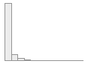 | 10827  (99.9%)
8 | Aggressive CBCL  [numeric]  CBCL_SCR_SYN_AGGRESSIVE_R | Mean (sd) : 2.8 (4)  min < med < max:  0 < 1 < 33  IQR (CV) : 4 (1.4) | 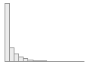 | 10827  (99.9%)
9 | Negative Urgency UPSS  [numeric]  UPPS_Y_SS_NEGATIVE_URGENCY | Mean (sd) : 7.8 (2.3)  min < med < max:  4 < 8 < 16  IQR (CV) : 3 (0.3) | 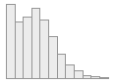 | 10811  (99.7%)
10 | Lack of Planning UPSS  [numeric]  UPPS_Y_SS_LACK_OF_PLANNING | Mean (sd) : 7.8 (2.2)  min < med < max:  4 < 8 < 16  IQR (CV) : 3 (0.3) | 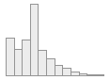 | 10811  (99.7%)
11 | Sensation Seeking UPSS  [numeric]  UPPS_Y_SS_SENSATION_SEEKING | Mean (sd) : 9.5 (2.7)  min < med < max:  3 < 9 < 16  IQR (CV) : 3 (0.3) | 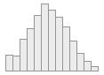 | 10812  (99.7%)
12 | Positive Urgency UPSS  [numeric]  UPPS_Y_SS_POSITIVE_URGENCY | Mean (sd) : 7.4 (2.7)  min < med < max:  4 < 8 < 16  IQR (CV) : 4 (0.4) | 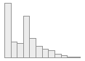 | 10811  (99.7%)
13 | Lack of Perseverance UPSS  [numeric]  UPPS_Y_SS_LACK_OF_PERSEVERANCE | Mean (sd) : 7 (2.3)  min < med < max:  4 < 7 < 16  IQR (CV) : 3 (0.3) | 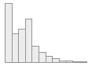 | 10811  (99.7%)
14 | Behavioural Inhibition System  [numeric]  Mean of  (BISBAS2_Y,  BISBAS3_Y,  BISBAS4_Y,  BISBAS6_Y) | Mean (sd) : 1.2 (0.7)  min < med < max:  0 < 1.2 < 3  IQR (CV) : 1 (0.6) | 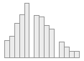 | 10811  (99.7%)
15 | BAS Reward Responsiveness  [numeric]  Mean of  (BISBAS8_Y,  BISBAS10_Y,  BISBAS11_Y,  BISBAS12_Y) | Mean (sd) : 2 (0.6)  min < med < max:  0 < 2 < 3  IQR (CV) : 1 (0.3) | 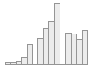 | 10811  (99.7%)
16 | BAS Drive  [numeric]  Mean of  (BISBAS13_Y,  BISBAS14_Y,  BISBAS15_Y,  BISBAS16_Y) | Mean (sd) : 0.9 (0.7)  min < med < max:  0 < 0.8 < 3  IQR (CV) : 0.8 (0.8) | 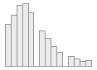 | 10811  (99.7%)
17 | BAS Fun  [numeric]  Mean of  (BISBAS17_Y,  BISBAS18_Y,  BISBAS19_Y,  BISBAS20_Y) | Mean (sd) : 1.1 (0.6)  min < med < max:  0 < 1 < 3  IQR (CV) : 0.8 (0.6) | 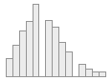 | 10811  (99.7%)

