Supporting Information for

Cholesterol taste avoidance in Drosophila melanogaster

Roshani Nhuchhen Pradhan1, Craig Montell2 and Youngseok Lee1,3,*

Youngseok Lee
Email: ylee@kookmin.ac.kr

This file includes:
Figures S1 to S3

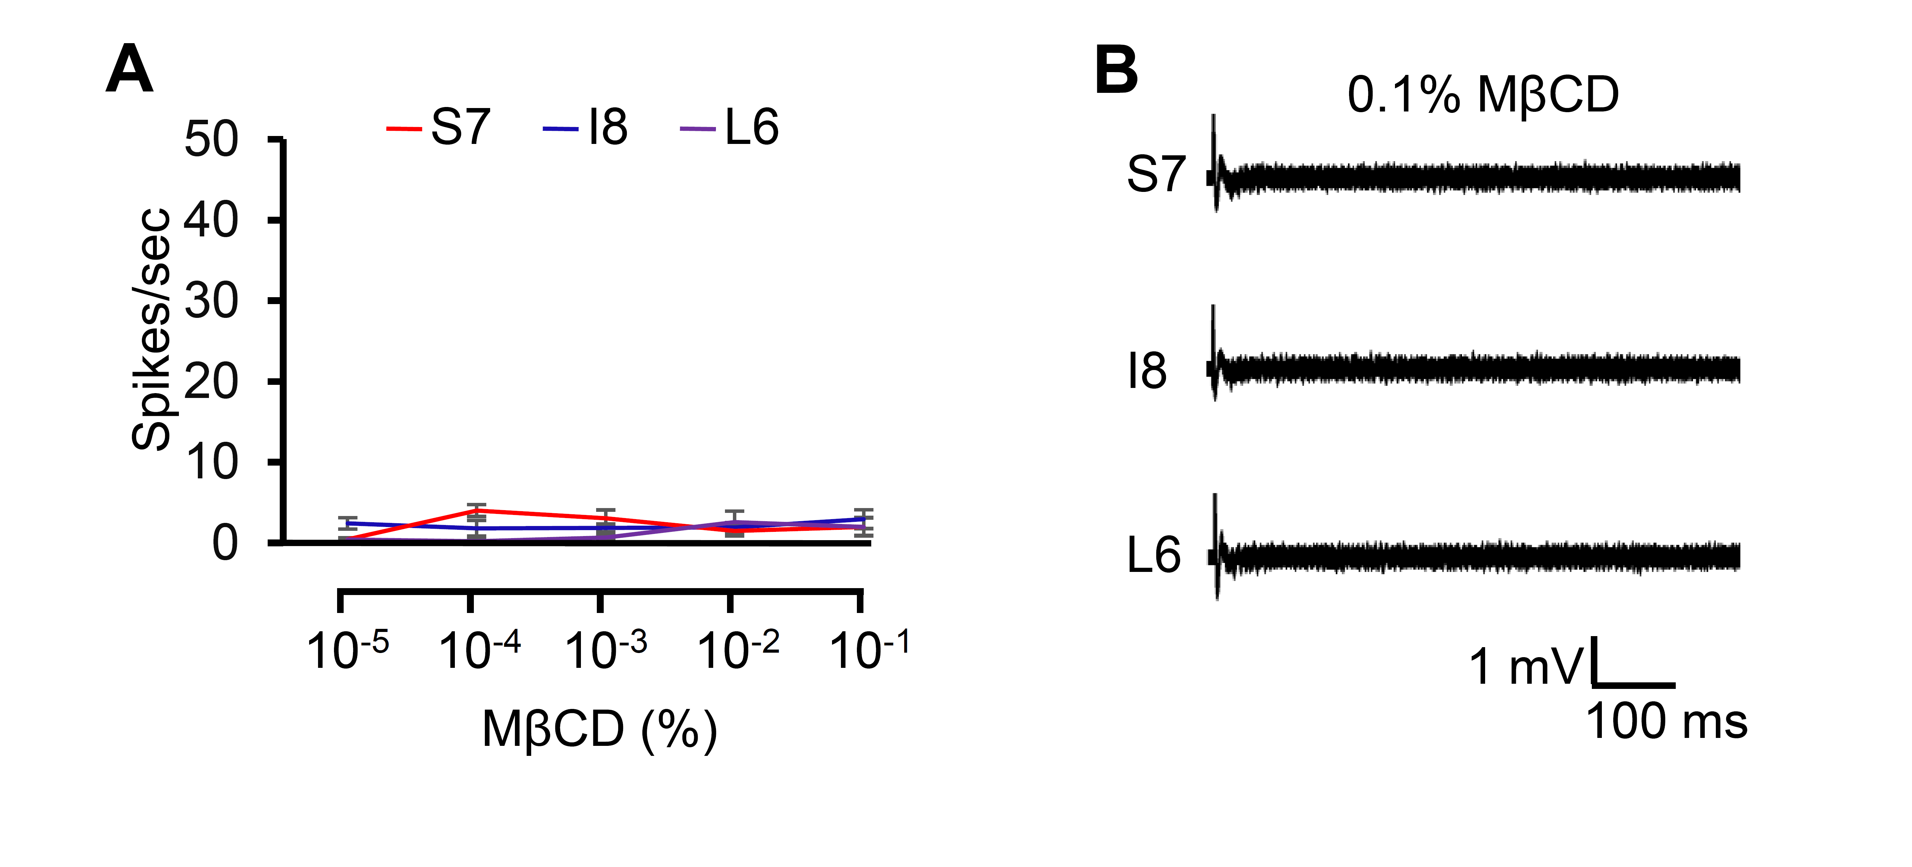
Figure 1—figure supplement 1. Electrophysiological analysis of different doses of MβCD. (A) Dose-dependent neuronal responses of w¹¹¹⁸ adult flies to MβCD from S7, I8, and L6 sensilla (n=10). (B) Representative sample traces corresponding to the data in (A). Error bars represent standard errors of the means (SEMs). Statistical analysis was performed using single-factor ANOVA with Scheffe's post hoc analysis to compare multiple datasets.

Figure 2—figure supplement 1. Electrophysiological analysis of different bitter GRs and TRP lines in the presence of 10⁻¹% CHL, with subset expression of Ir56d in bitter GRNs. (A) Electrophysiology analysis of broadly tuned bitter GRs with 10⁻¹% cholesterol (n=10). (B) Neuronal response analyses of TRP mutant lines with 10⁻¹% cholesterol (n=10). (C, D, E) Tip recording analyses of control flies and candidate IRs mutant flies (Ir7g¹, Ir25a², Ir51b¹, Ir56d¹, and Ir76b¹) with 10⁻³% stigmasterol (STG) from S6, S7, and S10 sensilla (n=10-12). (F) Relative spatial distributions of the Gr66a (green; anti-GFP) and Ir56d (red; anti-DsRed) reporters in the labella of Gr66a-I-GFP, Ir56d-GAL4/UAS-DsRed flies. Images were acquired by confocal microscopy. The scale bars represent 50 µm. All error bars represent standard errors of the means (SEMs). Statistical analysis was performed using single-factor ANOVA with Scheffe's post hoc analysis to compare multiple datasets. Asterisks indicate statistical significance compared to the control group (**P < 0.01).

Figure 3—figure supplement 1. Binary food choice assay with CHL and MβCD. (A) Dose-dependent binary food choice assay using control flies with 10⁻³%, 10⁻²%, and 10⁻¹% MβCD containing 2 mM sucrose vs 2 mM sucrose only (n=6). (B) Dose-dependent binary food choice assay comparing cholesterol (CHL) vs MβCD food. Sucrose (2 mM) was employed on both sides (n=6). (C) Behavioral analysis of control flies after switching the dye to 0.1% cholesterol (n=6). (D) Feeding assay of the RNAi lines for Ir7g, Ir25a, Ir51b, Ir56d, and Ir76b with UAS-Dicer2 driven by Gr33a-GAL4. (E) Feeding assay of the RNAi lines for Ir7g, Ir25a, Ir51b, Ir56d, and Ir76b with UAS-Dicer2 driven by ppk23-GAL4 (n=6). (F) Binary food choice assay of control flies and orco¹ mutants with 0.1% cholesterol (n=6). (G) Evaluation of the role of different organs in 0.1% cholesterol perception via feeding assay (n = 6). All error bars represent standard errors of the means (SEMs). Statistical analysis was performed using single-factor ANOVA with Scheffe's post hoc analysis to compare multiple datasets. Asterisks indicate statistical significance compared to the control group (**P < 0.01).

