Supporting Information

Conformational Variability of HIV-1 Env Trimer and Viral Vulnerability

Yiwei Cao¹ and Wonpil Im¹*

¹Department of Biological Sciences, Lehigh University, 111 Research Dr, Bethlehem, PA 18015, USA

*Corresponding Author: Wonpil Im (wonpil@lehigh.edu)

Name | Cleaved | TMD Position | CT Truncated | Number of Atoms | Simulation Time | Number of Simulation Runs
CH^{ΔCT} | Yes | High | Yes | 1,046,227 | 1 μs | 3
CL^{ΔCT} | Yes | Low | Yes | 1,040,888 | 1 μs | 3
UH^{ΔCT} | No | High | Yes | 1,080,915 | 1 μs | 3
UL^{ΔCT} | No | Low | Yes | 1,080,164 | 1 μs | 3
CH^{CT} | Yes | High | No | 1,080,113 | 1 μs | 3
CL^{CT} | Yes | Low | No | 1,078,556 | 1 μs | 3
UH^{CT} | No | High | No | 1,118,568 | 1 μs | 3
UL^{CT} | No | Low | No | 1,118,375 | 1 μs | 3
Table A. Simulation system information.

 | CH^{ΔCT}1 | CH^{ΔCT}2 | CH^{ΔCT}3 | CL^{ΔCT}1 | CL^{ΔCT}2 | CL^{ΔCT}3
A¹ | 19% | 7%⁴ | 36% | 21% | 16% | 1%
B¹ | 76% | 1% | 15% | 19% | 3% | 46%
C¹ | 43% | 13% | 17% | 19% | 14% | 19%
A&B² | 17% | 0% | 8% | 8% | 1% | 0%
A&C² | 6% | 0% | 1% | 6% | 0% | 0%
B&C² | 37% | 0% | 3% | 2% | 0% | 14%
A&B&C³ | 6% | 0% | 0% | 1% | 0% | 0%

 | UH^{ΔCT}1 | UH^{ΔCT}2 | UH^{ΔCT}3 | UL^{ΔCT}1 | UL^{ΔCT}2 | UL^{ΔCT}3
A | 5% | 32% | 2% | 3% | 9% | 5%
B | 35% | 38% | 41% | 2% | 28% | 2%
C | 12% | 16% | 53% | 45% | 3% | 33%
A&B | 1% | 15% | 1% | 0% | 5% | 0%
A&C | 1% | 9% | 1% | 1% | 1% | 2%
B&C | 4% | 10% | 20% | 1% | 2% | 1%
A&B&C | 1% | 5% | 1% | 0% | 1% | 0%

 | CH^{CT}1 | CH^{CT}2 | CH^{CT}3 | CL^{CT}1 | CL^{CT}2 | CL^{CT}3
A | 7% | 10% | 9% | 15% | 0% | 7%
B | 2% | 15% | 19% | 22% | 0% | 0%
C | 44% | 2% | 25% | 14% | 4% | 23%
A&B | 0% | 2% | 0% | 3% | 0% | 0%
A&C | 1% | 0% | 1% | 1% | 0% | 1%
B&C | 1% | 0% | 9% | 5% | 0% | 0%
A&B&C | 0% | 0% | 0% | 1% | 0% | 0%

 | UH^{CT}1 | UH^{CT}2 | UH^{CT}3 | UL^{CT}1 | UL^{CT}2 | UL^{CT}3
A | 1% | 1% | 26% | 33% | 1% | 2%
B | 2% | 23% | 26% | 45% | 67% | 48%
C | 4% | 34% | 13% | 3% | 38% | 17%
A&B | 0% | 1% | 5% | 14% | 1% | 0%
A&C | 0% | 1% | 1% | 2% | 1% | 1%
B&C | 0% | 9% | 3% | 2% | 29% | 1%
A&B&C | 0% | 1% | 0% | 1% | 1% | 0%
Table B. Frequency of epitope accessibility for antibody PGT128. ¹Three protein chains are referred to as A, B, and C. ²“A&B” denotes that the epitopes on both chains A and B are concurrently accessible. ³“A&B&C” denotes that the epitopes on all three chains are concurrently accessible. ⁴Red text highlights cases where the frequency of epitope accessibility on an individual chain is <10%. The same notations apply for Supplementary Table 3 and 4.

 | CH^{ΔCT}1 | CH^{ΔCT}2 | CH^{ΔCT}3 | CL^{ΔCT}1 | CL^{ΔCT}2 | CL^{ΔCT}3
A | 0% | 0% | 0% | 0% | 0% | 0%
B | 20% | 34% | 1% | 11% | 0% | 15%
C | 0% | 0% | 1% | 0% | 0% | 0%
A&B | 0% | 0% | 0% | 0% | 0% | 0%
A&C | 0% | 0% | 0% | 0% | 0% | 0%
B&C | 0% | 0% | 0% | 0% | 0% | 0%
A&B&C | 0% | 0% | 0% | 0% | 0% | 0%

 | UH^{ΔCT}1 | UH^{ΔCT}2 | UH^{ΔCT}3 | UL^{ΔCT}1 | UL^{ΔCT}2 | UL^{ΔCT}3
A | 1% | 0% | 0% | 0% | 1% | 0%
B | 0% | 1% | 2% | 0% | 1% | 0%
C | 2% | 0% | 0% | 0% | 0% | 0%
A&B | 0% | 0% | 0% | 0% | 0% | 0%
A&C | 0% | 0% | 0% | 0% | 0% | 0%
B&C | 0% | 0% | 0% | 0% | 0% | 0%
A&B&C | 0% | 0% | 0% | 0% | 0% | 0%

 | CH^{CT}1 | CH^{CT}2 | CH^{CT}3 | CL^{CT}1 | CL^{CT}2 | CL^{CT}3
A | 0% | 0% | 0% | 0% | 0% | 0%
B | 1% | 0% | 2% | 3% | 0% | 31%
C | 0% | 0% | 0% | 0% | 5% | 0%
A&B | 0% | 0% | 0% | 0% | 0% | 0%
A&C | 0% | 0% | 0% | 0% | 0% | 0%
B&C | 0% | 0% | 0% | 0% | 0% | 0%
A&B&C | 0% | 0% | 0% | 0% | 0% | 0%

 | UH^{CT}1 | UH^{CT}2 | UH^{CT}3 | UL^{CT}1 | UL^{CT}2 | UL^{CT}3
A | 0% | 1% | 1% | 0% | 0% | 0%
B | 0% | 1% | 0% | 0% | 0% | 0%
C | 0% | 1% | 0% | 0% | 2% | 0%
A&B | 0% | 0% | 0% | 0% | 0% | 0%
A&C | 0% | 0% | 0% | 0% | 0% | 0%
B&C | 0% | 0% | 0% | 0% | 0% | 0%
A&B&C | 0% | 0% | 0% | 0% | 0% | 0%
Table C. Frequency of epitope accessibility for antibody PG9.

 | CH^{ΔCT}1 | CH^{ΔCT}2 | CH^{ΔCT}3 | CL^{ΔCT}1 | CL^{ΔCT}2 | CL^{ΔCT}3
A | 0% | 0% | 10% | 18% | 0% | 4%
B | 2% | 2% | 5% | 4% | 20% | 5%
C | 41% | 3% | 1% | 0% | 3% | 4%
A&B | 0% | 0% | 0% | 0% | 0% | 0%
A&C | 0% | 0% | 0% | 0% | 0% | 0%
B&C | 0% | 0% | 0% | 0% | 1% | 0%
A&B&C | 0% | 0% | 0% | 0% | 0% | 0%

 | UH^{ΔCT}1 | UH^{ΔCT}2 | UH^{ΔCT}3 | UL^{ΔCT}1 | UL^{ΔCT}2 | UL^{ΔCT}3
A | 15% | 0% | 1% | 7% | 15% | 4%
B | 4% | 0% | 1% | 0% | 7% | 13%
C | 24% | 5% | 32% | 33% | 6% | 45%
A&B | 0% | 0% | 0% | 0% | 2% | 0%
A&C | 7% | 0% | 1% | 1% | 1% | 1%
B&C | 0% | 0% | 0% | 0% | 0% | 10%
A&B&C | 0% | 0% | 0% | 0% | 0% | 0%

 | CH^{CT}1 | CH^{CT}2 | CH^{CT}3 | CL^{CT}1 | CL^{CT}2 | CL^{CT}3
A | 14% | 13% | 0% | 0% | 2% | 9%
B | 9% | 3% | 1% | 4% | 2% | 3%
C | 9% | 11% | 10% | 0% | 0% | 24%
A&B | 2% | 0% | 0% | 0% | 0% | 2%
A&C | 1% | 2% | 0% | 0% | 0% | 3%
B&C | 1% | 0% | 0% | 0% | 0% | 0%
A&B&C | 0% | 0% | 0% | 0% | 0% | 0%

 | UH^{CT}1 | UH^{CT}2 | UH^{CT}3 | UL^{CT}1 | UL^{CT}2 | UL^{CT}3
A | 17% | 0% | 16% | 4% | 22% | 5%
B | 6% | 0% | 1% | 0% | 0% | 0%
C | 57% | 19% | 57% | 35% | 14% | 44%
A&B | 2% | 0% | 0% | 0% | 0% | 0%
A&C | 6% | 0% | 11% | 2% | 2% | 0%
B&C | 2% | 0% | 1% | 0% | 0% | 0%
A&B&C | 0% | 0% | 0% | 0% | 0% | 0%
Table D. Frequency of epitope accessibility for antibody VRC01.

 | CH^{ΔCT}1 | CH^{ΔCT}2 | CH^{ΔCT}3 | CL^{ΔCT}1 | CL^{ΔCT}2 | CL^{ΔCT}3
A | 7%, 0%¹ | 4%, 0% | 9%, 8% | 3%, 0% | 24%, 0% | 7%, 4%
B | 29%, 2%² | 14%, 0% | 12%, 0% | 0%, 0% | 10%, 10% | 0%, 0%
C | 8%, 8% | 14%, 10% | 10%, 5% | 32%, 7% | 4%, 1% | 22%, 16%
A&B | 7%, 0% | 4%, 0% | 9%, 0% | 0%, 0% | 10%, 0% | 0%, 0%
A&C | 7%, 0% | 4%, 0% | 9%, 5% | 3%, 0% | 4%, 0% | 7%, 4%
B&C | 8%, 2% | 14%, 0% | 10%, 0% | 0%, 0% | 4%, 1% | 0%, 0%
A&B&C | 7%, 0% | 4%, 0% | 9%, 0% | 0%, 0% | 4%, 0% | 0%, 0%

 | UH^{ΔCT}1 | UH^{ΔCT}2 | UH^{ΔCT}3 | UL^{ΔCT}1 | UL^{ΔCT}2 | UL^{ΔCT}3
A | 16%, 12% | 49%, 1% | 9%, 7% | 14%, 5% | 23%, 19% | 43%, 10%
B | 2%, 2% | 5%, 5% | 10%, 9% | 7%, 7% | 3%, 1% | 5%, 0%
C | 22%, 13% | 25%, 25% | 23%, 23% | 26%, 3% | 6%, 5% | 5%, 5%
A&B | 2%, 2% | 5%, 1% | 9%, 7% | 7%, 5% | 3%, 1% | 5%, 0%
A&C | 16%, 12% | 25%, 1% | 9%, 7% | 14%, 3% | 6%, 5% | 5%, 5%
B&C | 2%, 2% | 5%, 5% | 10%, 9% | 7%, 3% | 3%, 1% | 5%, 0%
A&B&C | 2%, 2% | 5%, 1% | 9%, 7% | 7%, 3% | 3%, 1% | 5%, 0%

 | CH^{CT}1 | CH^{CT}2 | CH^{CT}3 | CL^{CT}1 | CL^{CT}2 | CL^{CT}3
A | 9%, 0% | 30%, 0% | 48%, 18% | 12%, 4% | 22%, 0% | 5%, 5%
B | 0%, 0% | 0%, 0% | 31%, 8% | 11%, 11% | 24%, 11% | 24%, 1%
C | 2%, 2% | 3%, 2% | 7%, 0% | 24%, 0% | 6%, 2% | 2%, 2%
A&B | 0%, 0% | 0%, 0% | 31%, 8% | 11%, 4% | 22%, 0% | 5%, 1%
A&C | 2%, 0% | 3%, 0% | 7%, 0% | 12%, 0% | 6%, 0% | 2%, 2%
B&C | 0%, 0% | 0%, 0% | 7%, 0% | 11%, 0% | 6%, 2% | 2%, 1%
A&B&C | 0%, 0% | 0%, 0% | 7%, 0% | 11%, 0% | 6%, 0% | 2%, 1%

 | UH^{CT}1 | UH^{CT}2 | UH^{CT}3 | UL^{CT}1 | UL^{CT}2 | UL^{CT}3
A | 5%, 4% | 18%, 16% | 33%, 0% | 31%, 0% | 31%, 0% | 41%, 0%
B | 26%, 16% | 8%, 5% | 11%, 7% | 2%, 1% | 2%, 0% | 18%, 1%
C | 25%, 0% | 7%, 0% | 20%, 9% | 3%, 2% | 29%, 15% | 7%, 7%
A&B | 5%, 4% | 8%, 5% | 11%, 0% | 2%, 0% | 2%, 0% | 18%, 0%
A&C | 5%, 0% | 7%, 0% | 20%, 0% | 3%, 0% | 29%, 0% | 7%, 0%
B&C | 25%, 0% | 7%, 0% | 11%, 7% | 2%, 1% | 2%, 0% | 7%, 1%
A&B&C | 5%, 0% | 7%, 0% | 11%, 0% | 2%, 0% | 2%, 0% | 7%, 0%
Table E. Frequency of epitope accessibility for antibody 35O22. ¹The first value represents the frequency of epitope accessibility considering only glycan shielding, and the second value represents the frequency considering the shielding of both glycan and membrane. Red text highlights cases where the first value is <10%. ²Magenta text highlights cases where the first value is ≥10% but the second value is <10%.

Glycosylation Site | Composition and Type | Sequence
N197,  N355¹ | HexNAc(2)Hex(5)  High-mannose | 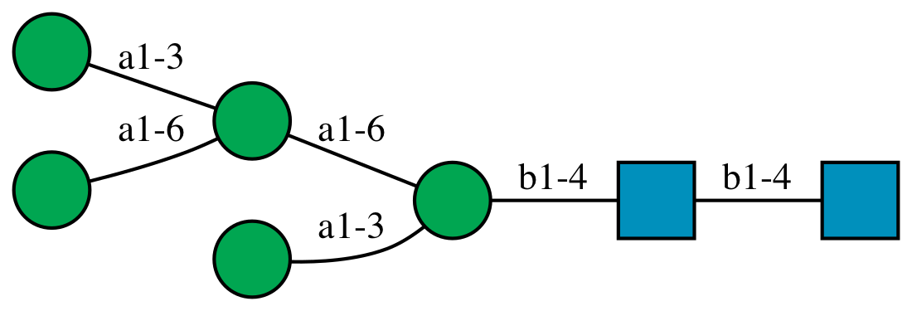
N276¹ | HexNAc(2)Hex(7)  High-mannose | 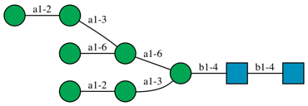
N160¹ | HexNAc(2)Hex(8)  High-mannose | 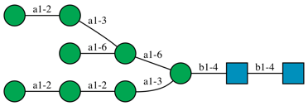
N133, N156,  N234, N262,  N295, N301,  N332, N339,  N363, N386,  N392, N411,  N448 | HexNAc(2)Hex(9)  High-mannose | 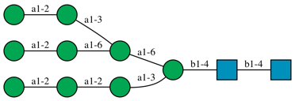
N88, N137,  N185E, N185H,  N398, N406,  N618, N637² | HexNAc(4)Hex(5)  Fuc(1)Neu5Ac(2)  Complex | 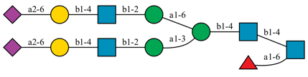
N462,  N611^{2,3} | HexNAc(5)Hex(6)  Fuc(1)Neu5Ac(3)  Complex | 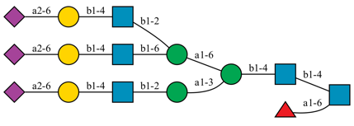
Table F. Glycosylation sites, selected glycan compositions, and sequences used in this study. ¹The same composition can correspond to multiple possible sequences, depending on which branch the mannose (Man) is attached to. In such cases, one representative sequence was selected for structural modeling. ²N-Acetylneuraminic acid (Neu5Ac) can be either α2-3 or α2-6 linked to galactose (Gal). In this study, the α2-6 linkage was used for all non-reducing terminal Neu5Ac. ³Both the α1-3 and α1-6 branches can contain one or two antennae. Here, we added one antenna to the α1-3 branch and two antennae to the α1-6 branch.

CT-truncated (ΔCT)
Lipid Name | Lipid Head/Tail | Number of Lipids in Leaflets
Lipid Name | Lipid Head/Tail | Exoplasmic | Cytoplasmic
POPC | PC (16:0/18:1(9Z)) | 120 | 56
PLPC | PC (16:0/18:2(9Z,12Z)) | 165 | 88
PAPE | PE (16:0/20:4(5Z,8Z,11Z,14Z)) | 23 | 96
POPE | PE (16:0/18:1(9Z)) | 23 | 112
POPI | PI (16:0/18:1(9Z)) | 0 | 40
PAPS | PS (16:0/20:4(5Z,8Z,11Z,14Z)) | 0 | 88
POPA | PA (16:0/18:1(9Z)) | 0 | 8
SSM | SM (d18:1/18:0) | 83 | 40
NSM | SM (d18:1/24:1) | 83 | 40
CMH | GlcCer (d18:1/16:0) | 30 | 0
CHOL | Cholesterol | 278 | 232
TOTAL |  | 805 | 800

Full-length (CT)
Lipid Name | Lipid Head/Tail | Number of Lipids in Leaflets
Lipid Name | Lipid Head/Tail | Exoplasmic | Cytoplasmic
POPC | PC (16:0/18:1(9Z)) | 120 | 49
PLPC | PC (16:0/18:2(9Z,12Z)) | 165 | 77
PAPE | PE (16:0/20:4(5Z,8Z,11Z,14Z)) | 23 | 84
POPE | PE (16:0/18:1(9Z)) | 23 | 98
POPI | PI (16:0/18:1(9Z)) | 0 | 35
PAPS | PS (16:0/20:4(5Z,8Z,11Z,14Z)) | 0 | 77
POPA | PA (16:0/18:1(9Z)) | 0 | 7
SSM | SM (d18:1/18:0) | 83 | 35
NSM | SM (d18:1/24:1) | 83 | 35
CMH | GlcCer (d18:1/16:0) | 30 | 0
CHOL | Cholesterol | 278 | 203
TOTAL |  | 805 | 700
Table G. Membrane lipid composition.

Stage |  | Ensemble | Time Step (fs) | Total Time (ns) | Position Restraint Force Constant (kJ/mol⋅nm²) |  |  | Dihedral Restraint Force Constant (kJ/mol⋅nm²)
 |  |  |  |  | Protein Backbone | Protein Side Chain | Lipid Head Group | Glycan Ring
Equilibration | 1 | NVT | 1 | 1.25 | 4000 | 2000 | 1000 | 1000
Equilibration | 2 | NVT | 1 | 1.25 | 2000 | 1000 | 400 | 400
Equilibration | 3 | NPT | 1 | 1.25 | 1000 | 500 | 400 | 200
Equilibration | 4 | NPT | 2 | 5 | 500 | 200 | 200 | 200
Equilibration | 5 | NPT | 2 | 5 | 200 | 50 | 40 | 100
Equilibration | 6 | NPT | 2 | 5 | 50 | N/A | N/A | N/A
Production |  | NPT | 4 | 1000 | N/A | N/A | N/A | N/A
Table H. Simulation settings for the equilibration and production stages.

