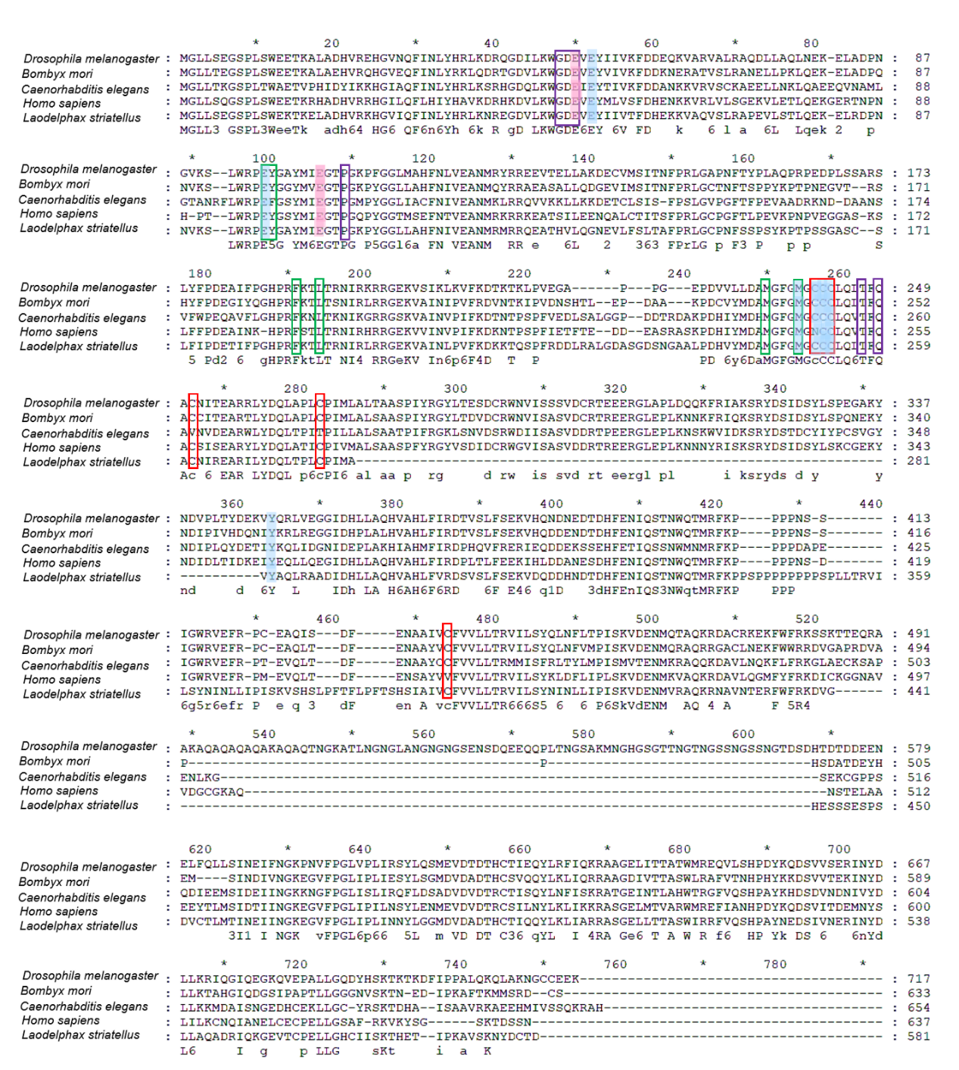Alignment of Glutamate-cysteine ligase (GCL) amino acid sequences
The sequence of GCL in Laodelphax striatellus was compared to those of Drosophila melanogaster, Bombyx mori, Caenorhabditis elegans, and Homo sapiens, and the accession numbers of these proteins on NCBI are Q9W3K5.1, BDP27722.1, Q20117.2, and P48506.2 respectively. Blue shadow = glutamate-binding; Pink shadow = magnesium-binding; Purple Frame = ATP/ADP-binding; Green Frame = cysteine-binding; Red Frame = conserved cysteine

