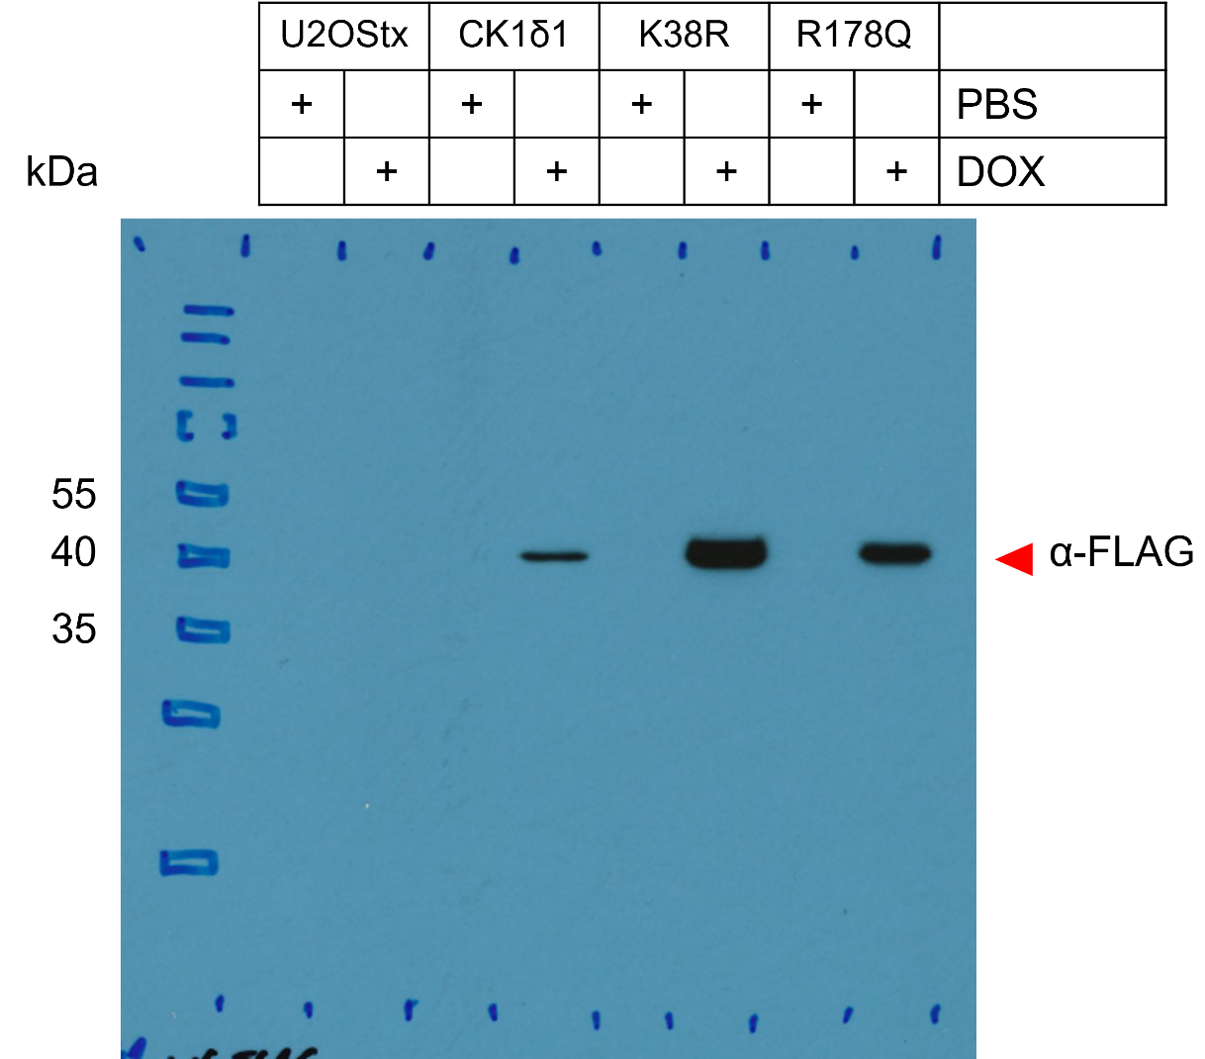
Figure 3B – Source Data 1a. Original film corresponding to Figure 3B, upper panel. Using the basal U2OStx line and the stable cell line generated to induce either wild-type CK1δ1, kinase-dead CK1δ1 (CK1δ1-K38R), and tau-like CK1δ1 (CK1δ1-R178Q), cells were treated with either PBS (negative control) or DOX (doxycycline) to induce protein expression. Resulting blots were decorated with anti-FLAG antibody to detect overexpressed CK1δ1.
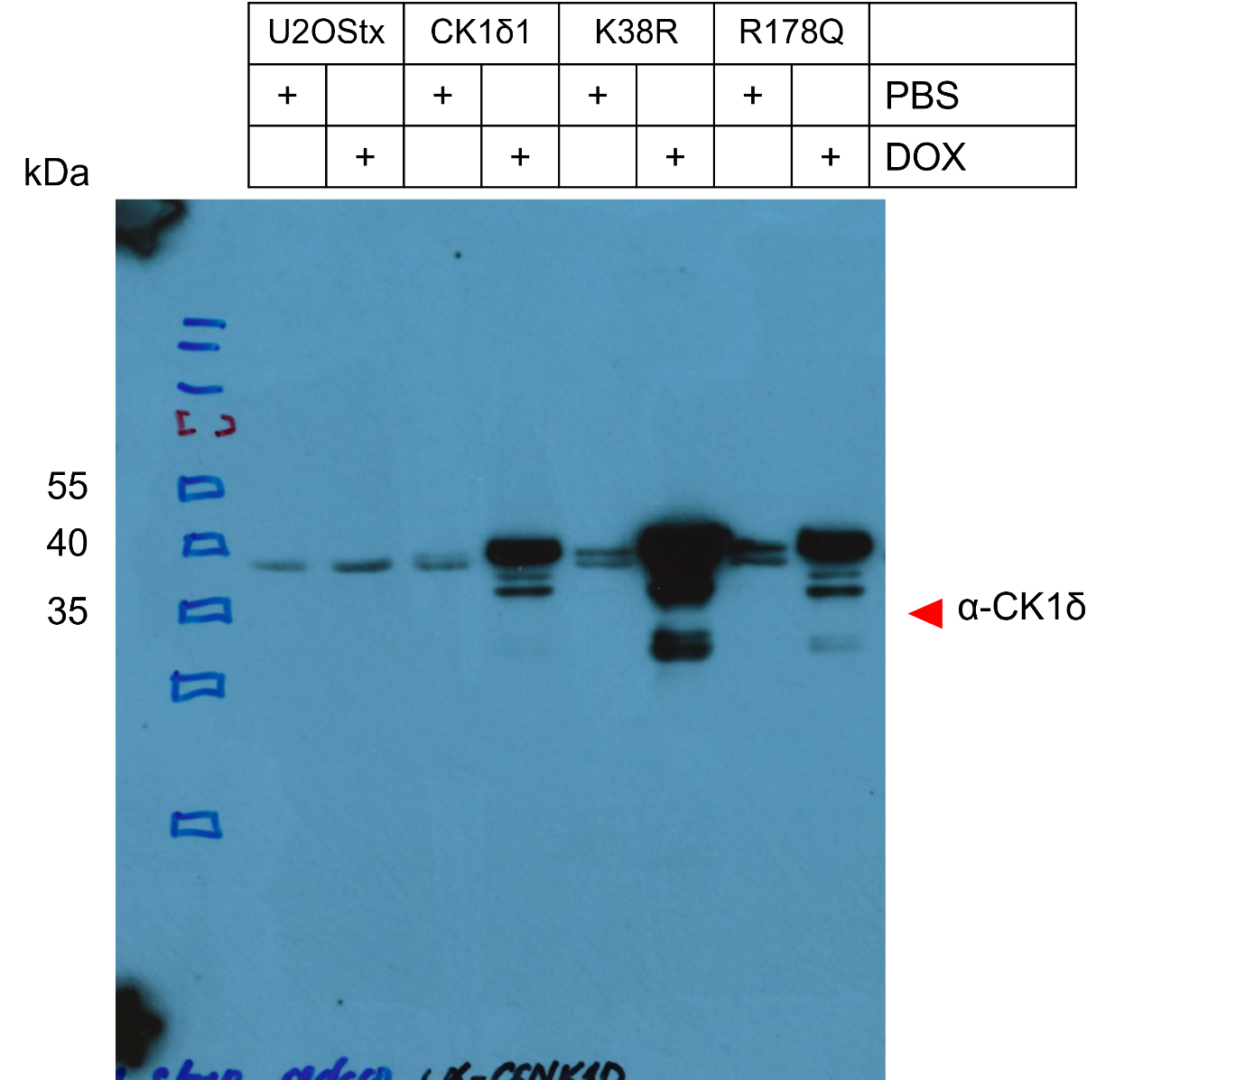
Figure 3B – Source Data 1b. Original film corresponding to Figure 3B, lower panel. Using the basal U2OStx line and the stable cell line generated to induce either wild-type CK1δ1, kinase-dead CK1δ1 (CK1δ1-K38R), and tau-like CK1δ1 (CK1δ1-R178Q), cells were treated with either PBS (negative control) or DOX (doxycycline) to induce protein expression. Resulting blots were decorated with anti-CK1δ antibody (abcam, ab85320) to detect both endogenous and overexpressed CK1δ1.

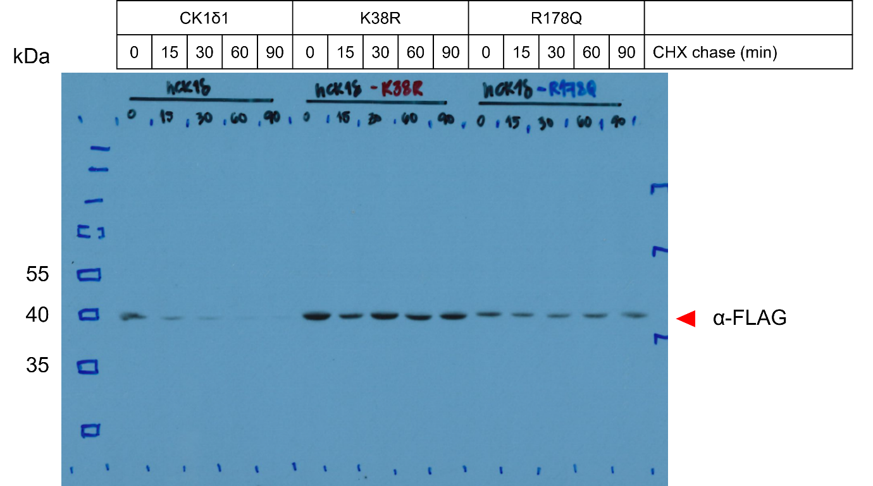
Figure 3C – Source Data 1. Original film corresponding to Figure 3C. Wild-type CK1δ1, kinase-dead CK1δ1 (CK1δ1-K38R), and tau-like CK1δ1 (CK1δ1-R178Q) were induced and treated with CHX to arrest protein translation and assess the stability of the kinase. Resulting blots were decorated with anti-FLAG antibody.

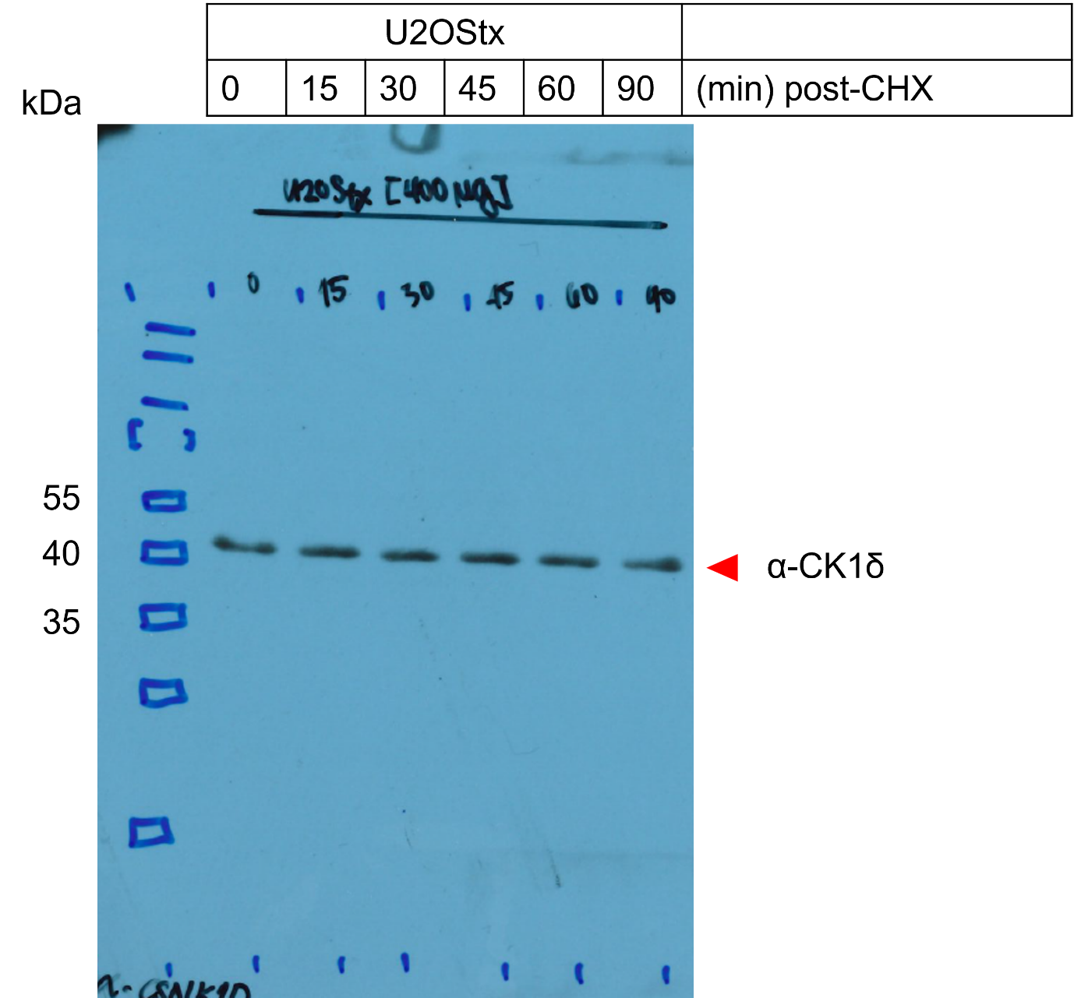
Figure 3D – Source Data 1. Original film corresponding to Figure 3D. U2OStx cells were treated with CHX and protein samples were for immunoblotting. The blot was decorated with anti-CK1δ antibody.

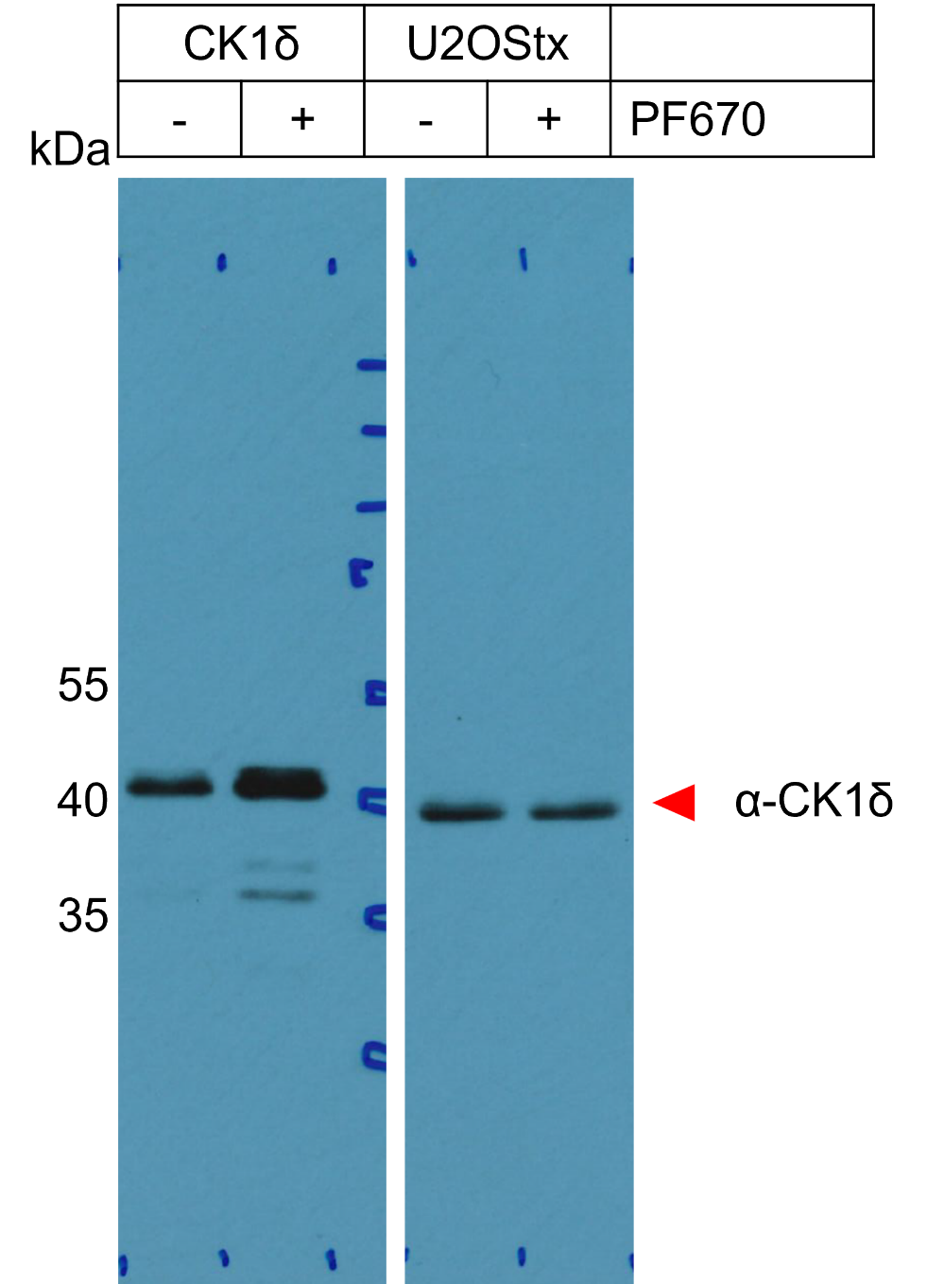
Figure 3F – Source Data 1. Original film corresponding to Figure 3F. U2OStx and U2OStx_CK1δ were treated with PF670 and protein samples were extracted to assess CK1δ stability. Resulting blots were decorated with anti-CK1δ antibody.

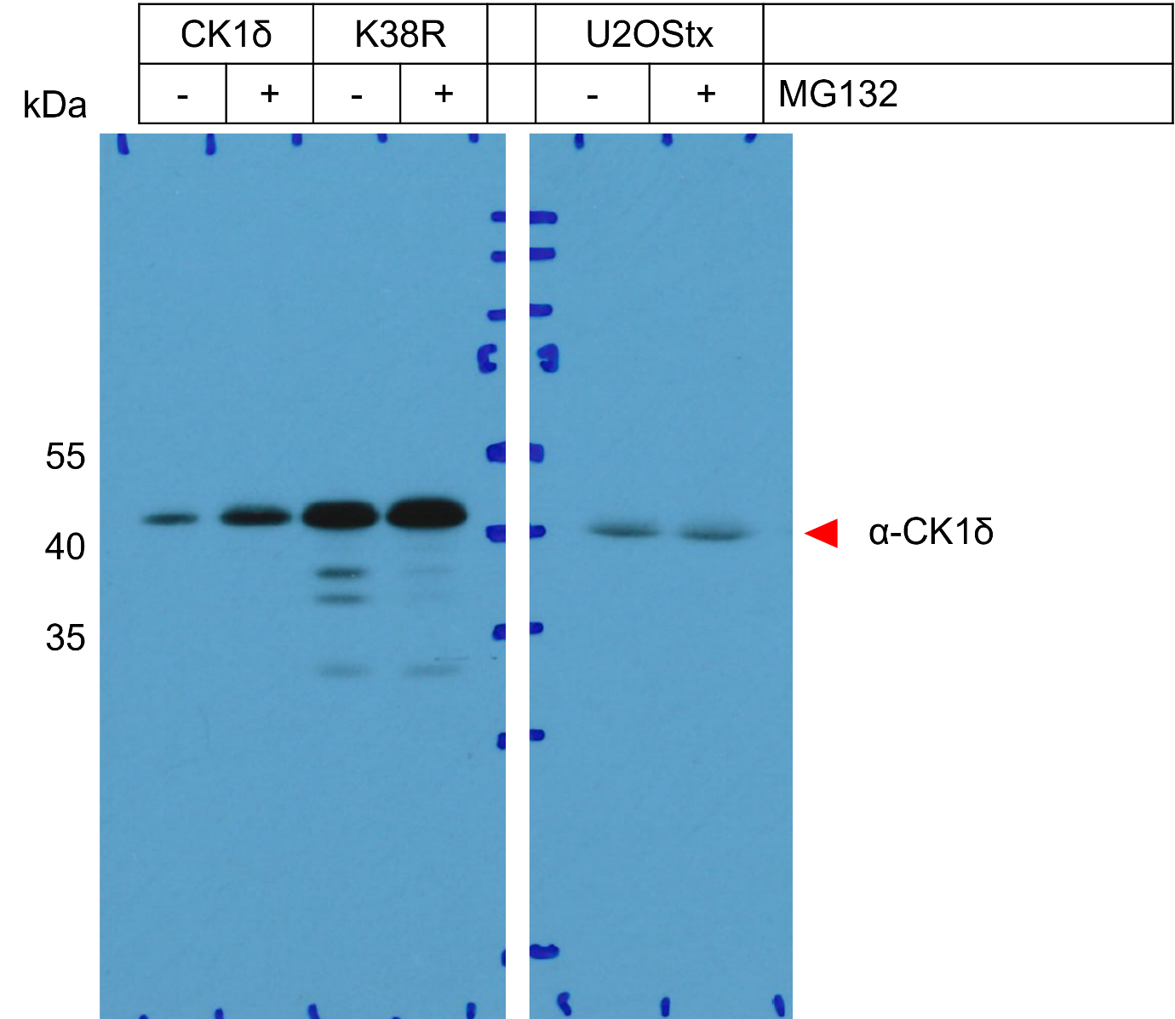
Figure 3G – Source Data 1. Original film corresponding to Figure 3G. U2OStx, U2OStx_CK1δ and U2OStx_CK1δ-K38R cells were treated with MG132 and protein samples were extracted for immunoblotting. The blot was decorated with anti-CK1δ antibody.

