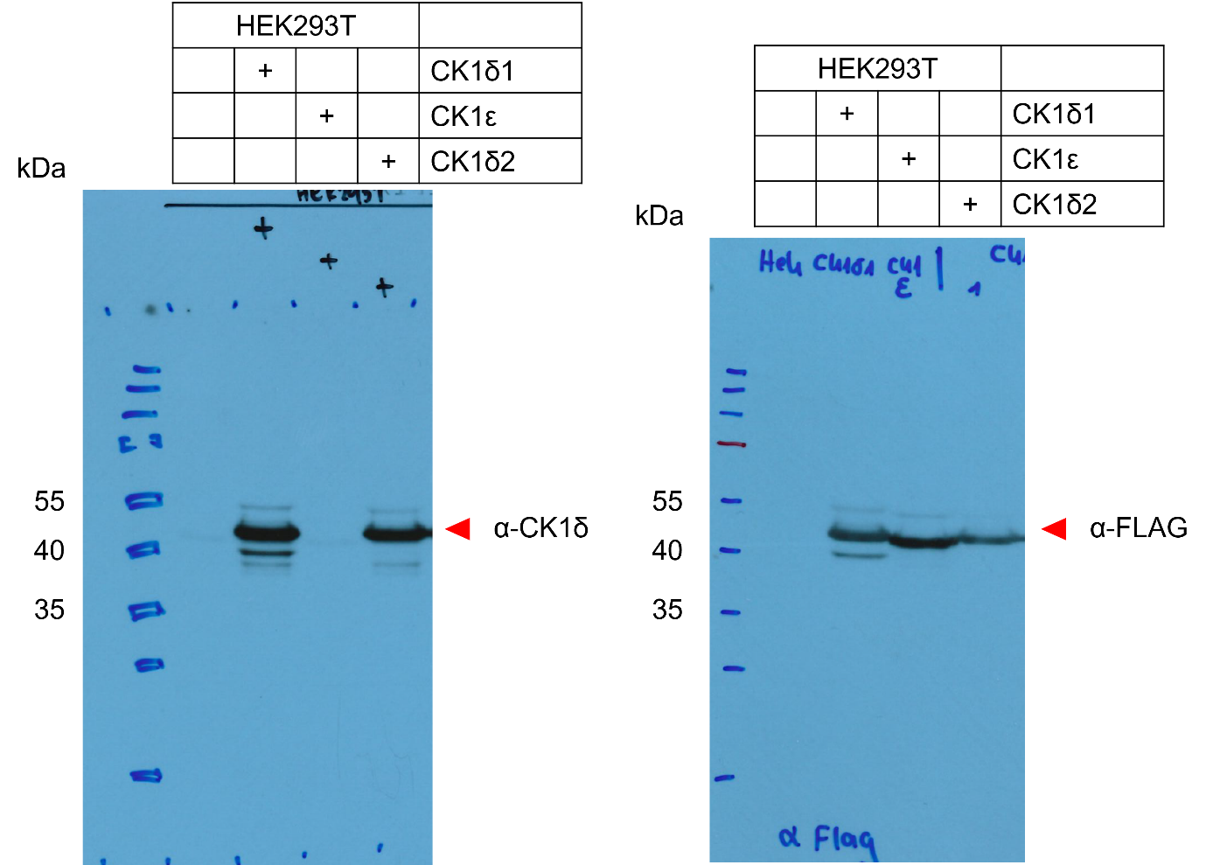
Figure 3 – figure supplement 1A – Source Data 1. Original film corresponding to Figure 3 – figure supplement 1A. HEK293T cells were transfected with either CK1δ1, CK1ε, or CK1δ2 and protein samples were extracted for immunoblotting. The blot was decorated with anti-CK1δ antibody, then stripped and redecorated with anti-FLAG antibody.

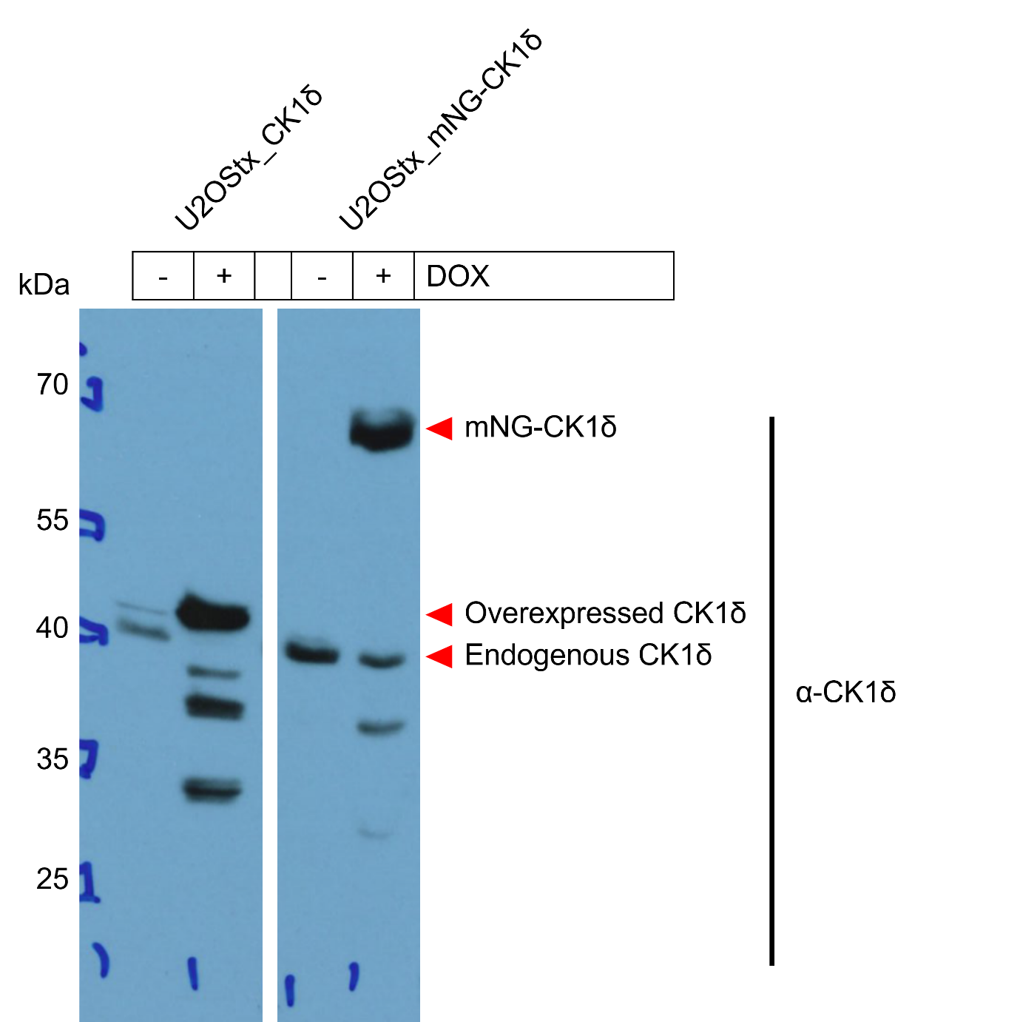
Figure 3 – figure supplement 1B, C – Source Data 1. Original film corresponding to Figure 3 . figure supplement 1 – panels B and C. Stable U2OStx_CK1δ and U2OStx_mNG-CK1δ cells were induced with DOX and protein samples were taken for immunoblotting. The blot was decorated with anti-CK1δ antibody.

