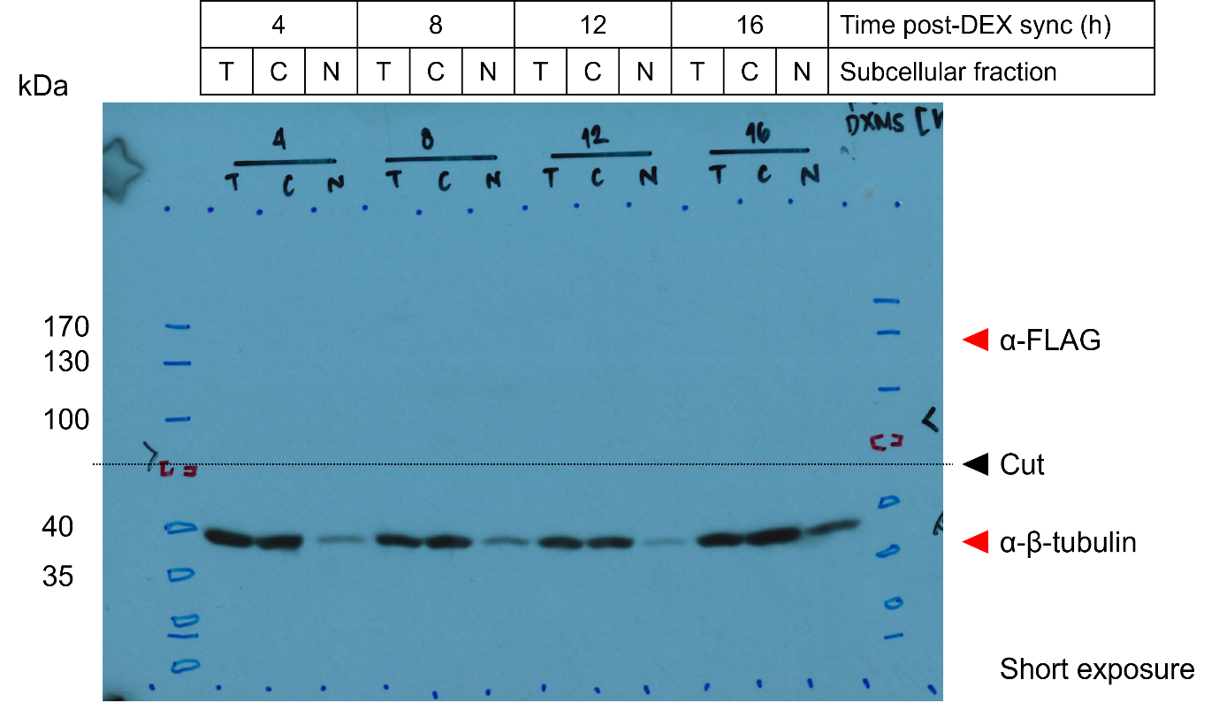
Figure 6 – figure supplement 1D, Source Data 1. Original film corresponding to Figure 6 – figure supplement 1D. U2OStx cells were synchronized with dexamethasone (DEX) and protein samples were taken 4, 8, 12, and 16 h post-synchronization for immunoblotting. The top half of the blot was decorated with anti-hPER2 antibody (in-house) and the lower half was decorated with anti-β-tubulin as a subcellular fractionation control.

