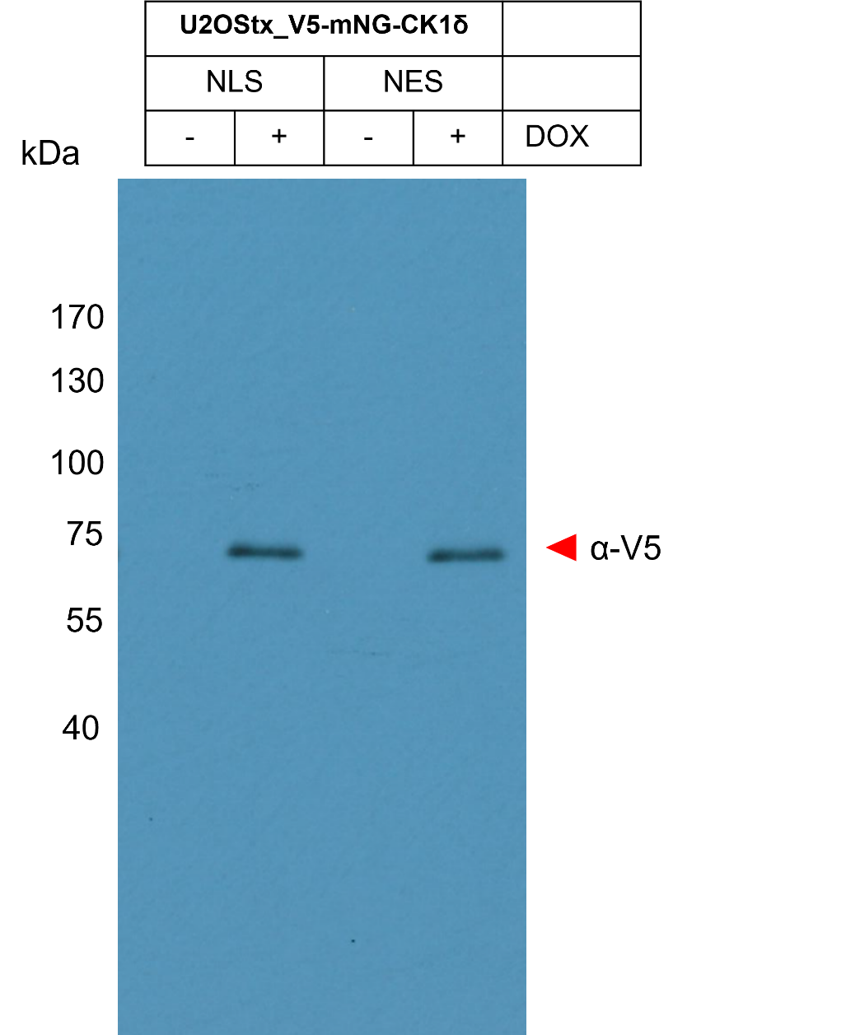
Figure 7, Source Data 1. Original film corresponding to Figure 7D. Stable U2OStx cell lines expressing inducible V5-NLS-mNG-CK1δ and V5-NES-mNG-CK1δ were generated, induced with DOX and protein was extracted for immunoblotting. The membrane was decorated with anti-V5 antibody.

