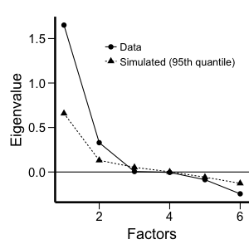
Table 1-source data 1. Scree plot for the exploratory factor analysis on all cognitive measures. The plot shows the eigenvalues associated with each factor plotted against each factor, and supports the decision to retain two factors.

