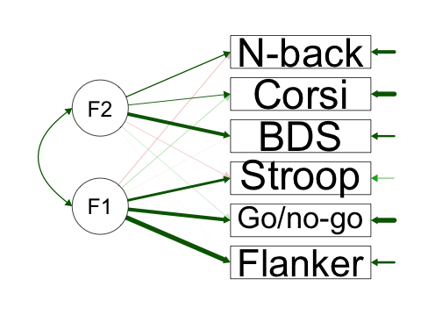
Table 1-source data 2. Path diagram for the exploratory factor analysis on all cognitive measures. F1 (Cognitive Control) and F2 (Working Memory) refer to the factors extracted from an exploratory factor analysis on all six cognitive measures, with promax rotation (N = 287).

