Parameter | Description | Units | Bounds
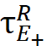 | Rise time of 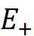 conductance | ms | 1 - 400
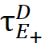 | Decay time of conductance | ms | 1 – 400
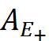 | Conductance amplitude () | unitless | 0 – 10
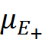 | Receptive field location () | unitless | -5 – 5
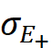 | Width of conductance spatial profile () | unitless | 0 – 10
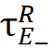 | Rise time of 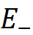 conductance | ms | 1 - 400
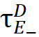 | Decay time of conductance | ms | 1 - 400
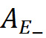 | Conductance amplitude () | unitless | 0 – 20
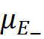 | Receptive field location () | unitless | -5 – 10
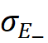 | Width of conductance spatial profile () | unitless | 0 - 10
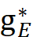 | stimulus-independent E conductance | unitless | 0 - 20
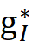 | stimulus-independent I conductance | unitless | 0 - 100
V_{E} | Reversal potential (E) | mV | 0 (fixed)
V_{I} | Reversal potential (I) | mV | -74(fixed)
V_{L} | Resting potential | mV | -65 (fixed)

Excitation-Removal of excitation model parameters (related to Figures 6, 7).

