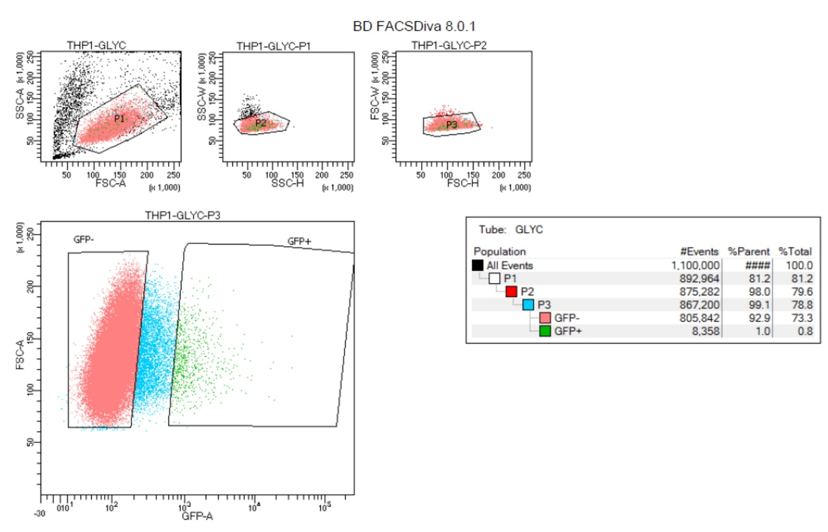
Supplementary file 10. Profiling of GlyC-KD THP-1 cell population prior to green fluorescent protein (GFP)-based sorting post-shRNA transduction.

