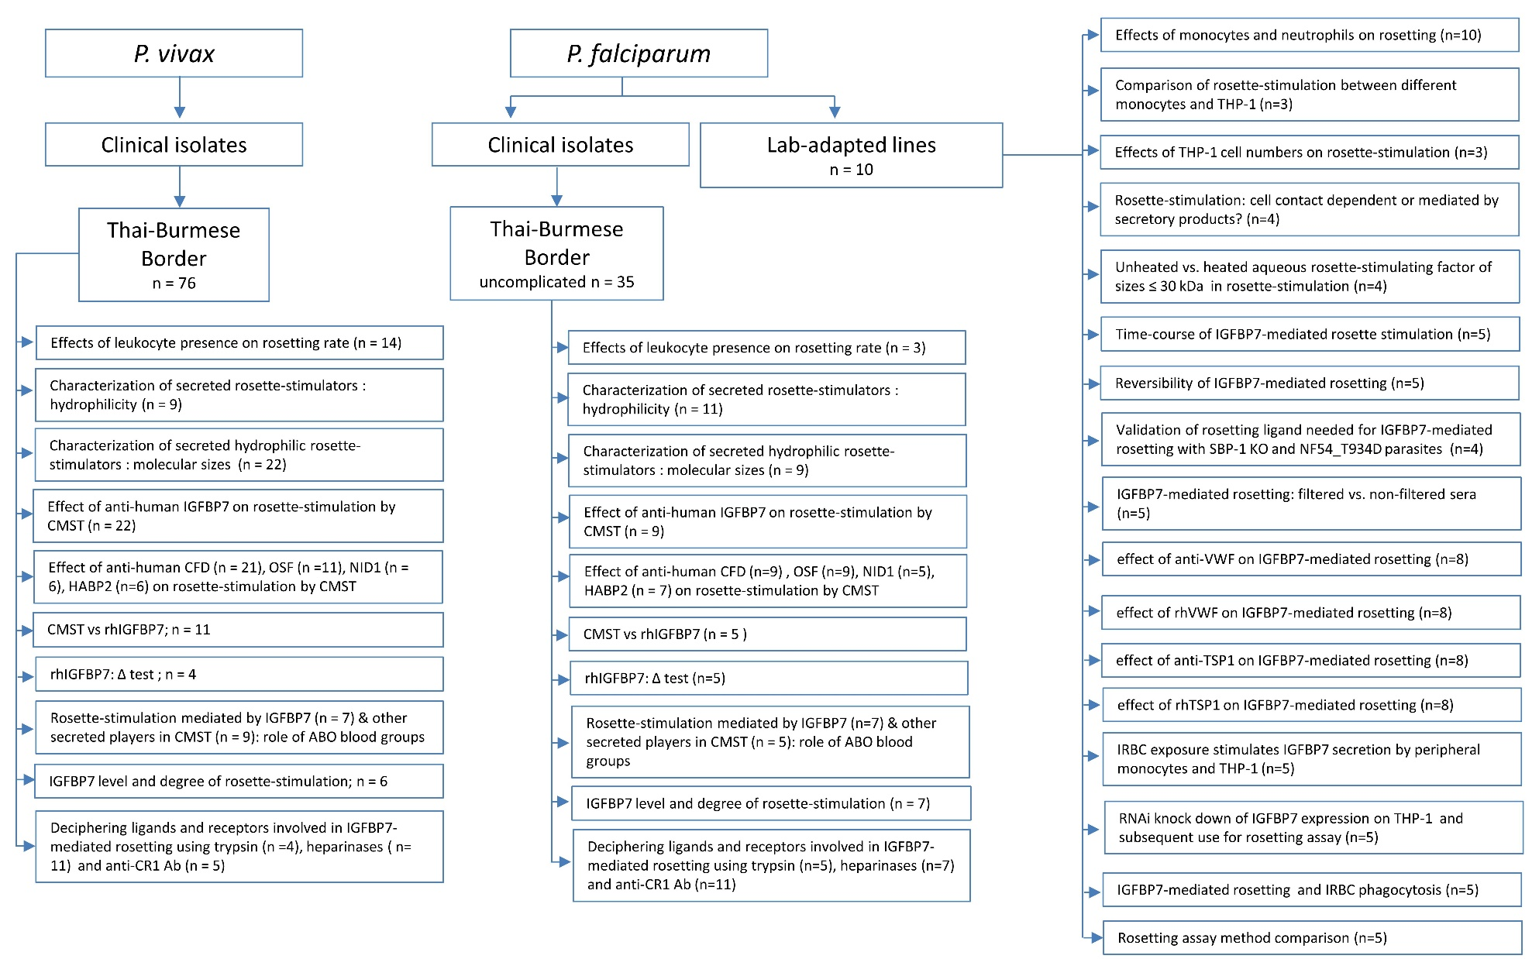
Supplementary file 6: Experiment flow. Flow chart showing the experiments done in the project, along with the number of samples recruited for each experiment.

