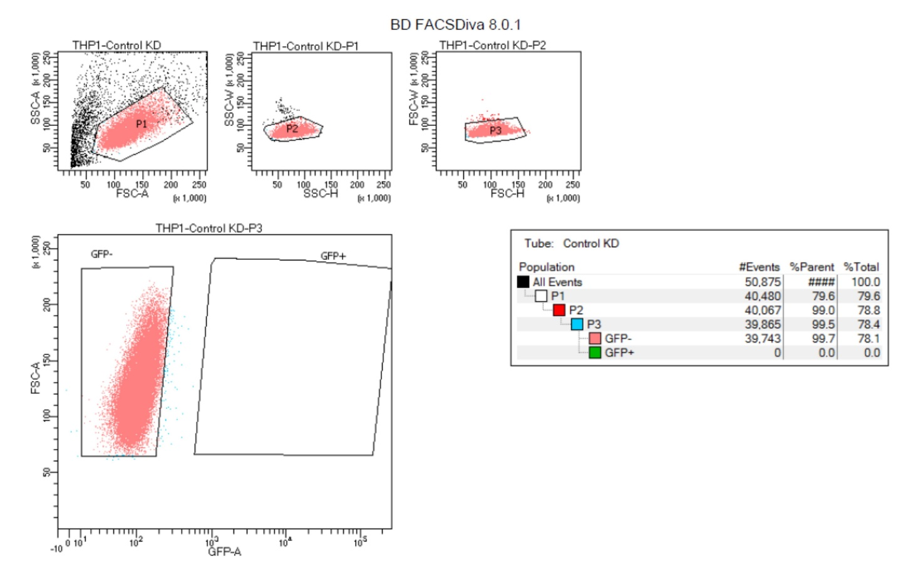
Supplementary file 8. Profiling of THP-1 cell population prior to green fluorescent protein (GFP)-based sorting post-shRNA transduction. This is the profile of THP-1_WT as GFP-free control for cell sorting.

