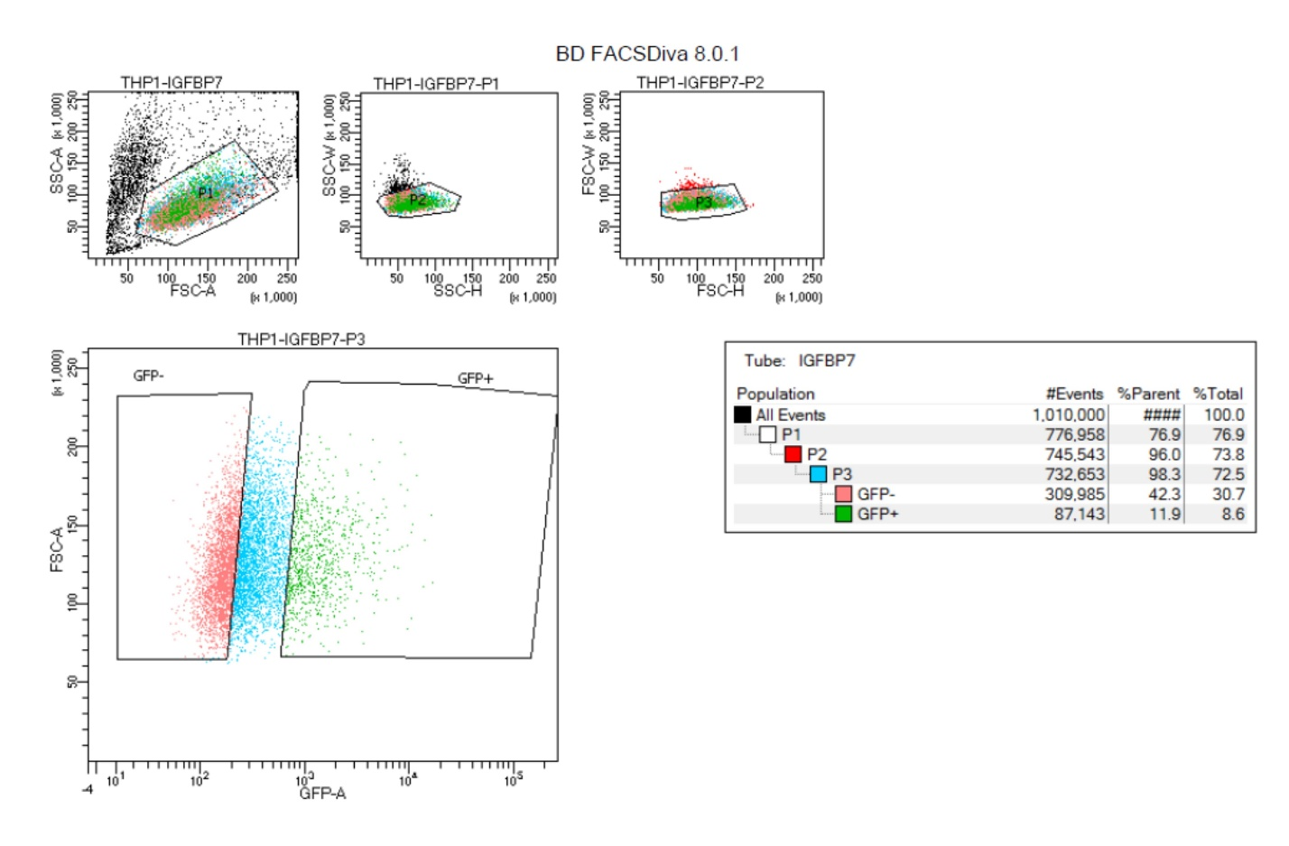
Supplementary file 9. Profiling of IGFBP-KD THP-1 cell population prior to green fluorescent protein (GFP)-based sorting post-shRNA transduction.

