Figure 3 Source Data 1:

Source Data Fig 3A.
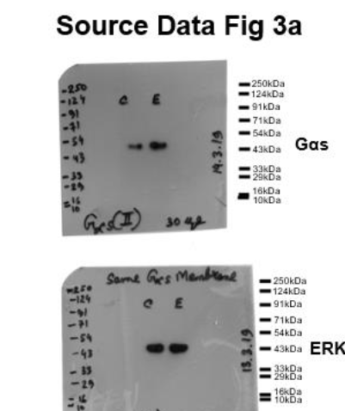

Figure legend: Source Data Fig 3A: Western blot pictures (uncut) showing the impact of MS-275 on Gαs protein expression; ERK immunoblot was considered as the loading control.

