Figure 3 Source Data 3:

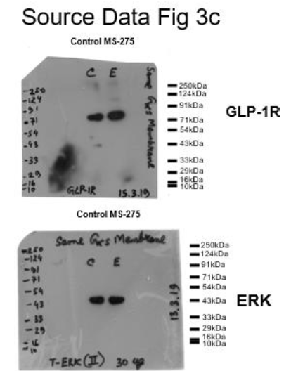

Figure legend: Western blot pictures (uncut) showing the impact of MS-275 on GLP-1R protein expression; ERK immunoblot was considered as the loading control.

