Figure 3 Source Data 4:

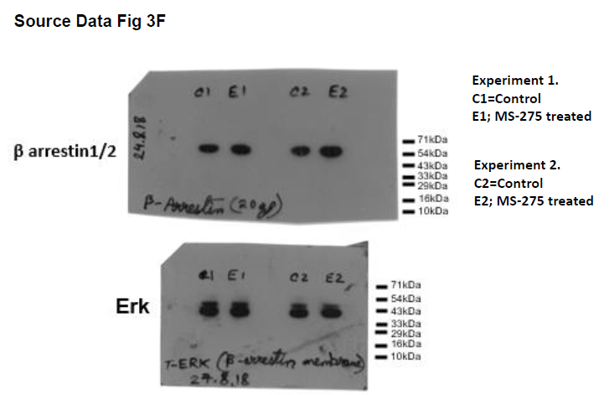

Figure 3 Source Data 4: Source Data 3 F: Western blot pictures (uncut) showing the impact of MS-275 on beta-arrestin protein expression; ERK immunoblot was considered as the loading control

.

