Figure 7 Source Data 2:
a. Source Data Fig 7F

GLP-1R

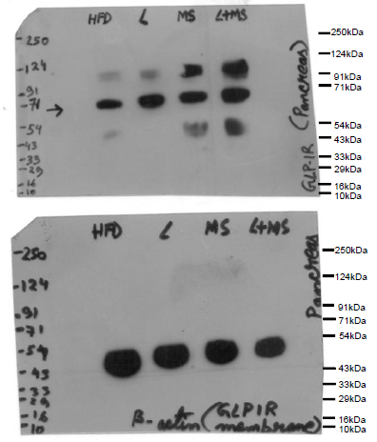
Beta
Actin

Figure 7 Source Data 2: Source Data Fig 7F: Western blot pictures (uncut) showing the impact of the vehicle, Liraglutide, MS-275, and combined Liraglutide and MS-275 co-therapy on GLP-1R protein expression in pancreatic tissue pooled from each group; Beta-actin immunoblot served as the loading control.

b. Source Data Figure 7G: l.
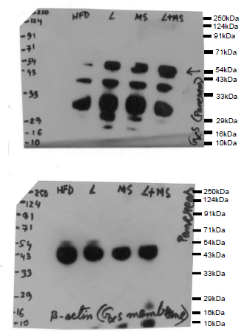

Gαs

Β-actin

Figure 7 Source Data 2: Source Data Fig 7G: Western blot pictures (uncut) showing the impact of the vehicle, Liraglutide, MS-275, and combined Liraglutide and MS-275 co-therapy on Gαs protein expression in pancreatic tissue pooled from each group. Beta-actin immunoblot served as the loading control.

