Supplementary File 1

Supplementary File 1: Table1

Compound | Structure | Nature | Liraglutide treatment | cAMP generation (fold change) | St. Dev
PBS |  | Vehicle control | - | 1 | 0.2
 |  |  | + | 8.2 | 2.8
MS-275 | 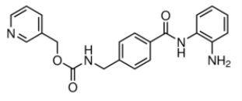 | Class1 HDAC inhibitor | - | 3.7 | 0.1
 |  |  | + | 31.7 | 3.1
Trichostatin A | 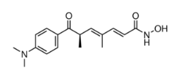 | Class1 HDAC inhibitor | - | 1.9 | 0.1
 |  |  | + | 15.2 | 0.6
SAHA | 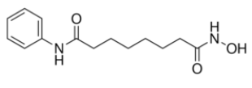 | Class1 HDAC inhibitor | - | 1.3 | 0.1
 |  |  | + | 17.8 | 0.1
AR-42 | 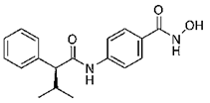 | Class1 HDAC inhibitor | - | 1.5 | 0.1
 |  |  | + | 23.6 | 1.4
Valproic acid | 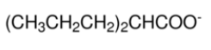 | Class1 HDAC inhibitor | - | 0.6 | 0.2
 |  |  | + | 7.0 | 0.3

Supplementary File 1: Table1 legend:
Primary hits in small molecule screening library at a concentration of 10µM. BRIN-BD11 pancreatic beta cells treated for 18 hours to assess its effect on GLP-1R (liraglutide) mediated cAMP generation. Results are reported as fold-increase over vehicle control in a cAMP-responsive luciferase reporter assay. Data represented as mean ±SD (n=2 replicates per treatment).

