Compound syntheses and purification

Synthesis of alexafluor-JK3/32 adduct (JK3/32-488):
3-[(dimethylamino)methylidene)]-2,3-dihydro-1H-indol-2-one.

3-[(dimethylamino)methylidene]-1-{(4-fluorophenyl)methyl]-2,3-dihydro-1H-indol-2-one.

(3Z)-1-[(4-fluorophenyl)methyl]-3-({[4-(prop-2-yn-1-yloxy)phenyl]amino}methylidene)-2,3-dihydro-1H-indol-2-one (1191-146)

Alexafluor-JK3/32-triazole (JK3/32-488):
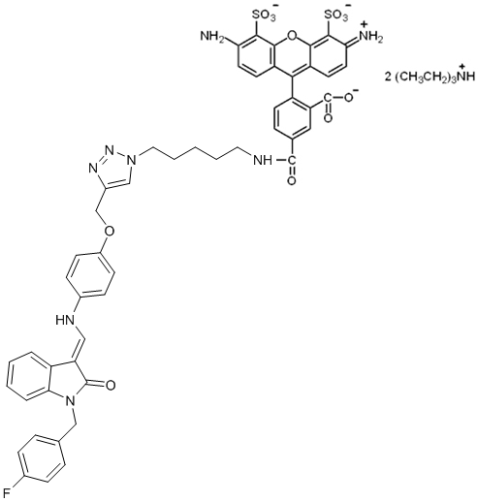

Synthesis of JK3/32:

1-benzyl-3-[(dimethylamino)methylidene]-2,3-dihydro-1H-indol-2-one.

1-benzyl-3-[(4-methoxyphenyl)aminomethylidene]-2,3-dihydro-1H-indol-2-one (JK3/32)

(3Z)-3-[(4-methoxyanilino)methylidene]-1-phenyl-1,3-dihydro-2H-indol-2-one (JK3-42)

(3Z)-3-[(4-methoxyanilino)methylidene]-1,3-dihydro-2H-indol-2-one (JK3-38)

(Z)-1-benzyl-3-(2-(4-methoxyphenyl)hydrazono)indolin-2-one (21-RS-7)

(Z)-1-benzyl-3-(2-phenylhydrazono)indolin-2-one (21-RS-8):

(Z)-3-(2-(4-methoxyphenyl)hydrazono)-1-phenylindolin-2-one (21-RS-9):

1-benzyl-3-(2-(3,4-dimethoxyphenyl)-2-oxoethyl)-3-hydroxyindolin-2-one (21-RS-11 (aka “R21”)):

1-benzyl-3-(2-(3,4-dimethoxyphenyl)-2-oxoethylidene)indolin-2-one (21-RS-17)

(3Z)-1-benzyl-3-[(2-methoxyanilino)methylidene]-1,3-dihydro-2H-indol-2-one (1191-104)

4-{[(Z)-(1-benzyl-2-oxo-1,2-dihydro-3H-indol-3-ylidene)methyl]amino}benzonitrile (1191-112)

(3Z)-1-benzyl-6-fluoro-3-[(4-methoxyanilino)methylidene]-1,3-dihydro-2H-indol-2-one (1191-121)

4-({(3Z)-5-fluoro-3-[(4-methoxyanilino)methylidene]-2-oxo-2,3-dihydro-1H-indol-1-yl}methyl)benzonitrile (1191-120)

(3Z)-5-fluoro-1-[(4-fluorophenyl)methyl]-3-[(4-methoxyanilino)methylidene]-1,3-dihydro-2H-indol-2-one (1191-124)

(3Z)-1-[(3,5-dimethyl-1,2-oxazol-4-yl)methyl]-3-[(4-methoxyanilino)methylidene]-1,3-dihydro-2H-indol-2-one (1191-106)

(3Z)-3-[(4-methoxyanilino)methylidene]-1-(2-phenylethyl)-1,3-dihydro-2H-indol-2-one (1191-137)

(3Z)-1-[(4-fluorophenyl)methyl]-3-[(4-methoxyanilino)methylidene]-1,3-dihydro-2H-indol-2-one (1191-140)

(3Z)-3-[(4-fluoroanilino)methylidene]-1-[(4-fluorophenyl)methyl]-1,3-dihydro-2H-indol-2-one (1191-141)

(3Z)-5-fluoro-3-[(anilino)methylidene]-1-[(4-fluorophenyl)methyl]-1,3-dihydro-2H-indol-2-one (1191-125)

4-{[(Z)-(1-(4-fluoro)phenylmethyl-2-oxo-1,2-dihydro-5-fluoro-3H-indol-3-ylidene)methyl]amino}benzonitrile (1191-126)

