Supplementary file 2
Approaching boiling point stability of an alcohol dehydrogenase through computationally-guided enzyme engineering
Friso S. Aalbers, Maximilian J. L. J. Fürst, Stefano Rovida, Milos Trajkovic, J. Rubén Gómez Castellanos, Sebastian Bartsch, Andreas Vogel, Andrea Mattevi, and Marco W. Fraaije

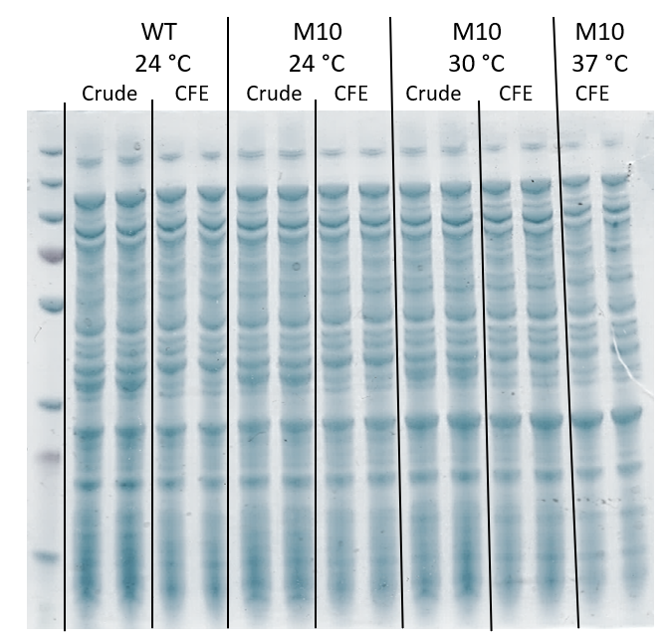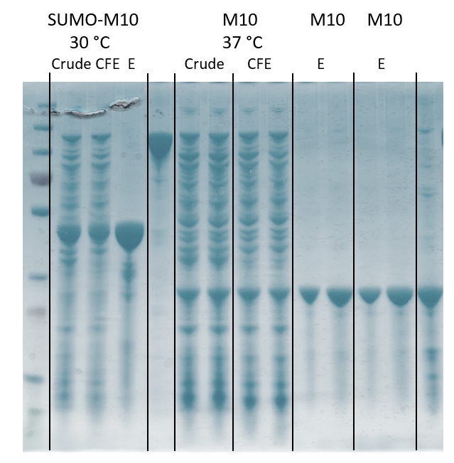
0
0
0
Supplementary file 2A. Expression comparison wild-type ADHA and M9 at different temperatures, with biological duplicates. The expression at 37 °C was 16 hours (overnight), whereas the expression at 30 °C and 24 °C were for 38 hours. Protein ladder (first lane on the left) is pre-stained PageRuler (ThermoScientific, MA USA). The black arrow indicated the position of the ADHA on the gel. Crude = crude extract, after sonication and before centrifugation. CFE = cell-free extract, after spinning down cell-debris. E = elute, fraction collected after addition of imidazole, during IMAC purification.

1 2 3 4 5 6 7 8 9 10 11
0
0
Supplementary file 2B. Purification of His-SUMO-M9*. The left arrow indicates the size of SUMO-M9*, the arrow in the right side indicates the size of M9* after SUMO cleavage. 1. Ladder, 2. Cell-free extract, 3. Flow-through, 4. First elute, 5. Second elute, 6. First flow-through after SUMO cleavage (low concentration), 7. First flow-through after SUMO cleavage (high concentration), 8. Second flow-through after SUMO cleavage (low concentration), 9. Second flow-through after SUMO cleavage (high concentration), 10. and 11. Elute with imidazole after SUMO cleavage.

