Supplementary File 5

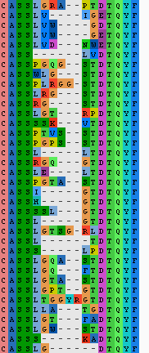
Supplementary Figure 4: Sequence alignment of the CDR3 sequences from the largest cluster of TCR beta PT1 expanded CDR3s. The CDR3s of the largest cluster of PT1 expanded CDR3 beta sequences (see Figure 6D and E) were aligned using the MUSCLE alignment algorithm in Aliview (https://ormbunkar.se/aliview/).

