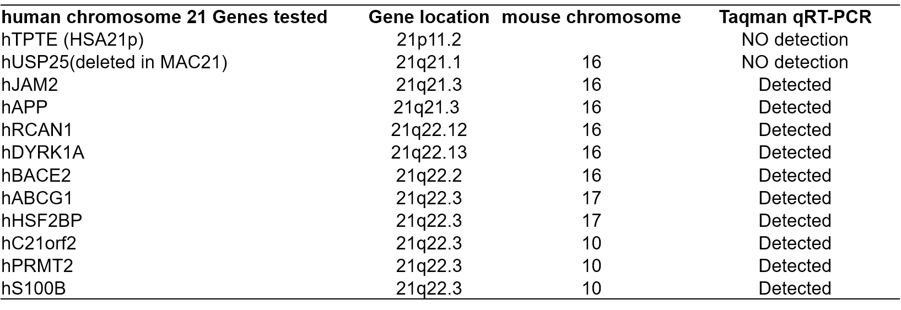

**Figure 3–Source Data 1. HSA21 genes were tested in TcMAC21 using human specific Taqman assay**