**Figure 4–Source Data 2. Percentage of brain volume in TcMAC21 and Eu were analyzed by MRI**

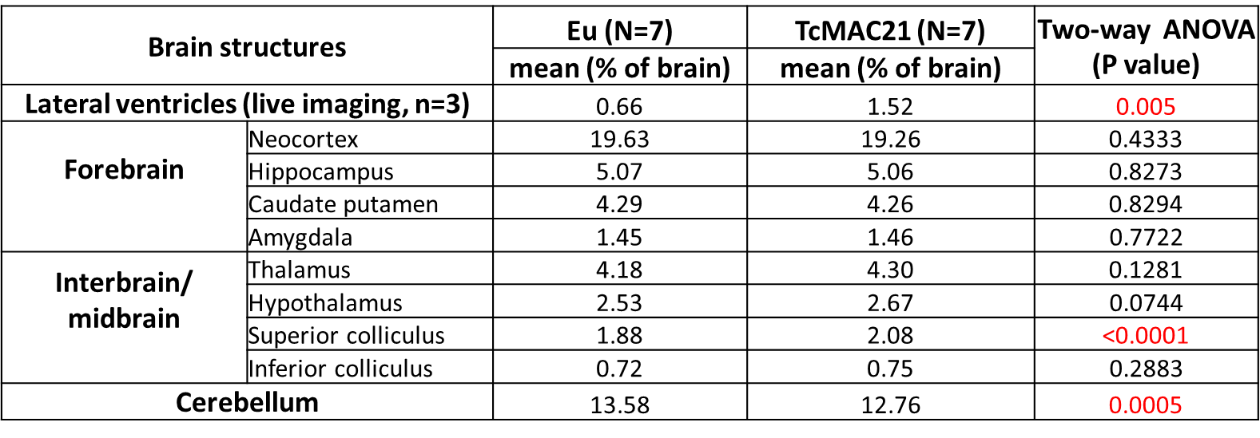

* Segmentation of brain, hippocampus, cerebellum and lateral ventricle were manually verified, and data were analyzed by two-way ANOVA.