**Figure 5–Source Data 1. Peripheral blood analyses in TcMAC21 and Eu**

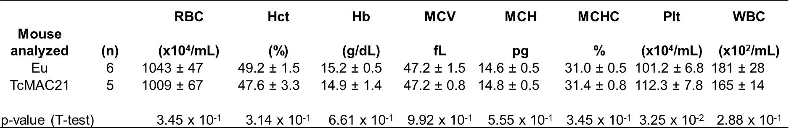

*Data were analyzed by two-tailed t-test and expressed as mean ± SD.