**Figure 6–Source Data 1. Husbandry in TcMAC21**

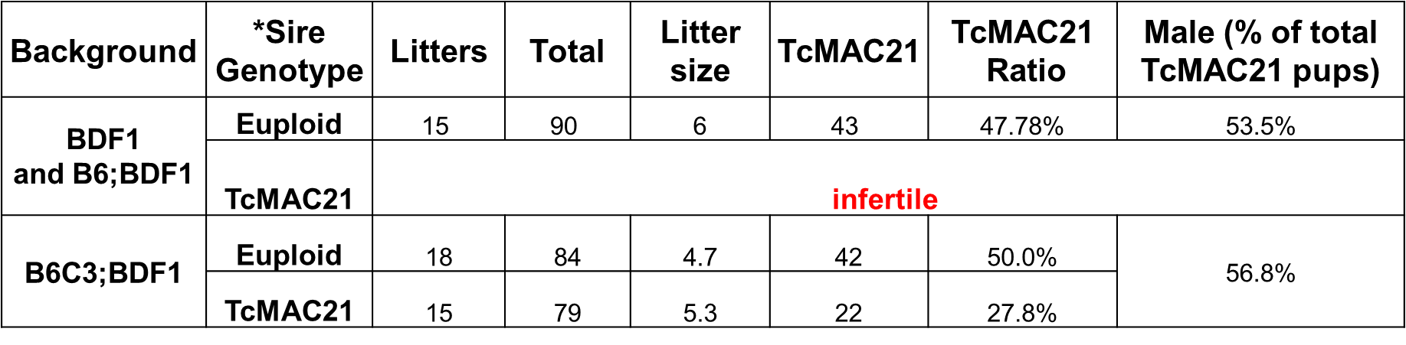

* Sire genotype means the genotype of male in mating cages. For example, if sire genotype is “euploid”, there are an euploid male and TcMAC21 female(s) in the same mating cage.