HPLC Traces for Racemic, Scalemic and Enantioenriched Br-Piperidine Derivatives (±)-S2a, (±)-S3a, (+)-6a, (+)-7a, (–)-S3a, (–)-8a and (+)-S4a

tert-Butyl cis-(±)-4-(4-bromophenyl)-3-(quinolin-8-ylcarbamoyl)piperidine-1-carboxylate ((±)-S2a)
Conditions: Chiralpak IA 3-column, 85:15 n-hexane:i-PrOH, flow rate: 1 mL·min^{–1}, 35 ºC, UV detection wavelength: 210.4 nm. Retention times: 11.9 min (3S,4S enantiomer), 17.3 min (3R,4R enantiomer).

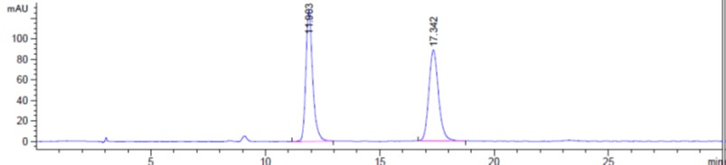
tert-Butyl (+)-(3R,4R)-4-(4-bromophenyl)-3-(quinolin-8-ylcarbamoyl)piperidine-1-carboxylate ((+)-6a)

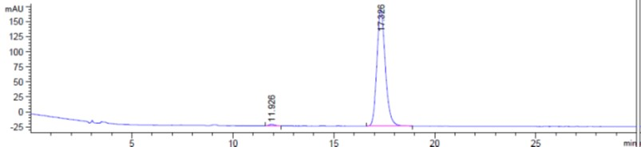
ee = 98.2%

tert-Butyl trans-(±)-4-(4-bromophenyl)-3-(quinolin-8-ylcarbamoyl)piperidine-1-carboxylate ((±)-S3a)
Conditions: Chiralpak IA 3-column, 85:15 n-hexane:i-PrOH, flow rate: 1 mL·min^{–1}, 35 ºC, UV detection wavelength: 254.1 nm. Retention times: 9.1 min (3R,4S enantiomer), 12.2 min (3S,4R enantiomer).

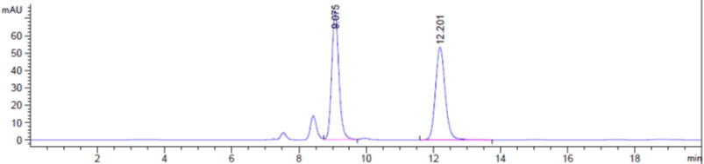
tert-Butyl (–)-(3R,4S)-4-(4-bromophenyl)-3-(quinolin-8-ylcarbamoyl)piperidine-1-carboxylate
((–)-S3a)

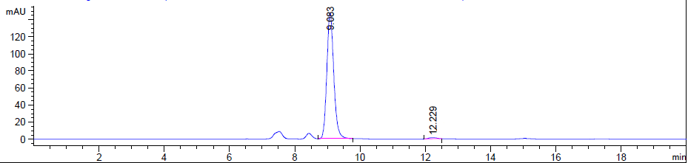
ee 98.0%

tert-Butyl (+)-(3S,4R)-4-(4-bromophenyl)-3-(quinolin-8-ylcarbamoyl)piperidine-1-carboxylate ((+)-7a)

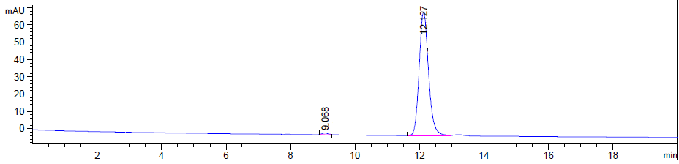
ee = 98.4%

Scalemic Mixture of Enantioenriched Br-Piperidines (+)-S4a and (–)-8a

Conditions: Chiralpak ID 3-column, 90:10 n-hexane:i-PrOH, flow rate: 1 mL·min^{–1}, 35 ºC, UV detection wavelength: 210.4 nm. Retention times: 8.0 min (3R,4S enantiomer), 8.6 min (3S,4R enantiomer).

tert-Butyl (+)-(3R,4S)-4-(4-bromophenyl)-3-(hydroxymethyl)piperidine-1-carboxylate ((+)-S4a)

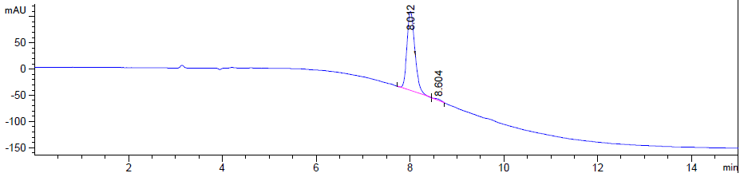
ee = 98.1%

tert-Butyl (–)-(3S,4R)-4-(4-bromophenyl)-3-(hydroxymethyl)piperidine-1-carboxylate ((–)-8a)

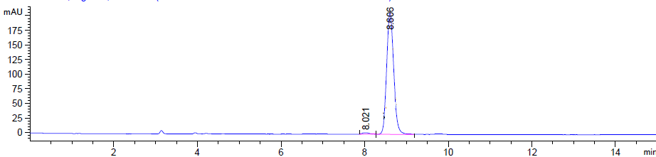
ee = 98.1%

HPLC Traces for Racemic, Scalemic and Enantioenriched I-Piperidine Derivatives (±)-S2b, (±)-S3b, (+)-6b, (+)-7b, (–)-S3b, (–)-8b and (+)-S4b

tert-Butyl cis-(±)-4-(4-iodophenyl)-3-(quinolin-8-ylcarbamoyl)piperidine-1-carboxylate ((±)-S2b):

Conditions: Chiralpak IA 3-column, 85:15 n-hexane:i-PrOH, flow rate: 1 mL·min^{–1}, 35 ºC, UV detection wavelength: 210.4 nm. Retention times: 12.2 min (3S,4S enantiomer), 17.7 min (3R,4R enantiomer).

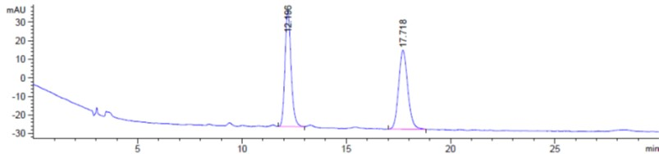

tert-Butyl (+)-(3R,4R)-4-(4-iodophenyl)-3-(quinolin-8-ylcarbamoyl)piperidine-1-carboxylate ((+)-6b

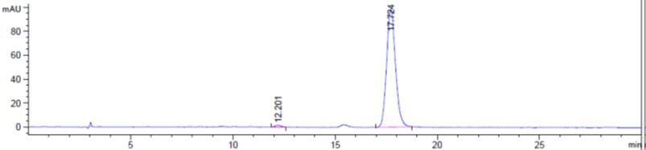
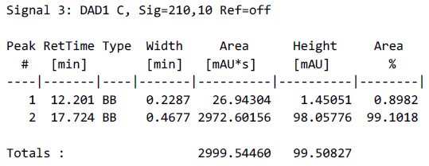 ee = 98.2%

tert-Butyl trans-(±)-4-(4-iodophenyl)-3-(quinolin-8-ylcarbamoyl)piperidine-1-carboxylate ((±)-S3b)

Conditions: Chiralpak IA 3-column, 85:15 n-hexane:i-PrOH, flow rate: 1 mL·min^{–1}, 35 ºC, UV detection wavelength: 254.1 nm. Retention times: 9.4 min (3R,4S enantiomer), 13.3 min (3S,4R enantiomer).

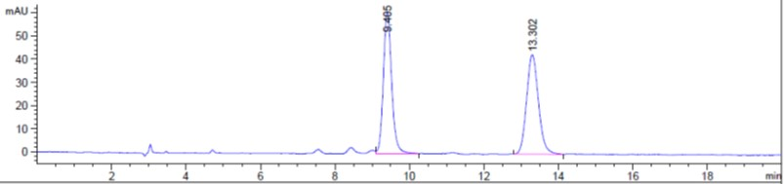

tert-butyl (–)-(3R,4S)-4-(4-iodophenyl)-3-(quinolin-8-ylcarbamoyl)piperidine-1-carboxylate
((–)-S3b)

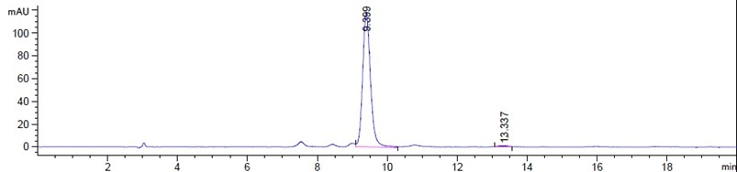
ee = 98.1%

tert-Butyl (+)-(3S,4R)-4-(4-iodophenyl)-3-(quinolin-8-ylcarbamoyl)piperidine-1-carboxylate ((+)-7b)
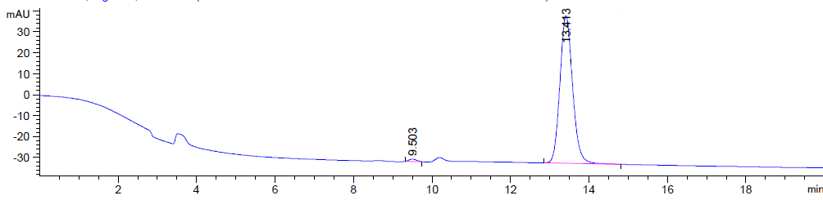
ee = 98.0%

Scalemic Mixture of Enantioenriched I-Piperidines (+)-S4b and (–)-8b

Conditions: Chiralpak ID 3-column, 90:10 n-hexane:i-PrOH, flow rate: 1 mL·min^{–1}, 35 ºC, UV detection wavelength: 230.1 nm. Retention times: 6.7 min (3R,4S enantiomer), 7.4 min (3S,4R enantiomer).

tert-Butyl (+)-(3R,4S)-4-(4-iodophenyl)-3-(hydroxymethyl)piperidine-1-carboxylate ((+)-S4b)

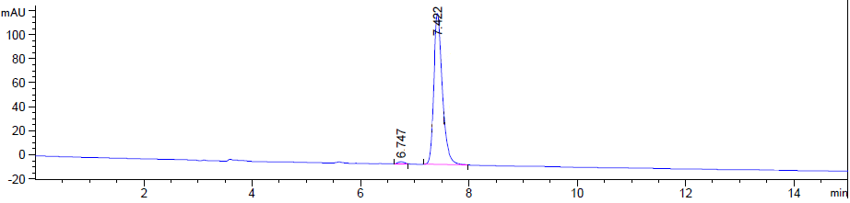
ee = 98.1%

tert-Butyl (–)-(3S,4R)-4-(4-iodophenyl)-3-(hydroxymethyl)piperidine-1-carboxylate ((–)-8b)

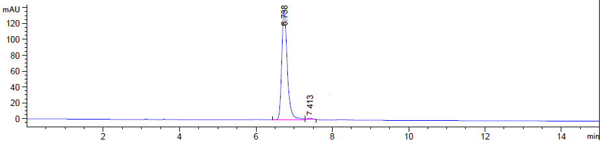
ee = 98.0%

