NMR Spectra for Novel Compounds

(±)-S2a
¹H NMR (500 MHz, (CD₃)₂SO, 373 K)
(±)-S2a
¹³C NMR (126 MHz, (CD₃)₂SO, 373 K)
(±)-S3a
¹H NMR (500 MHz, (CD₃)₂SO, 373 K)
(±)-S3a
¹³C NMR (126 MHz, (CD₃)₂SO, 373 K)
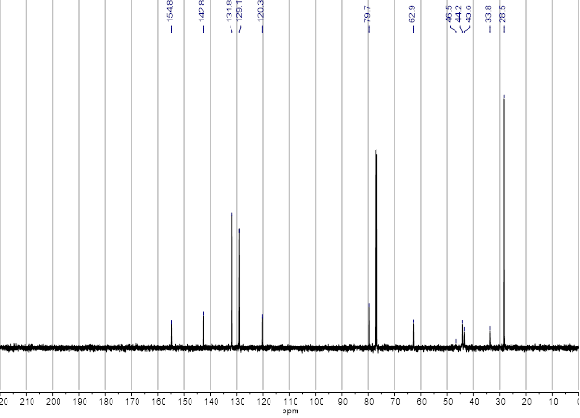
(+)-S4a
¹³C NMR (101 MHz, CDCl₃)
(+)-S4a
¹H NMR (400 MHz, CDCl₃)
(+)-S4a
HSQC NMR (400 MHz, CDCl₃)

(–)-9a
¹³C NMR (101 MHz, CDCl₃)
(–)-9a
¹H NMR (400 MHz, CDCl₃)
(–)-9a
HSQC (400 MHz, CDCl₃)

2 ∙ HCl
¹H NMR (400 MHz, CD₃OD)
2 ∙ HCl
¹³C NMR (101 MHz, CD₃OD)
2 ∙ HCl
COSY (400 MHz, CD₃OD)
2 ∙ HCl
HSQC (400 MHz, CD₃OD)
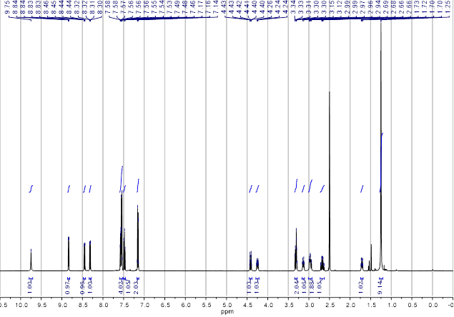
(±)-S2b
¹H NMR (500 MHz, (CD₃)₂SO, 373 K)
(±)-S2b
¹³C NMR (126 MHz, (CD₃)₂SO, 373 K)
(±)-S3b
¹³C NMR (126 MHz, (CD₃)₂SO, 373 K)
(±)-S3b
¹H NMR (500 MHz, (CD₃)₂SO, 373 K)
(+)-S4b
¹³C NMR (101 MHz, CDCl₃)
(+)-S4b
¹H NMR (400 MHz, CDCl₃)
(–)-9b
¹³C NMR (101 MHz, CDCl₃)
(–)-9b
¹H NMR (400 MHz, CDCl₃)
3 ∙ HCl
¹³C NMR (101 MHz, CD₃OD)
3 ∙ HCl
¹H NMR (400 MHz, CD₃OD)

