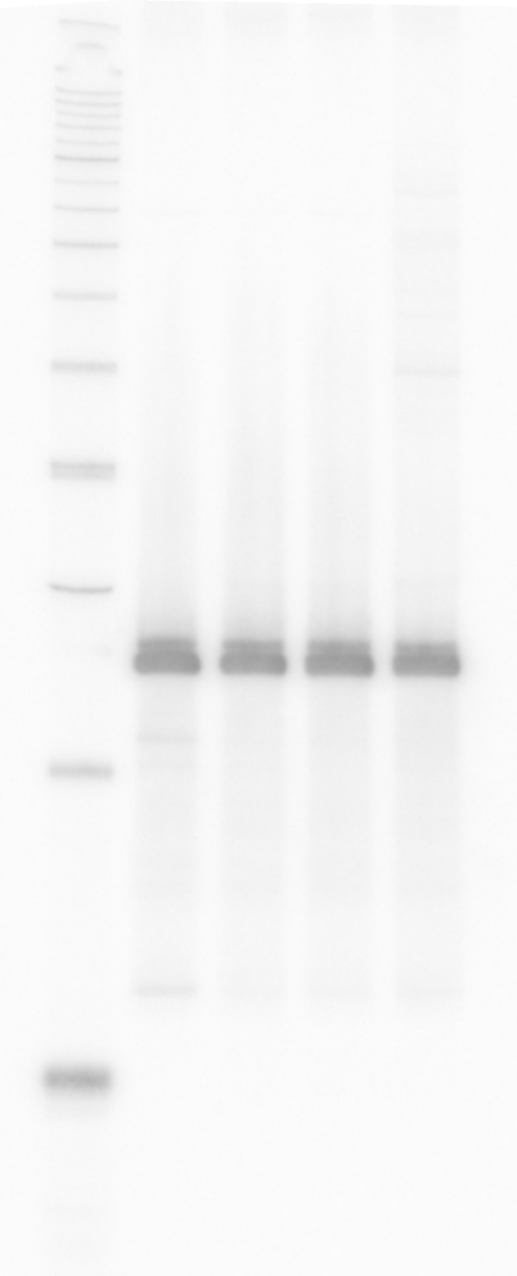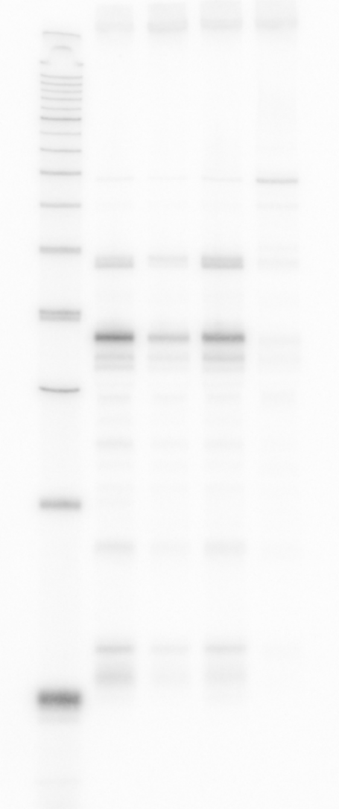Source data for Figure 1 Figure 1A
1 2 3 4 [lane]
1 2 3 4 [lane]
5S (KPO-0243) MicX (KPO-0145)

Figure 1B
Shown in Fig. 1B: 0-40 sites per gene (shaded in grey)

sites per gene | number of genes |  | sites per gene | number of genes |  | sites per gene | number of genes
0 | 1161 |  | 21 | 19 |  | 42 | 3
1 | 504 |  | 22 | 16 |  | 43 | 3
2 | 391 |  | 23 | 14 |  | 44 | 1
3 | 273 |  | 24 | 9 |  | 45 | 2
4 | 210 |  | 25 | 11 |  | 47 | 1
5 | 188 |  | 26 | 13 |  | 48 | 1
6 | 134 |  | 27 | 8 |  | 49 | 2
7 | 127 |  | 28 | 11 |  | 53 | 1
8 | 119 |  | 29 | 10 |  | 54 | 1
9 | 81 |  | 30 | 4 |  | 56 | 1
10 | 76 |  | 31 | 7 |  | 57 | 2
11 | 65 |  | 32 | 5 |  | 59 | 2
12 | 43 |  | 33 | 5 |  | 62 | 1
13 | 51 |  | 34 | 7 |  | 65 | 1
14 | 40 |  | 35 | 7 |  | 69 | 1
15 | 30 |  | 36 | 4 |  | 76 | 1
16 | 43 |  | 37 | 2 |  | 78 | 1
17 | 31 |  | 38 | 2 |  | 87 | 1
18 | 38 |  | 39 | 1 |  | 91 | 1
19 | 21 |  | 40 | 4 |  | 103 | 1
20 | 19 |  | 41 | 1

Figure 1C

Feature | Sites
CDS | 19330
asRNA | 1975
sRNA | 157
5‘ UTR | 2348
3‘ UTR | 1475
IGR | 1109

