Source data for Figure 1 – figure supplement 4 Figure 1 – figure supplement 4
1 2 3 4
Vcr016

Northern blot | sRNA | probe
1 | Vcr016 | riboprobe
[lane]
1 2 3 4 [lane]
5S

Northern blot | sRNA | probe
2 | Vcr041 | KPO-2025
1 2 3 4
Vcr041
[lane]
1 2 3 4 [lane]
5S

Northern blot | sRNA | probe
3 | Vcr044 | KPO-2026
3 | Vcr045 | KPO-0845
3 | Vcr053 | KPO-0852
[lane]
1 2 3 4
Vcr044

1 2 3 4 [lane]

Vcr045

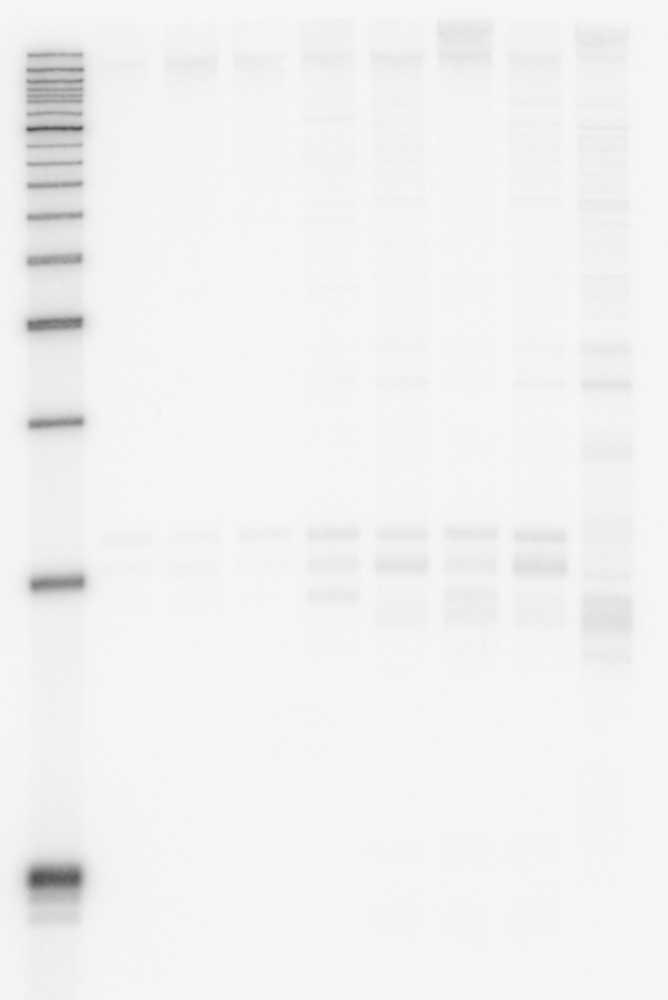1 2 3 4 [lane]
1 2 3 4 [lane]
Vcr053
5S

Northern blot | sRNA | probe
4 | Vcr064 | KPO-0860
4 | FarS (Vcr076) | KPO-0873

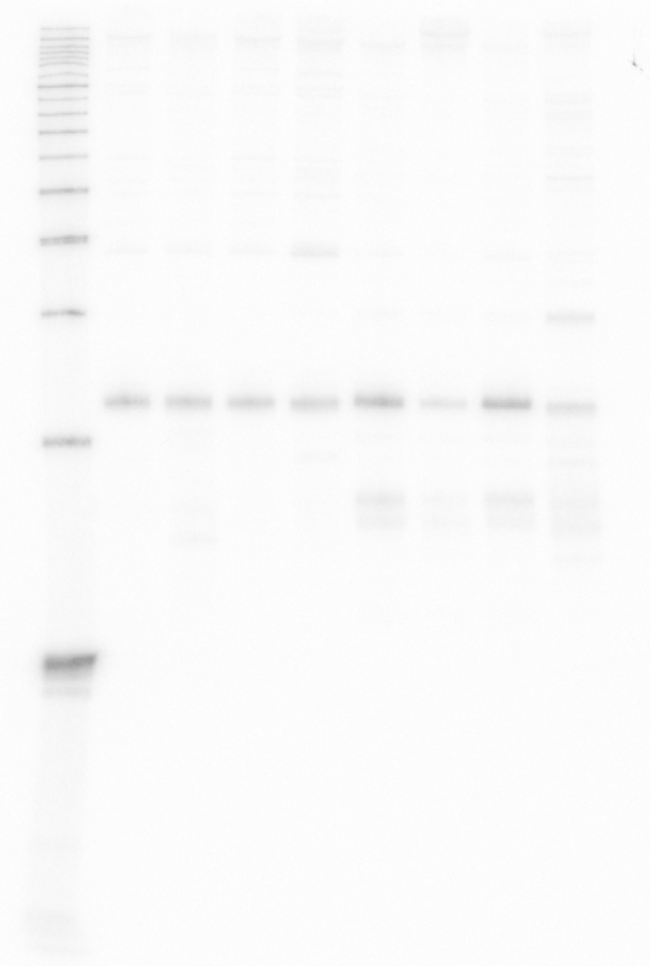
1 2 3 4 [lane]
Vcr064
1 2 3 4 [lane]
Vcr076 (FarS)
1 2 3 4 [lane]
5S

Northern blot | sRNA | probe
5 | Vcr079 | KPO-0875
5 | Vcr084 | KPO-0821

1 2 3 4 [lane]
1 2 3 4 [lane]
Vcr079

Vcr084

1 2 3 4 [lane]
5S

