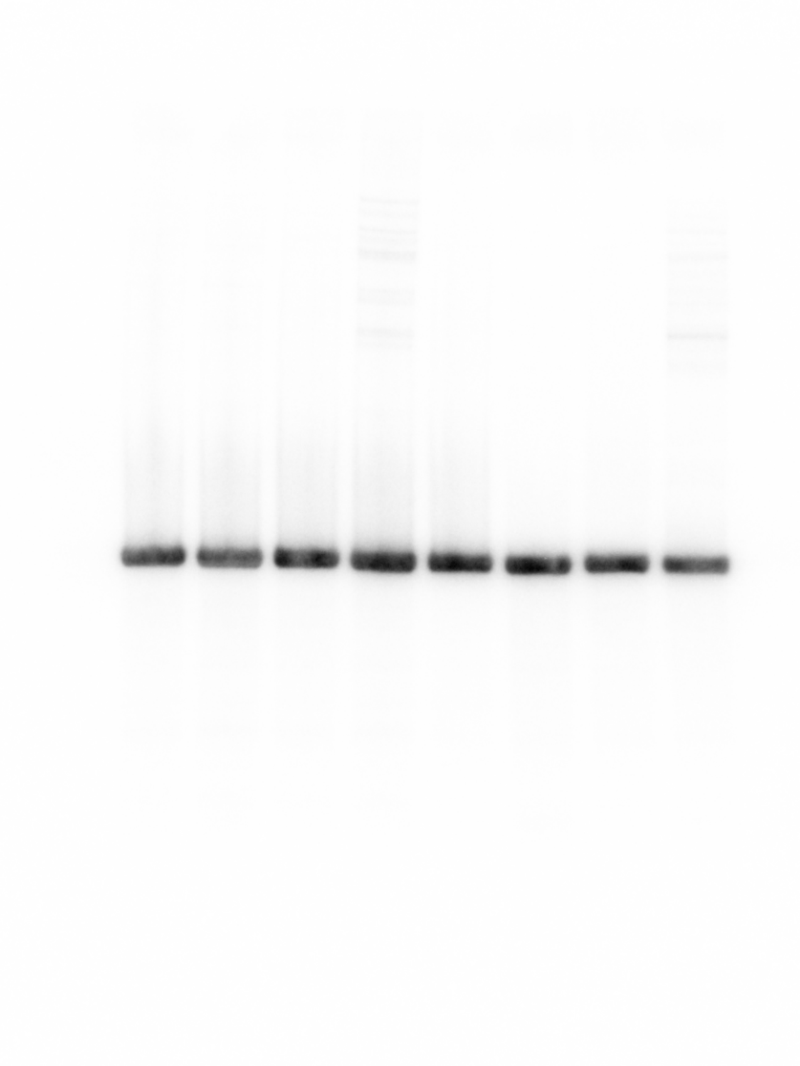Source data for Figure 1 – figure supplement 6 Figure 1 – figure supplement 6
1 2 3 4 [lane]
RyhB
1 2 3 4 [lane]

Northern blot | sRNA | probe
9 | RyhB | KPO-0597

5S

Northern blot | sRNA | probe
10 | Spot 42 | KPO-3726
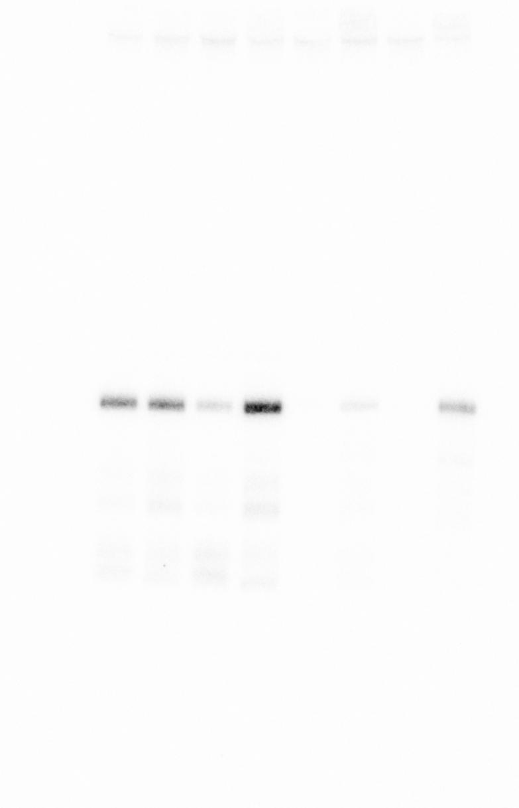
1 2 3 4 [lane]
Spot42
1 2 3 4 [lane]
5S

Figure 1 – figure supplement 6

Northern blot | sRNA | probe
8 | VqmR | KPO-0452

1 2 3 4 [lane]

5S
1 2 3 4 [lane]
VqmR

