Figure 2B

1 2 3 4 [lane]

1 2 3 4 [lane]

OppZ (KPO-0845) 5S (KPO-0243)

kDa
70
55
40
35
25
OppA

OppB
α-FLAG

kDa
70
55
40
35
25
RNAP
α-RNAP

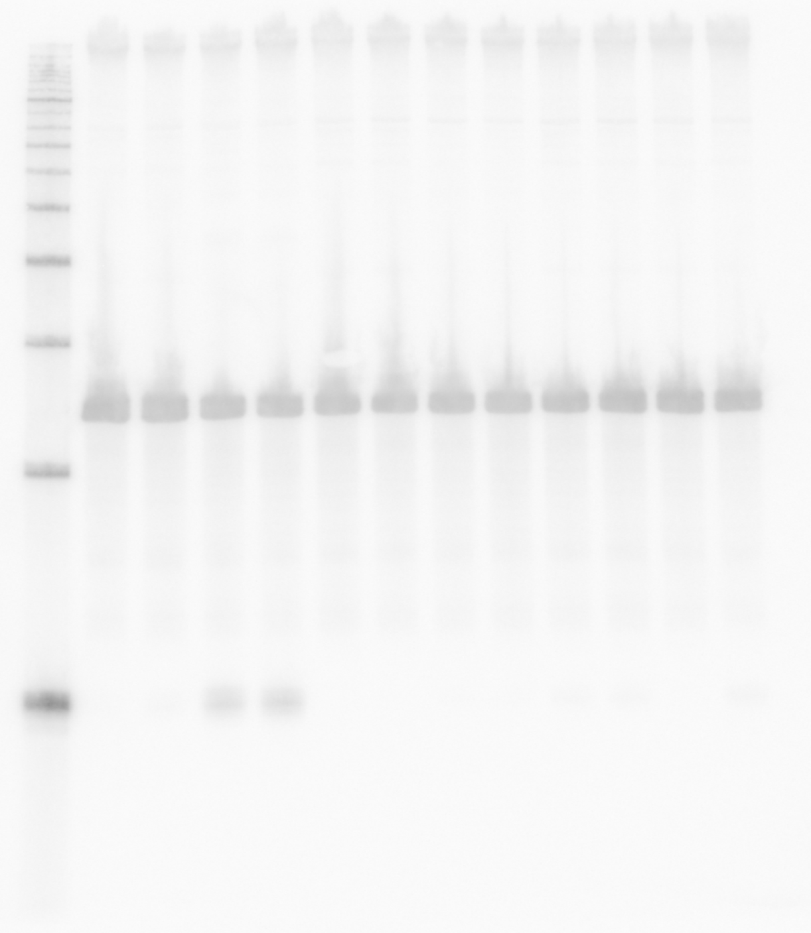5S (KPO-0243)
1 2 3 4 5 6 7 8 9 10 11 12 [lane]
O

ppZ (KPO-0845)

1 2 3 4 [lane]

1 2 3 4 [lane]

OppZ (KPO-0845) 5S (KPO-0243)

