Source data for Figure 2 – figure supplement 1

Figure 2 – figure supplement 1B
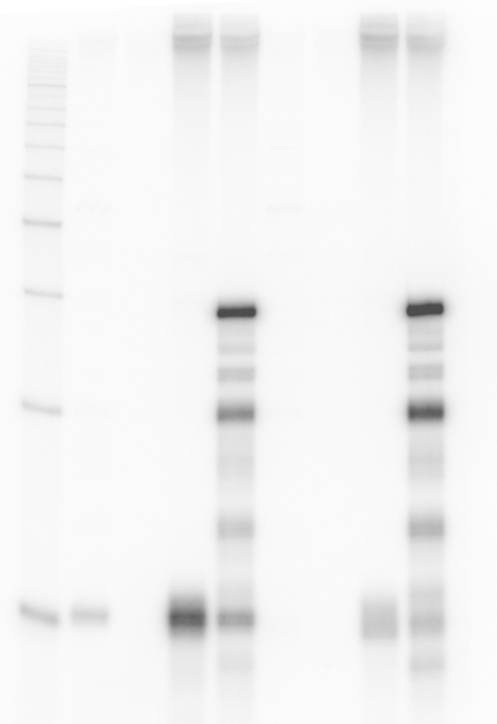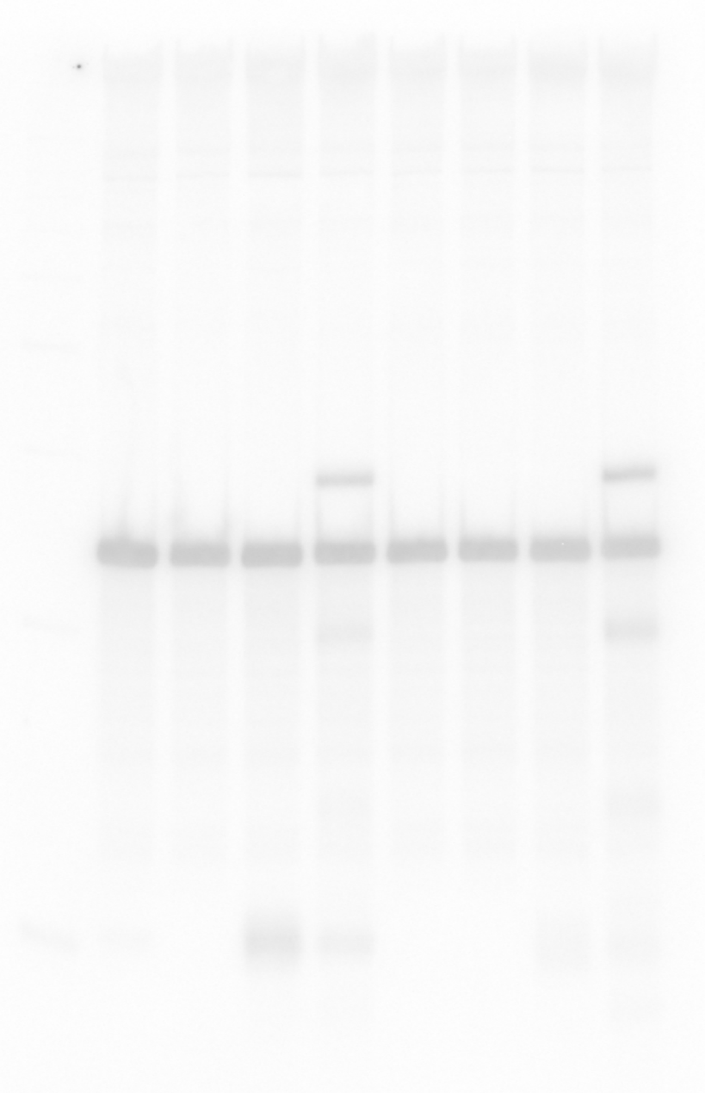
1 2 3 4 5 6 7 8 [lane]
1 2 3 4 5 6 7 8 [lane]
OppZ (KPO-2687) 5S (KPO-0243)

