# Figure 4B

kDa

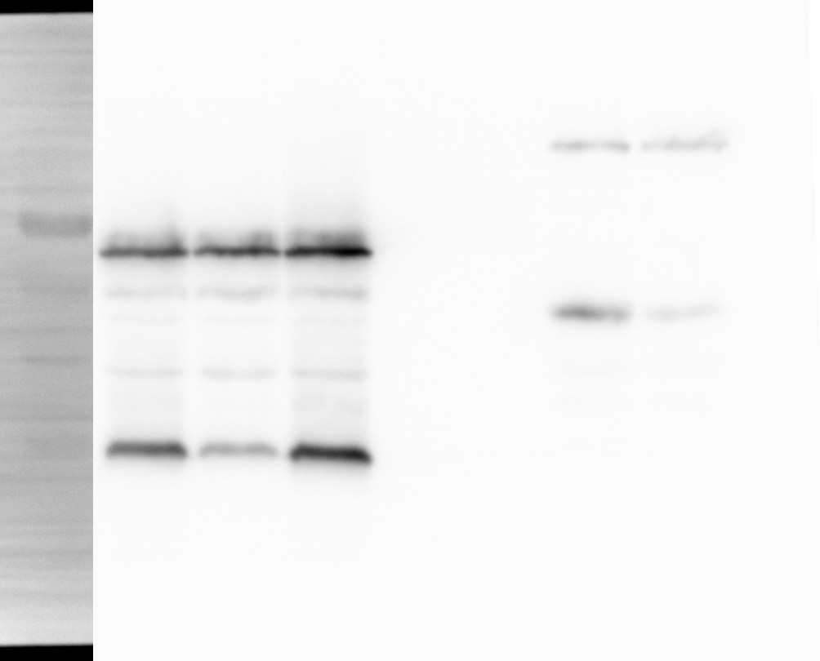

1 2 3 [lane]

α-FLAG

|  |  |  |  |
| --- | --- | --- | --- |
| 70 |  | OppA | 70 |
| 55 |  |  | 55 |
| 40 |  |  | 40 |
| 35 |  | OppB | 35 |

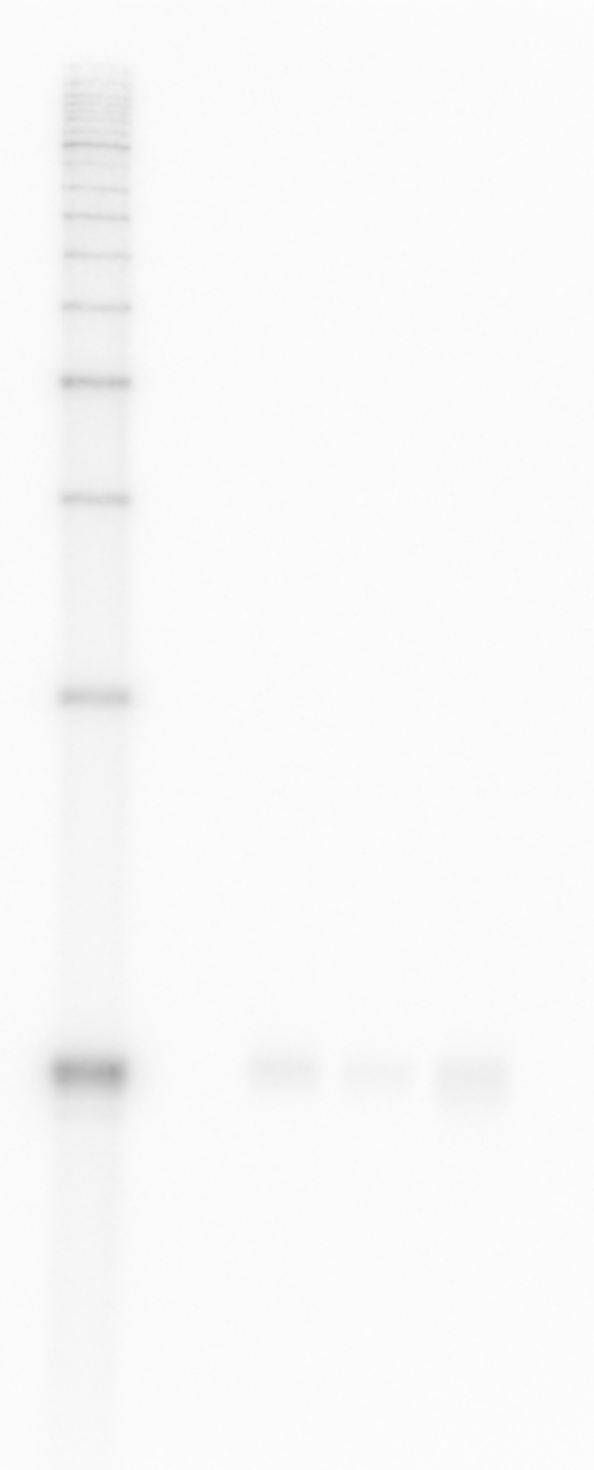

1 2 3 [lane]

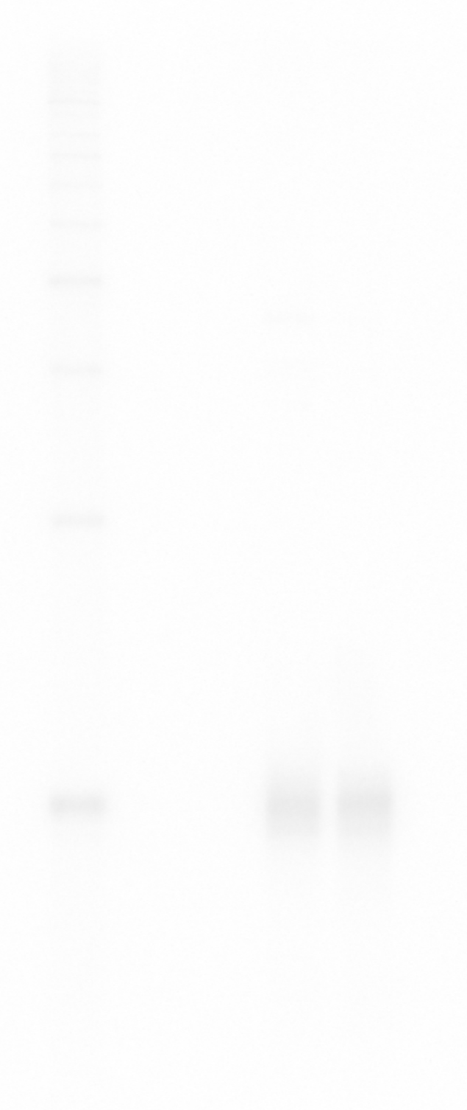

1 2 3 [lane]

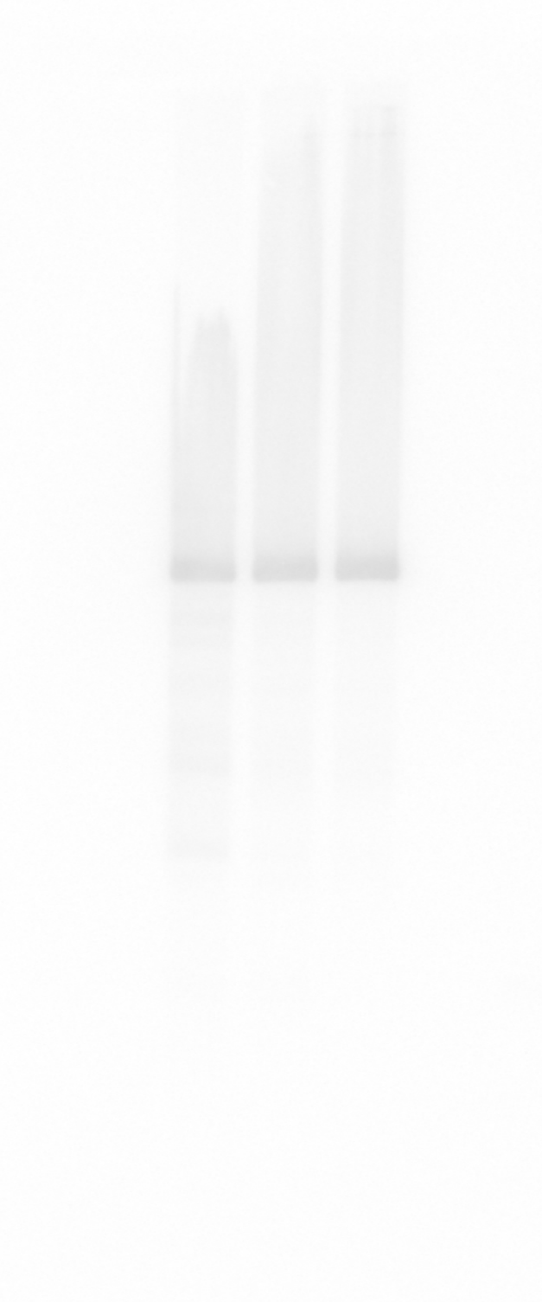

1 2 3 [lane]

native OppZ (KPO-2688)

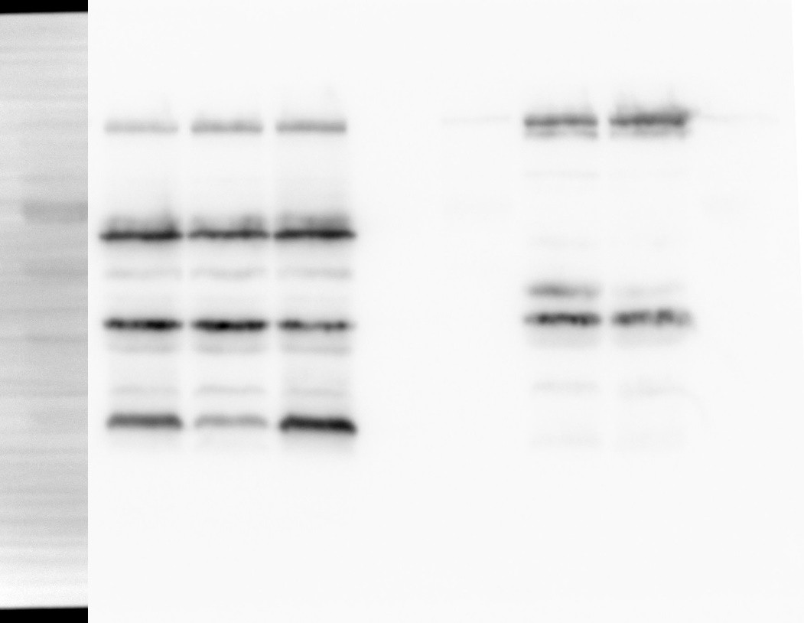

1 2 3 [lane]

kDa

RNAP

α-RNAP

regulator OppZ (KPO-3192)

5S (KPO-0243)

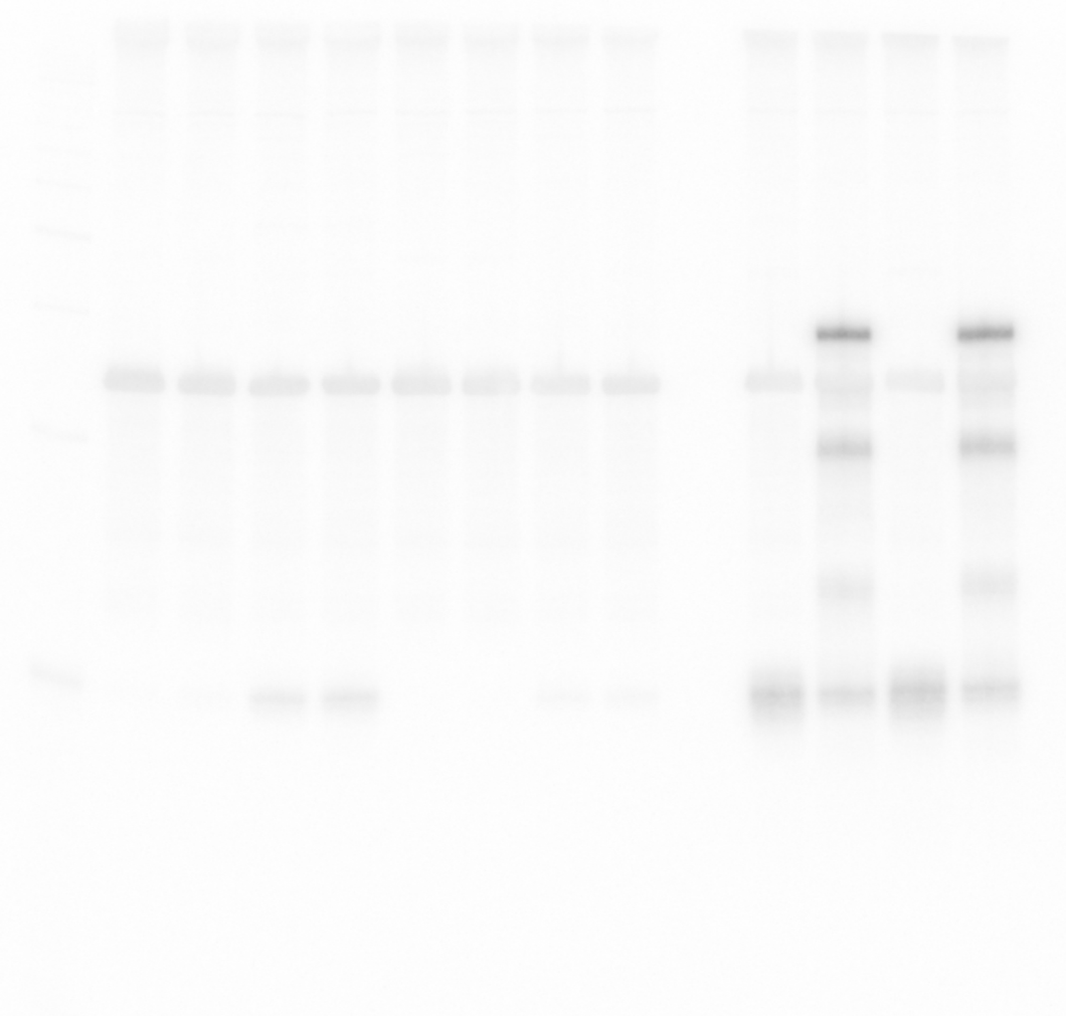

1 2 3 4 5 6 7 8 [lane]

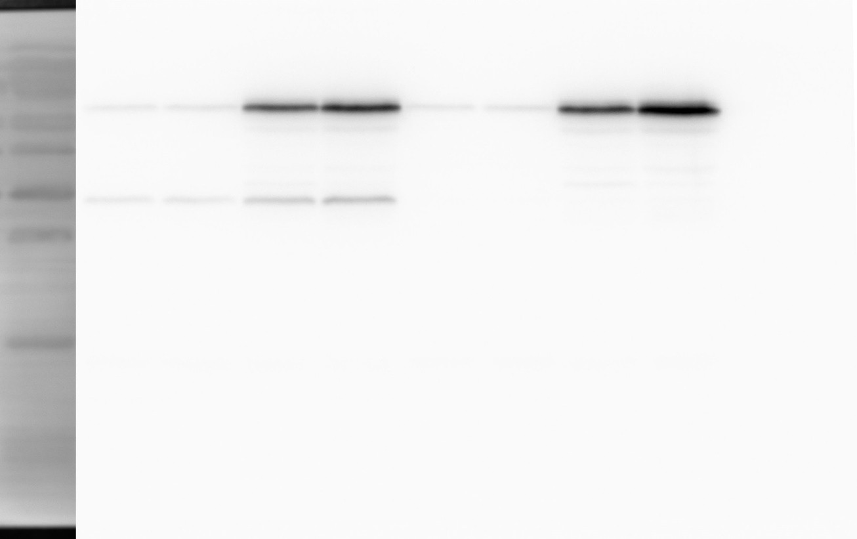

kDa 70

55

40

35

25

1

2

3

4 5

6 7

8 [lane]

OppA

OppB

α-FLAG

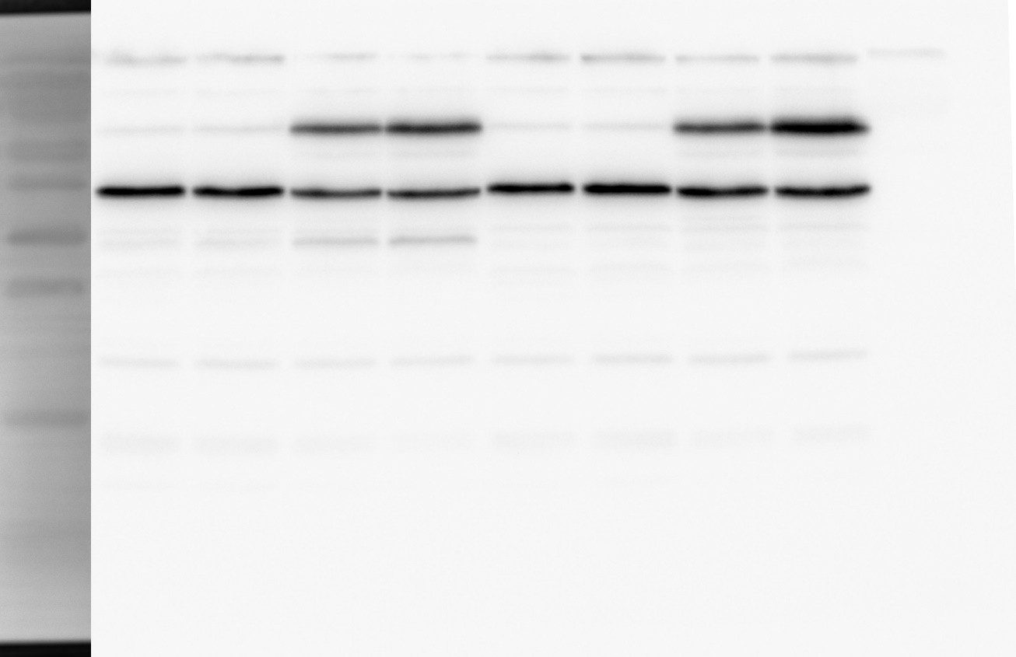

kDa 70

55

40

RNAP

35

25

1

2

3

4 5

6 7

8 [lane]

α-RNAP

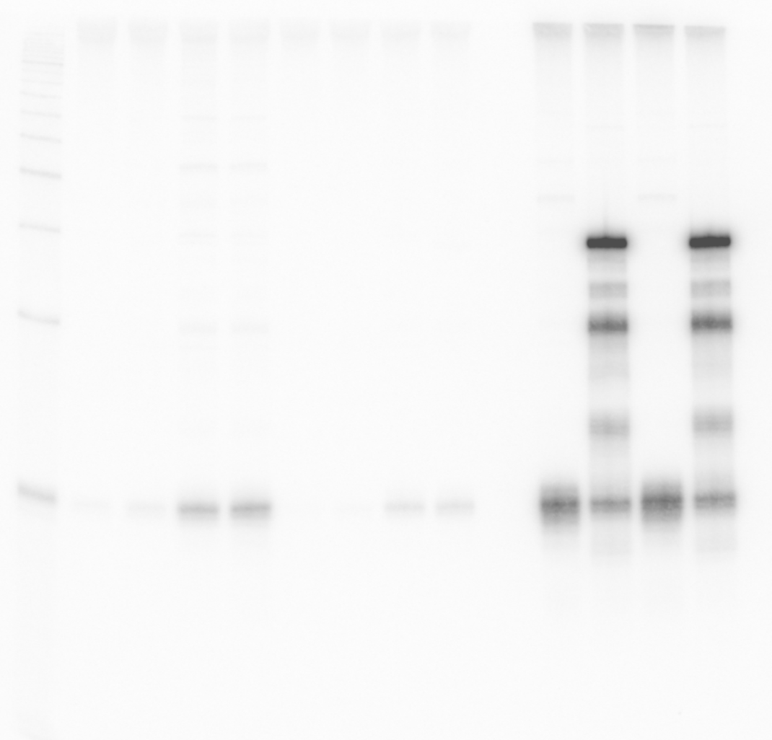

1 2 3 4 5 6 7 8 [lane]

OppZ (KPO-0845) 5S (KPO-0243)