Figure 4 – figure supplement 1A

Data:
- OppZ and 5S quantified from three biological replicates on Northern blots
- OppZ normalized to 5S levels
- Fold change relative to t = 0 min

strain | min | rep 1 | rep 2 | rep 3 | mean | SD
WT | 0 | 1.0000 | 1.0000 | 1.0000 | 1.0000 | 0.0000
 | 2 | 1.1272 | 1.8005 | 1.1009 | 1.3429 | 0.3238
 | 4 | 1.1031 | 1.1159 | 1.1230 | 1.1140 | 0.0083
 | 8 | 0.8733 | 0.9310 | 1.2083 | 1.0042 | 0.1462
 | 16 | 1.3418 | 1.0955 | 1.1696 | 1.2023 | 0.1032
 | 32 | 1.0512 | 0.9424 | 1.1430 | 1.0455 | 0.0820
oppB ATC | 0 | 1.0000 | 1.0000 | 1.0000 | 1.0000 | 0.0000
 | 2 | 1.5245 | 1.0153 | 0.9619 | 1.1673 | 0.2536
 | 4 | 1.7158 | 0.9489 | 1.1030 | 1.2559 | 0.3312
 | 8 | 1.4386 | 1.1048 | 1.2175 | 1.2536 | 0.1386
 | 16 | 1.2780 | 0.9040 | 1.0009 | 1.0609 | 0.1585
 | 32 | 0.8014 | 0.7710 | 0.9999 | 0.8574 | 0.1015

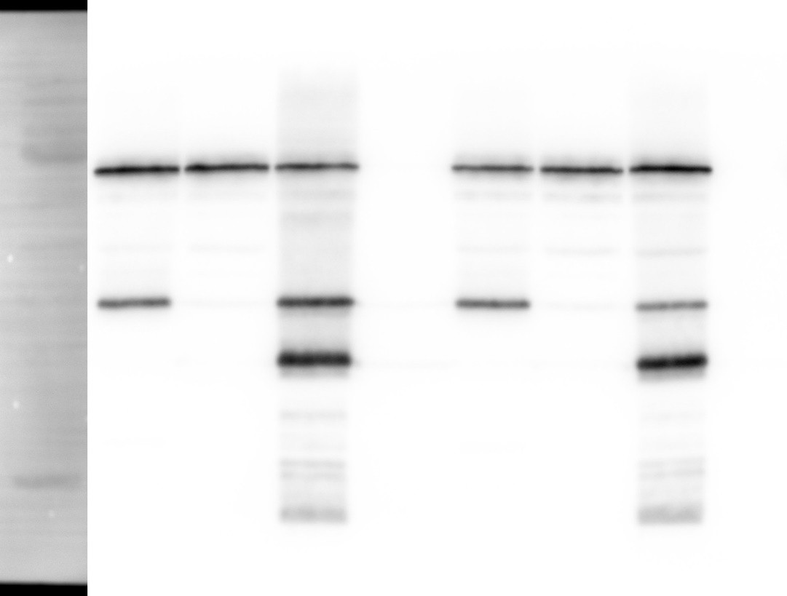kDa
1
2
3 [lane]
α-FLAG
kDa

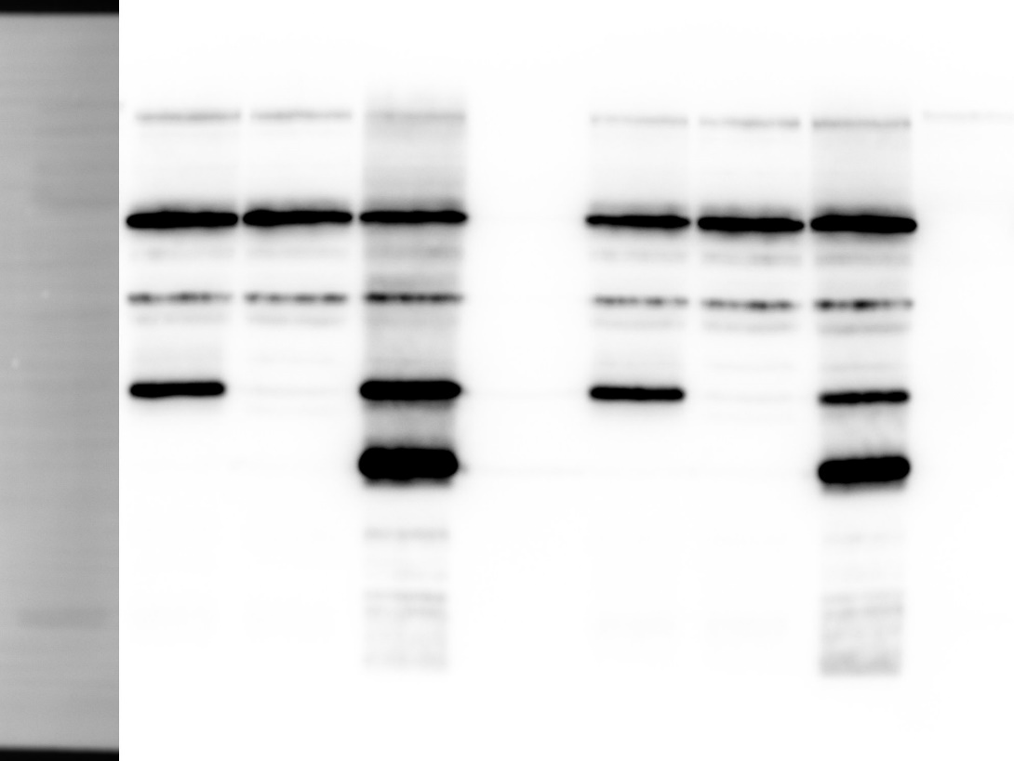
1
2
3 [lane]

RNAP
α-RNAP
70  55 |  | OppA | 70  55
40 |  |  | 40
35 |  | OppB | 35
25 |  |  | 25

1 2 3 [lane]
1 2 3 [lane]
OppZ (KPO-0845) 5S (KPO-0243)

