Source data for Figure 6 Figure 6B

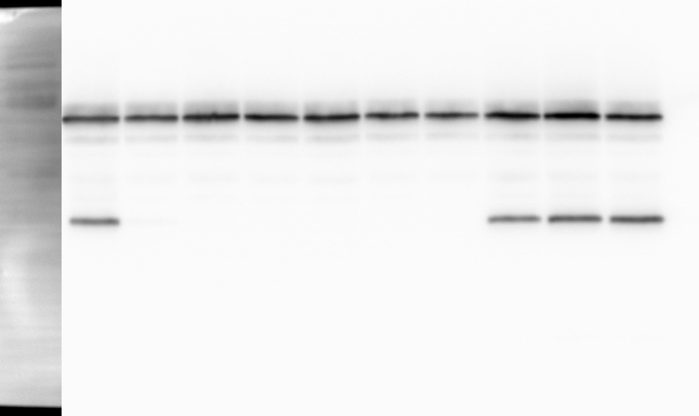kDa 70
55
40

35
25
1 2 3 4 5 6 7 8 9 10 [lane]
OppA

OppB

α-FLAG

kDa 70
55
40

35
25
RNAP

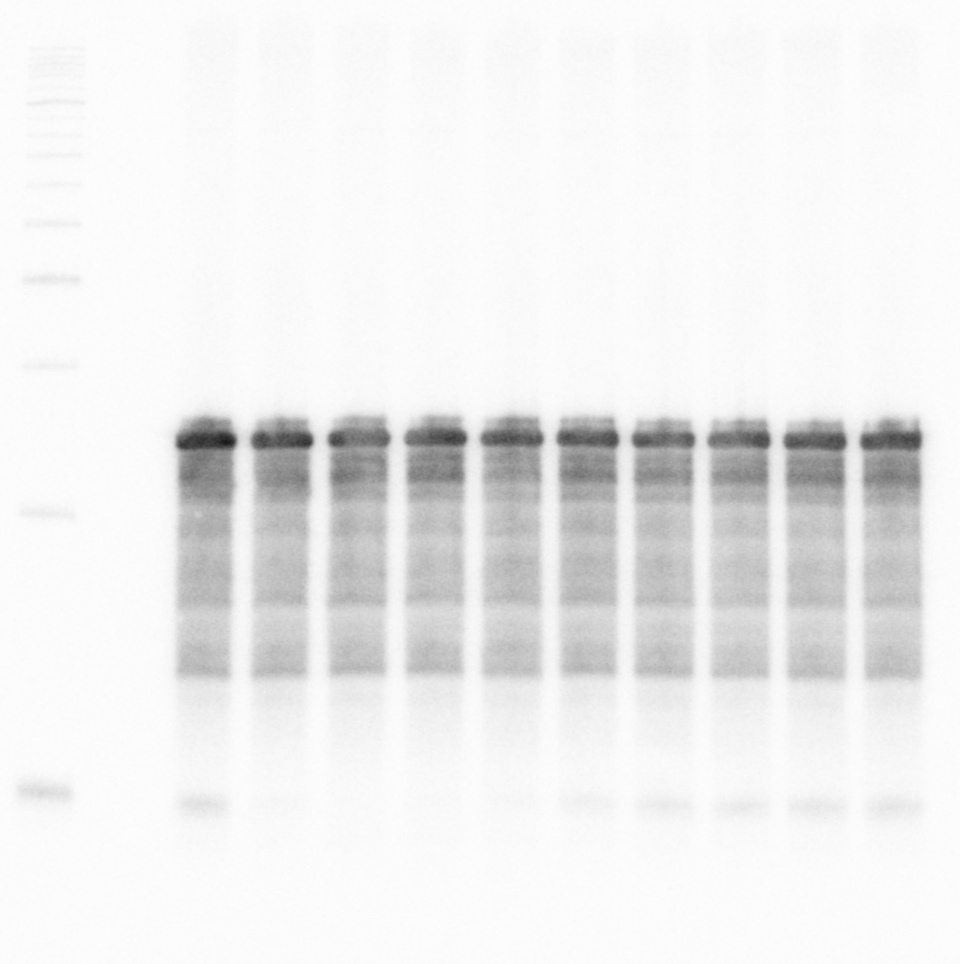α-RNAP
1 2 3 4 5 6 7 8 9 10 [lane]
1 2 3 4 5 6 7 8 9 10 [lane]
OppZ (KPO-0845) 5S (KPO-0243)

