Figure 7 – figure supplement 1B

Data: (fluorescence / OD600) - autofluorescence

target | sRNA | rep 1 | rep 2 | rep 3
carA | pCtrl | 361858.314 | 353026.158 | 376882.269
 | pCarZ | 5934.69912 | 5001.14263 | 4187.01872
 | pCarZ M1 | 474552.61 | 507863.509 | 494835.238
carA M1 | pCtrl | 376290.49 | 370151.581 | 373293.958
 | pCarZ | 329619.382 | 339412.4 | 359741.329
 | pCarZ M1 | 8554.77993 | 9839.31999 | 8020.39223
carB | pCtrl | 213977.98 | 216988.176 | 218533.447
 | pCarZ | 7774.23889 | 8082.55741 | 7674.90904
 | pCarZ M1 | 251059.148 | 269696.104 | 265688.202
carB M1 | pCtrl | 173751.276 | 186568.496 | 176131.298
 | pCarZ | 167966.978 | 175854.393 | 171251.735
 | pCarZ M1 | 7972.894 | 8041.1428 | 8006.85709

Figure 7 – figure supplement 1C

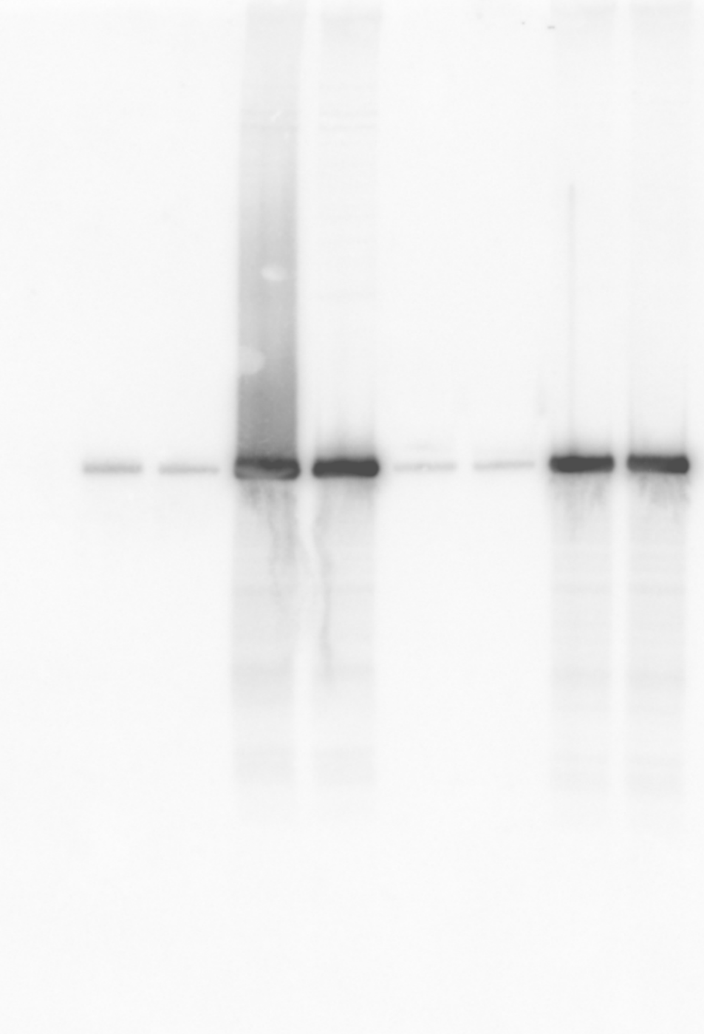1 2 3 4 [lane]
1 2 3 4 [lane]

CarZ (KPO-0821) 5S (KPO-0243)

Data: (fluorescence / OD600) - autofluorescence

sRNA | rep 1 | rep 2 | rep 3
pCtrl | 302626.046 | 241331.163 | 313665.23
pCarZ | 304283.345 | 241878.643 | 324403.628
pCarZ M1 | 303796.737 | 236465.074 | 310800.844

Figure 7 – figure supplement 1E
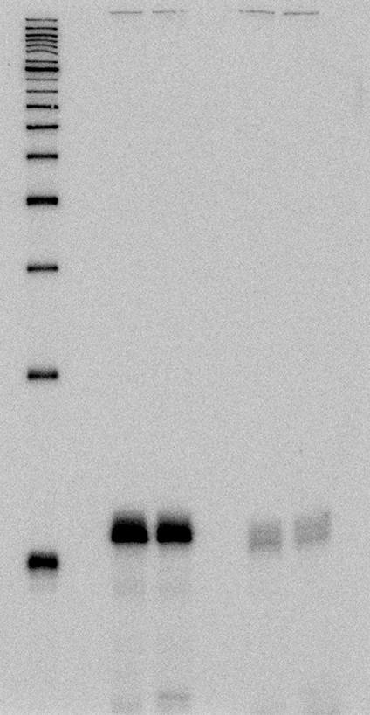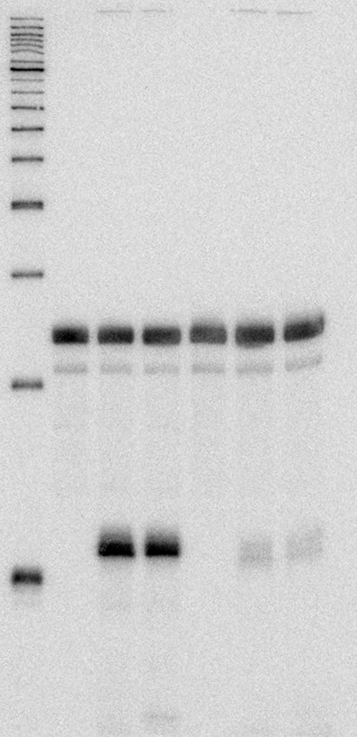
1 2 3 4
5 6 [lane]
1 2 3 4
5 6 [lane]
CarZ (KPO-2482) 5S (KPO-0243)

