Figure 8A

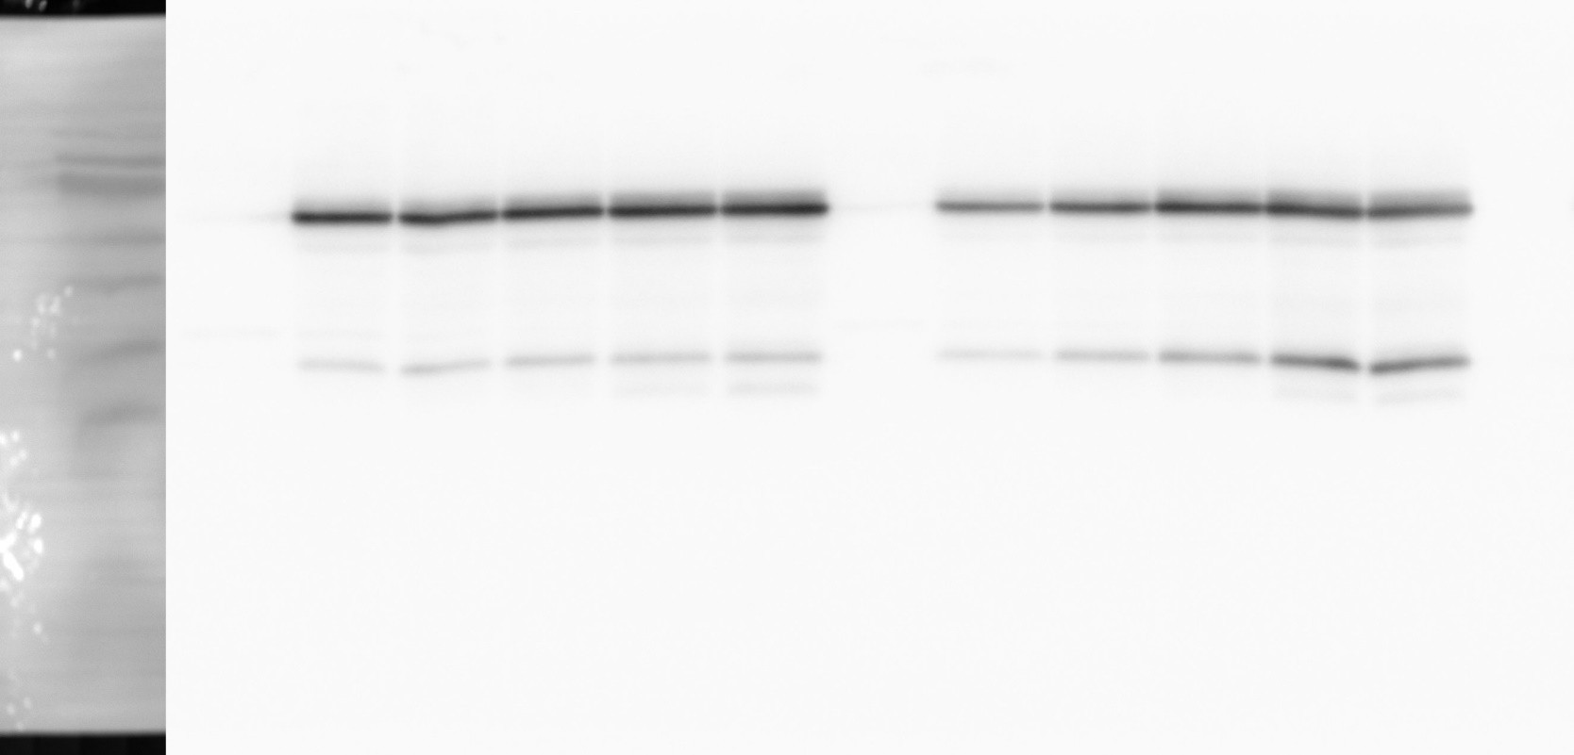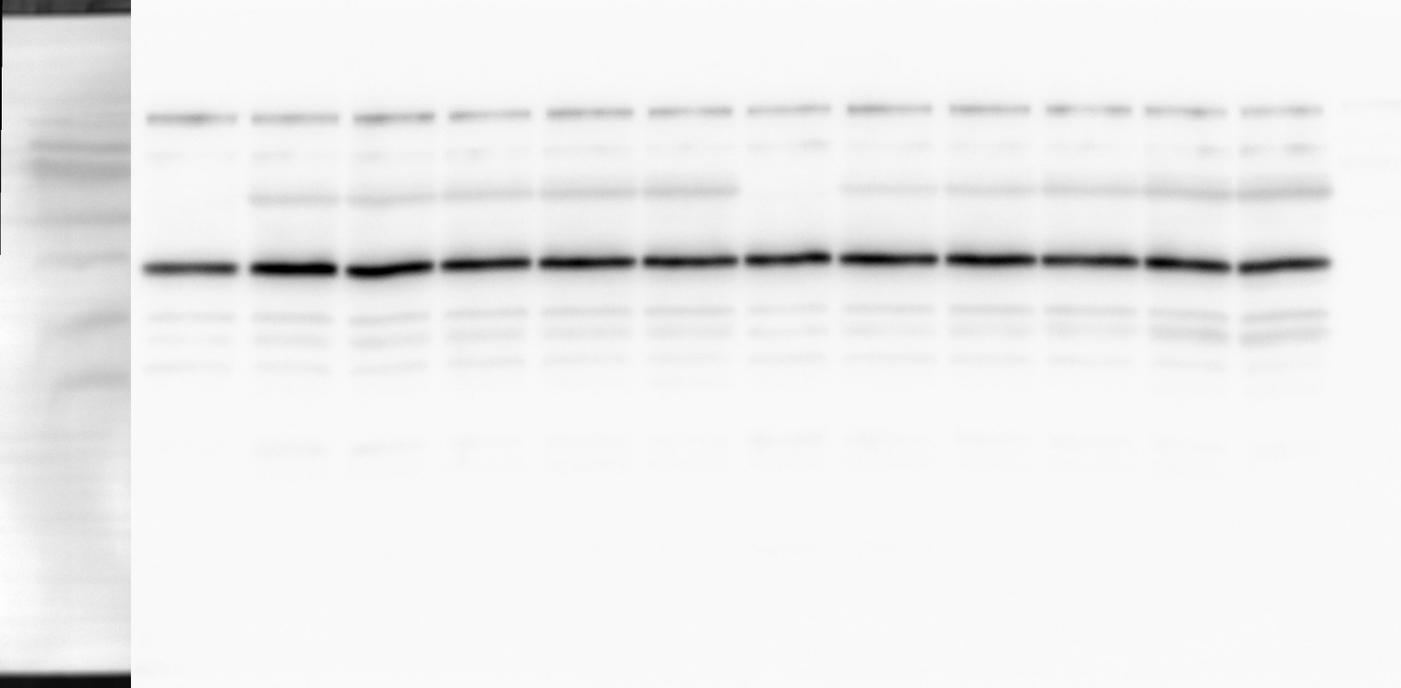kDa 70
55
40

35
25
1 2 3 4 5 6 7 8 9 10 11 12 [lane]
OppA OppB

α-FLAG

kDa 70
55
40

35
25

RNAP
1 2 3 4 5 6 7 8 9 10 11 12 [lane]

α-RNAP

1 2 3 4 5 6 7 8 9 10 11 12 [lane]
1 2 3 4 5 6 7 8 9 10 11 12

[lane]

OppZ (KPO-0845) 5S (KPO-0243)

Data:
- OppA and RNAP protein levels quantified from 3 biological replicates on Western blot
- OppA normalized to RNAP
- fold change relative to t = 180 min in the wild-type

 | wild-type |  |  |  |  | ΔoppZ
[min] | rep 1 | rep 2 | rep 3 | mean | SD | rep 1 | rep 2 | rep 3 | mean | SD
0 | 0.0011 | 0.0087 | 0.0114 | 0.0070 | 0.0131 | 0.0090 | 0.0127 | 0.0385 | 0.0201 | 0.0131
15 | 0.3183 | 0.4963 | 0.4379 | 0.4175 | 0.1319 | 0.1914 | 0.2795 | 0.5048 | 0.3252 | 0.1319
30 | 0.3649 | 0.5460 | 0.9571 | 0.6227 | 0.2310 | 0.2538 | 0.4504 | 0.8115 | 0.5052 | 0.2310
60 | 0.4143 | 0.8055 | 1.0480 | 0.7559 | 0.1971 | 0.5028 | 0.8228 | 0.9760 | 0.7672 | 0.1971
120 | 0.6499 | 0.8521 | 1.1490 | 0.8837 | 0.2178 | 0.9257 | 0.7025 | 1.2337 | 0.9540 | 0.2178
180 | 1.0000 | 1.0000 | 1.0000 | 1.0000 | 0.3215 | 1.2720 | 0.5812 | 1.2541 | 1.0358 | 0.3215

Figure 8C
Data:
- OppB and RNAP protein levels quantified from 3 biological replicates on Western blot
- OppB normalized to RNAP
- fold change relative to t = 180 min in the wild-type

 | wild-type |  |  |  |  | ΔoppZ
[min] | rep 1 | rep 2 | rep 3 | mean | SD | rep 1 | rep 2 | rep 3 | mean | SD
0 | 0.0050 | 0.0050 | 0.0050 | 0.0050 | 0.0006 | 0.0117 | 0.0131 | 0.0122 | 0.0123 | 0.0006
15 | 0.0821 | 0.2557 | 0.1842 | 0.1740 | 0.0120 | 0.2476 | 0.2765 | 0.2671 | 0.2637 | 0.0120
30 | 0.1451 | 0.4694 | 0.4680 | 0.3608 | 0.1037 | 0.4994 | 0.7493 | 0.6642 | 0.6376 | 0.1037
60 | 0.3246 | 0.6871 | 0.6299 | 0.5472 | 0.3920 | 1.2270 | 2.1251 | 1.3819 | 1.5780 | 0.3920
120 | 0.6700 | 0.7542 | 0.8692 | 0.7645 | 1.4678 | 2.5939 | 5.2683 | 1.8502 | 3.2375 | 1.4678
180 | 1.0000 | 1.0000 | 1.0000 | 1.0000 | 1.1140 | 3.9203 | 5.6435 | 2.9495 | 4.1711 | 1.1140

