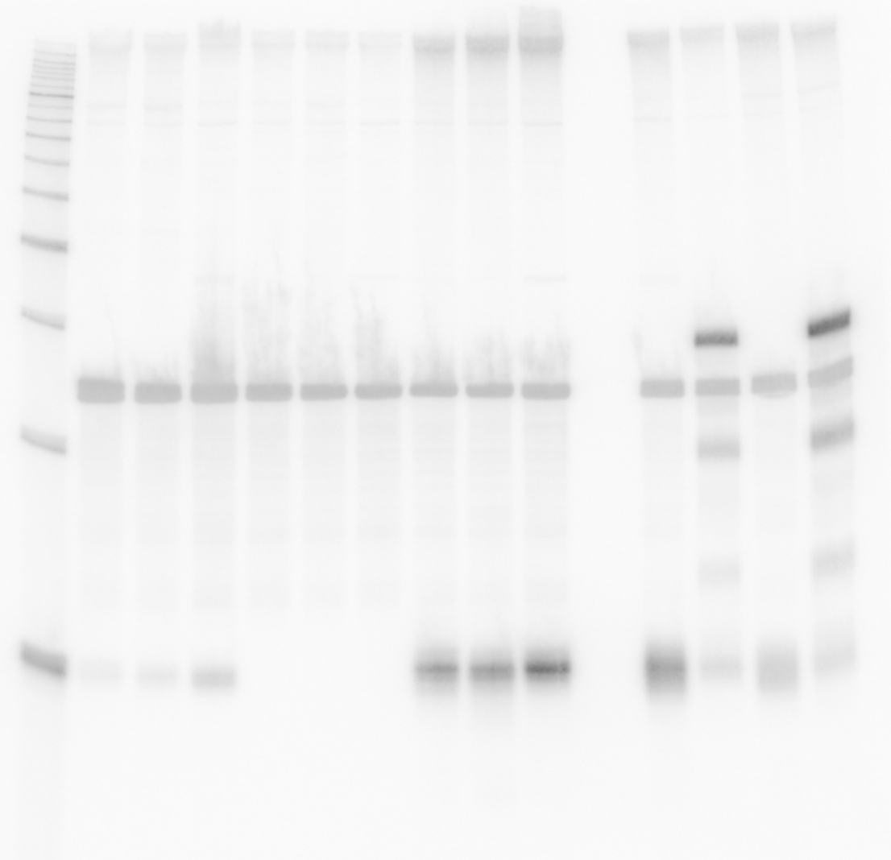
1 2 3 4 5 6 7 8 9 [lane]

Figure 8 – figure supplement 1A
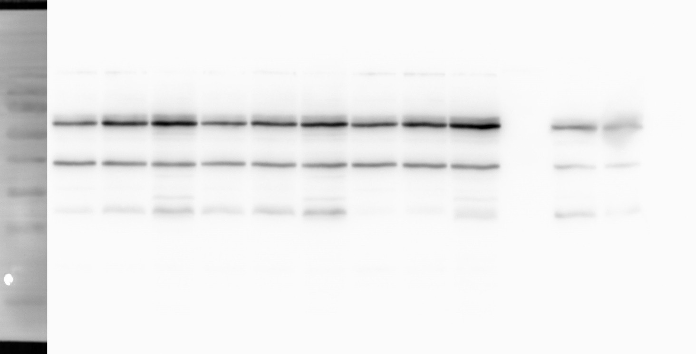
kDa 70
55
40
1 2 3 4 5 6 7 8 9 [lane]
OppA
35
25
OppB
α-FLAG
kDa 70
55
40
1 2 3 4 5 6 7 8 9 [lane]
RNAP
35
25
α-RNAP

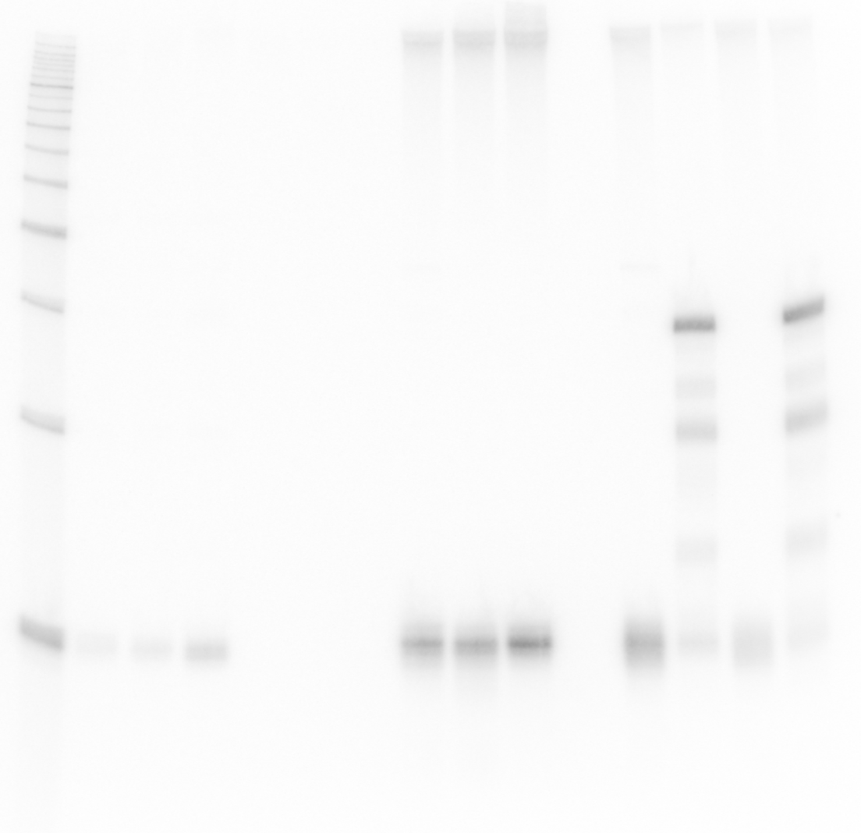
1 2 3 4 5 6 7 8 9 [lane]
OppZ (KPO-0845) 5S (KPO-0243)

Data:
- OppA. OppB and RNAP protein levels quantified from 4 biological replicates on Western blot
- OppA and OppB normalized to RNAP
- fold change in ΔoppZ pCtrl vs. wild-type pCtrl

 | OppA |  |  |  |  |  | OppB
OD600 | rep 1 | rep 2 | rep 3 | rep 4 | mean | SD | rep 1 | rep 2 | rep 3 | rep 4 | mean | SD
10 | 1.213 | 1.302 | 1.460 | 1.521 | 1.374 | 0.122 | 1.253 | 2.165 | 2.565 | 1.325 | 1.827 | 0.557
20 | 0.938 | 0.966 | 0.984 | 1.214 | 1.025 | 0.110 | 1.327 | 1.719 | 1.889 | 2.149 | 1.771 | 0.299
2+3h | 1.082 | 0.837 | 1.009 | 0.683 | 0.902 | 0.155 | 1.395 | 1.195 | 1.382 | 1.056 | 1.257 | 0.140

Figure 8 – figure supplement 1C
Data:
- OppA. OppB and RNAP protein levels quantified from 4 biological replicates on Western blot
- OppA and OppB normalized to RNAP
- fold change in ΔoppZ pOppZ vs. wild-type pCtrl

 | OppA |  |  |  |  |  | OppB
OD600 | rep 1 | rep 2 | rep 3 | rep 4 | mean | SD | rep 1 | rep 2 | rep 3 | rep 4 | mean | SD
10 | 1.234 | 1.301 | 1.295 | 1.184 | 1.253 | 0.048 | 0.158 | 0.328 | 0.188 | 0.209 | 0.220 | 0.064
20 | 0.949 | 0.951 | 0.852 | 1.403 | 1.039 | 0.214 | 0.154 | 0.303 | 0.149 | 0.087 | 0.173 | 0.080
2+3h | 1.197 | 1.127 | 1.126 | 1.060 | 1.127 | 0.048 | 0.327 | 0.447 | 0.254 | 0.096 | 0.281 | 0.127

