Supplementary Information

BipA exerts temperature-dependent control of biofilm-associated colony morphology in Vibrio cholerae
Teresa del Peso Santos¹, Laura Alvarez¹, Brandon Sit², Oihane Irazoki¹, Jonathon Blake², Benjamin R Warner⁴, Alyson R. Warr², Anju Bala¹, Vladimir Benes², Matthew K. Waldor², Kurt Fredrick⁴ and Felipe Cava¹

¹The laboratory for Molecular Infection Medicine Sweden (MIMS), Department of Molecular Biology. Umeå University. Umeå. Sweden.
²Howard Hughes Medical Institute, Brigham and Women's Hospital Division of Infectious Diseases and Harvard Medical School Department of Microbiology and Immunobiology, Boston, Massachusetts, USA.
³Genomics Core Facility, European Molecular Biology Laboratory (EMBL), Meyerhofstrasse 1, Heidelberg, Germany.
⁴Department of Microbiology, The Ohio State University, Columbus, OH 43210, USA; Center for RNA Biology, The Ohio State University, Columbus, OH 43210, USA.

Correspondence to: felipe.cava@umu.se
Keywords: biofilm, temperature, Vibrio cholerae, BipA, HapR, translation.
Running title: Temperature-dependent biofilm regulation in Vibrio cholerae
Table of contents:
Supplementary Figure 1
Supplementary Figure 2
Supplementary Figure 3
Supplementary Figure 4
Supplementary Figure 5
Supplementary Figure 6
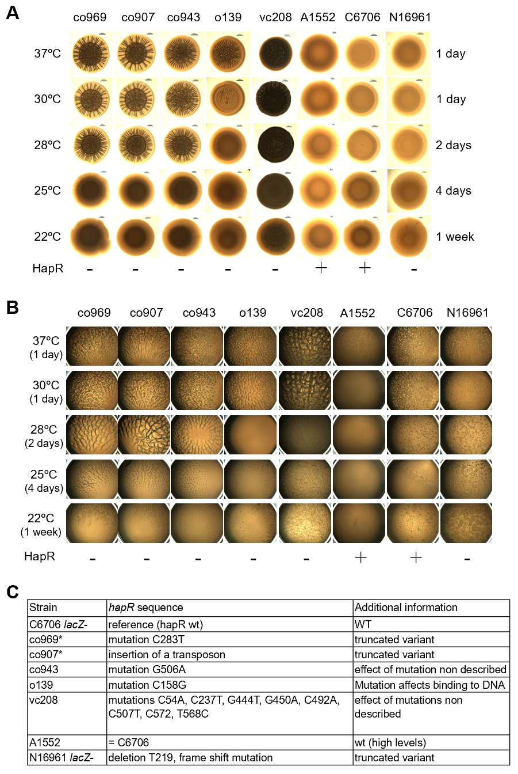
Supplementary Figure 1. Effect of temperature on CM and pellicle biofilm of different V. cholerae strains.
A. Effect of temperature on colony morphology (CM) of different V. cholerae strains. Pictures represent the maximum rugosity obtained for different V. cholerae strains incubated at different temperatures (37, 30, 28, 25 and 22ºC) during different times. The presence or absence of a functional variant of HapR in these strains is indicated. B. Pellicle biofilm formation for different V. cholerae strains incubated at different temperatures (37, 30, 28, 25 and 22ºC). The presence or absence of a functional variant of HapR is indicated. C. Table indicating the mutations in the hapR sequence of the above V. cholerae strains, which lead to truncated or inactive variants of the protein. Sequencing of hapR gene of the strains in panels A and B was performed in this study. To avoid any sequencing errors, sequencing was performed twice from two independent PCR products using primers FCP849 and FCP950 (Supplementary Table 3). The tool http://web.expasy.org/translate/ allowed to identify which of the changes in the sequence resulted in truncated variants of the protein. The C158G substitution in strain o139 leads to a T53R substitution; T53 has been reported to be involved in binding of HapR to DNA (Singh et al 2014), with a T53A substitution only allowing very weak binding (De Silva et al 2007).

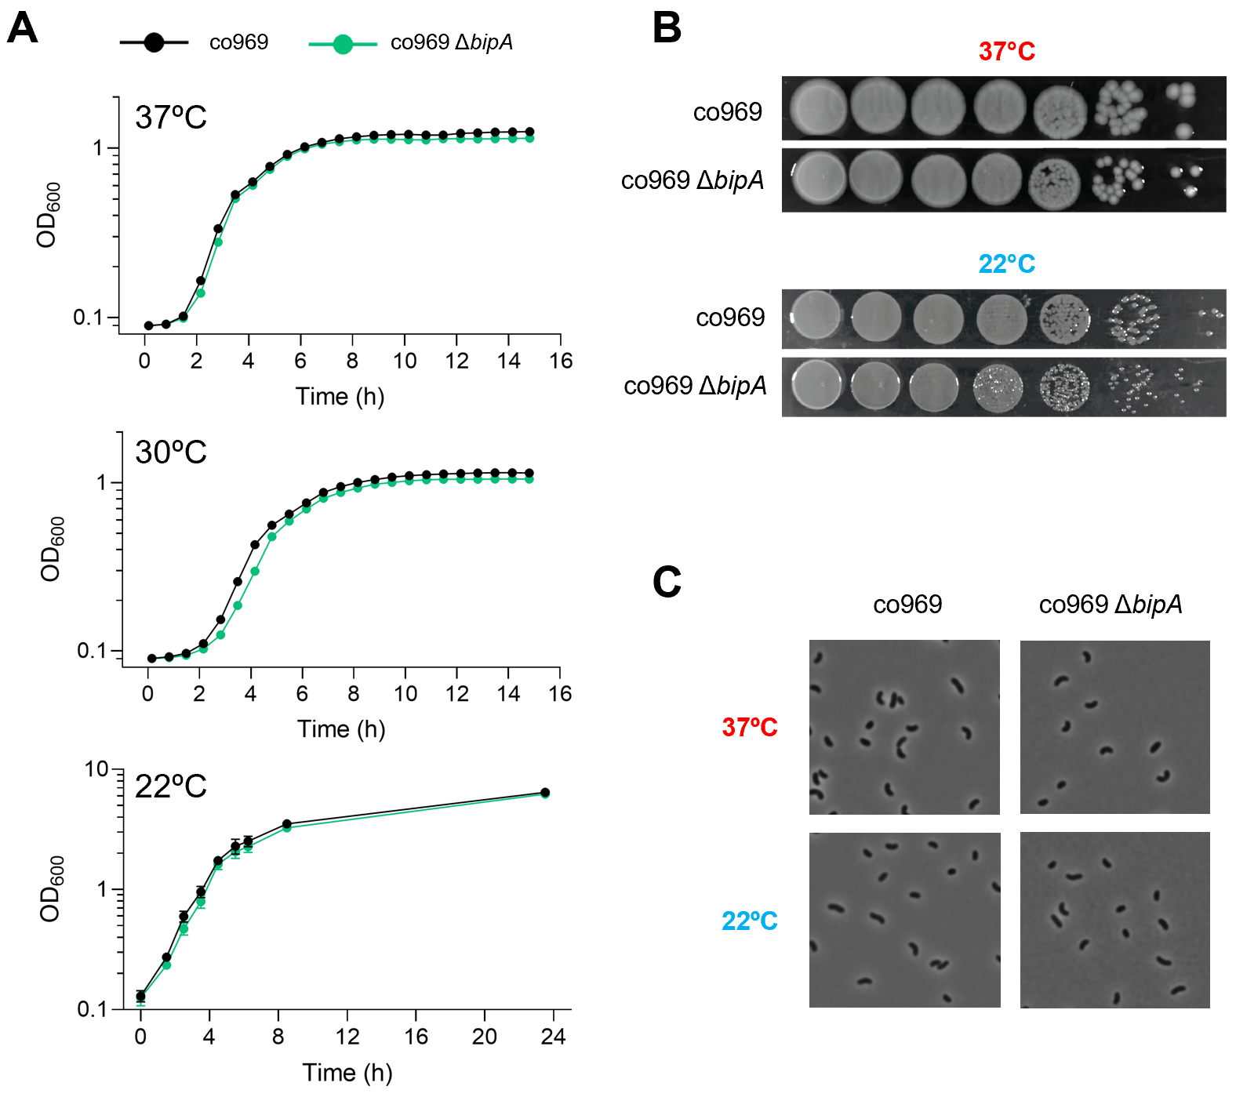
Supplementary Figure 2. Growth and cell morphology of V. cholerae co969 WT and ΔbipA strains at different temperatures. A. Growth curves of WT and ΔbipA strains at 37, 30 and 22ºC. B. Viability of WT and ΔbipA strains at 37ºC and 22ºC. C. Morphology of co969 and co969 ΔbipA grown at 37ºC or 22ºC in stationary phase.

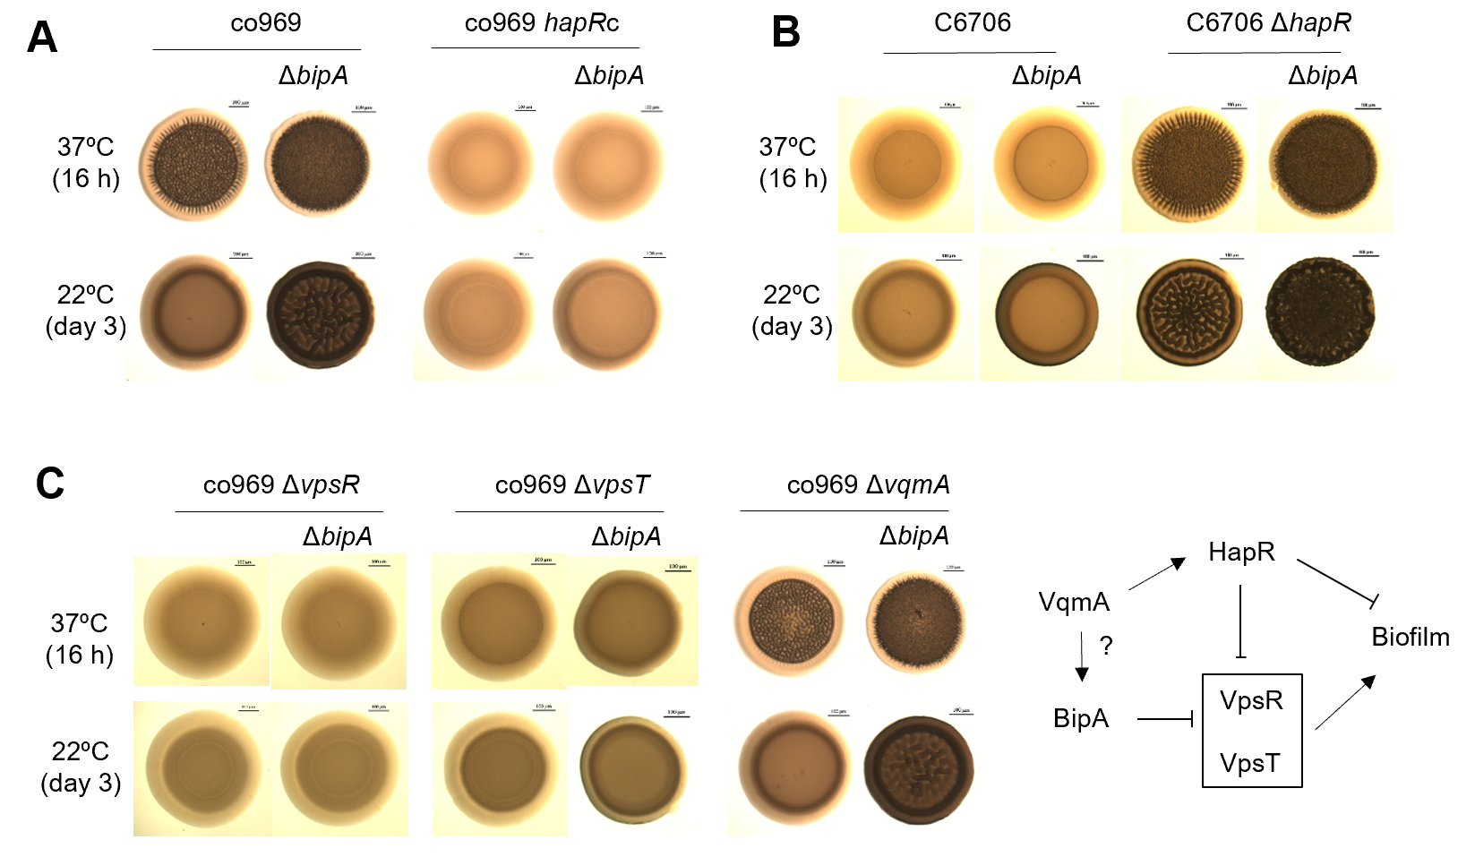
Supplementary Figure 3. Interplay of BipA with known biofilm regulators.
A. Colony morphology at 37ºC and 22ºC of co969, co969:hapRc (with a chromosomal replacement of the mutant hapR from co969 with the active hapR from C6706, hapRc), and their respective ΔbipA mutant variants. B. Colony morphology at 37ºC and 22ºC of C6706, C6706 ΔhapR, and their respective ΔbipA mutant variants. C. Colony morphology at 37ºC and 22ºC of co969, co969 ΔvpsR, co969 ΔvpsT, co969 ΔvqmA, and their respective ΔbipA mutant variants. To the right, schematic showing the impact of these different regulators on biofilm. The incubation times at 37ºC or 22ºC, leading to colonies with a similar number of CFUs/ colony, are indicated for each case.

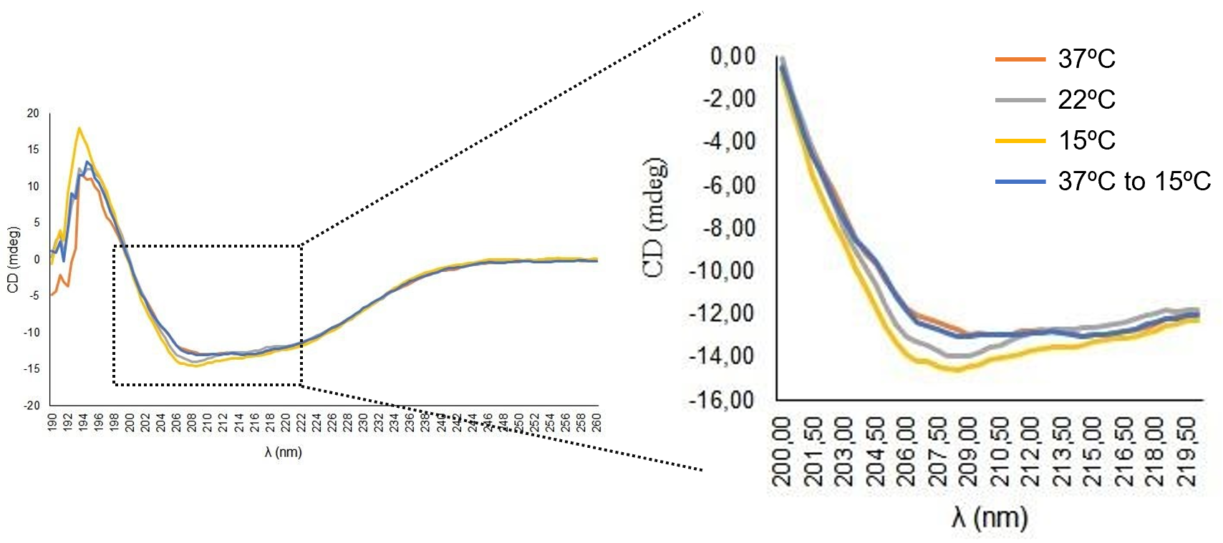
Supplementary Figure 4. BipA protein stability at different temperatures. Circular dichroism curve (mdeg represented against wavelength) of purified BipA-His pre-incubated at different temperatures (37ºC, 22ºC or 15ºC) for 30 min, or pre-incubated at 37ºC for 30 min and then sifted to 22ºC and further incubated for 30 min. Boxed graph shows the CD curve between 200 and 220 nm.

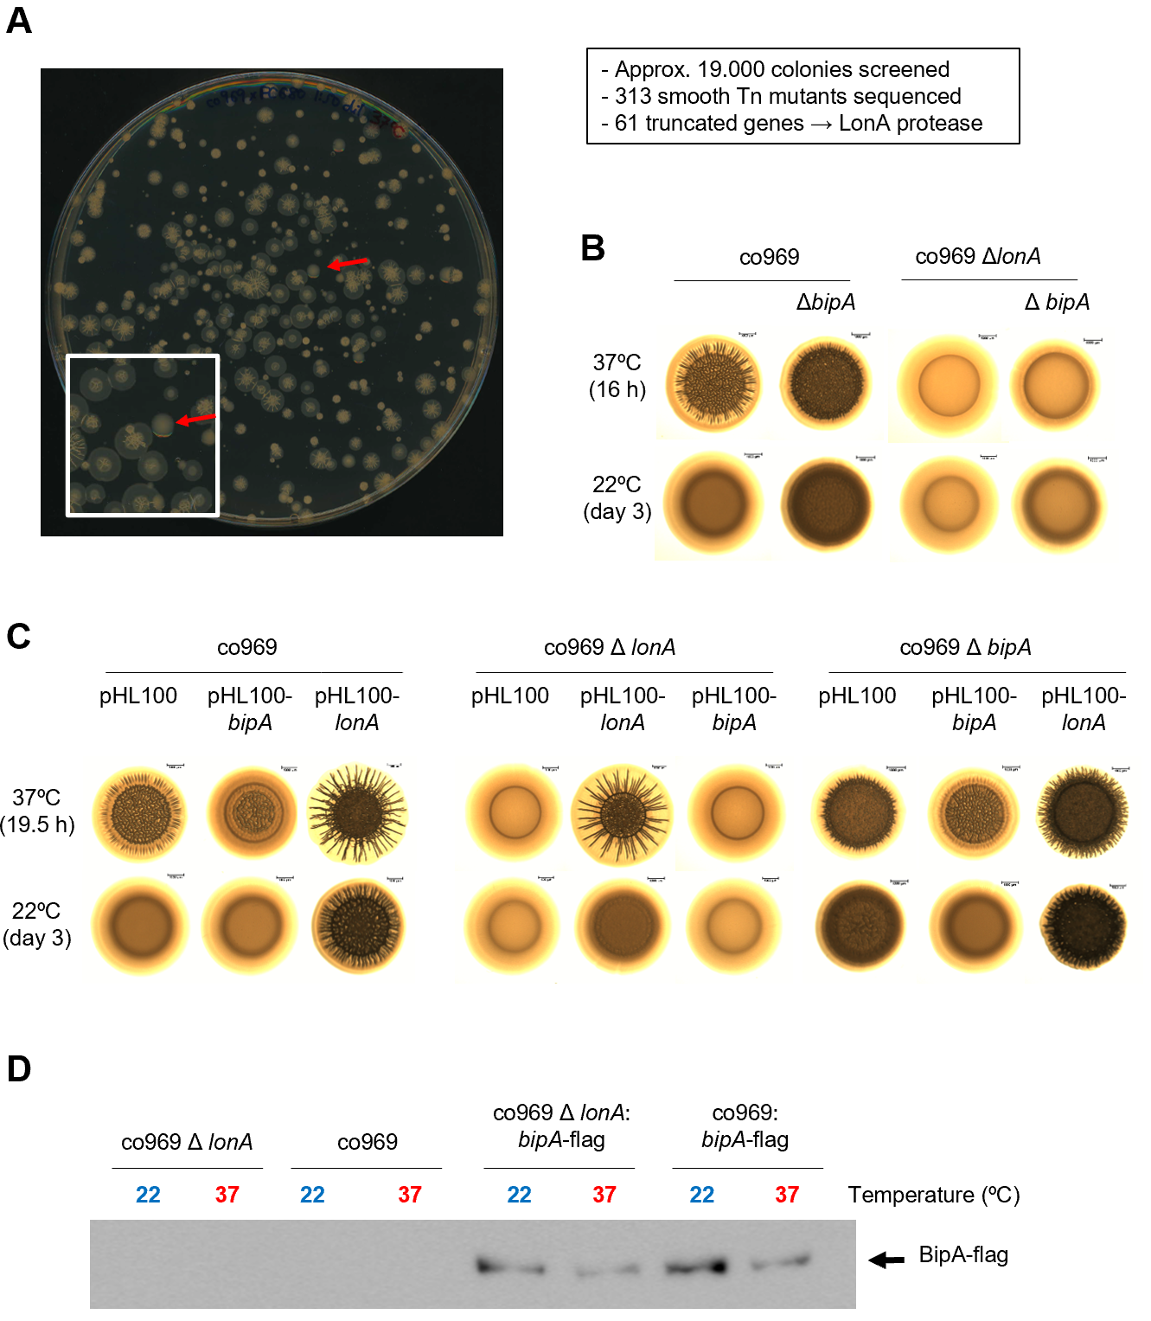
Supplementary Figure 5. V. cholerae BipA is not degraded by LonA protease.
A. Transposon mutagenesis screening for V. cholerae co969 mutants with a smooth colony morphology at 37ºC led to identification of LonA. Left, example of a LB (10 g/l NaCl) + Sm200 + Km50 agar plate used for selection of transposon mutants with a smooth colony phenotype at 37ºC (indicated with a red arrow). The number of screened transposon mutants, smooth colonies selected and final number of truncated genes is indicated to the right. B. Colony morphology at 37ºC and 22ºC of co969, co969 ΔlonA and their respective ΔbipA counterpart. C. Colony morphology at 37ºC and 22ºC of co969, co969 ΔbipA and co969 ΔlonA either carrying pHL100-lonA or pHL100-bipA, to either overexpress lonA or bipA from the IPTG-inducible P_{lac} promoter, or the pHL100 empty vector. D. Western blot showing the BipA-flag levels from V. cholerae co969:bipA-flag and co969 ΔlonA:bipA-flag rugose colonies grown at 37ºC or smooth colonies grown at 22ºC. V. cholerae co969 and co969 ΔlonA strains were used as a negative control. The gel is a representative of 2 independent experiments, each containing 2 biological replicates, containing each biological replicate 2 colonies pooled together.

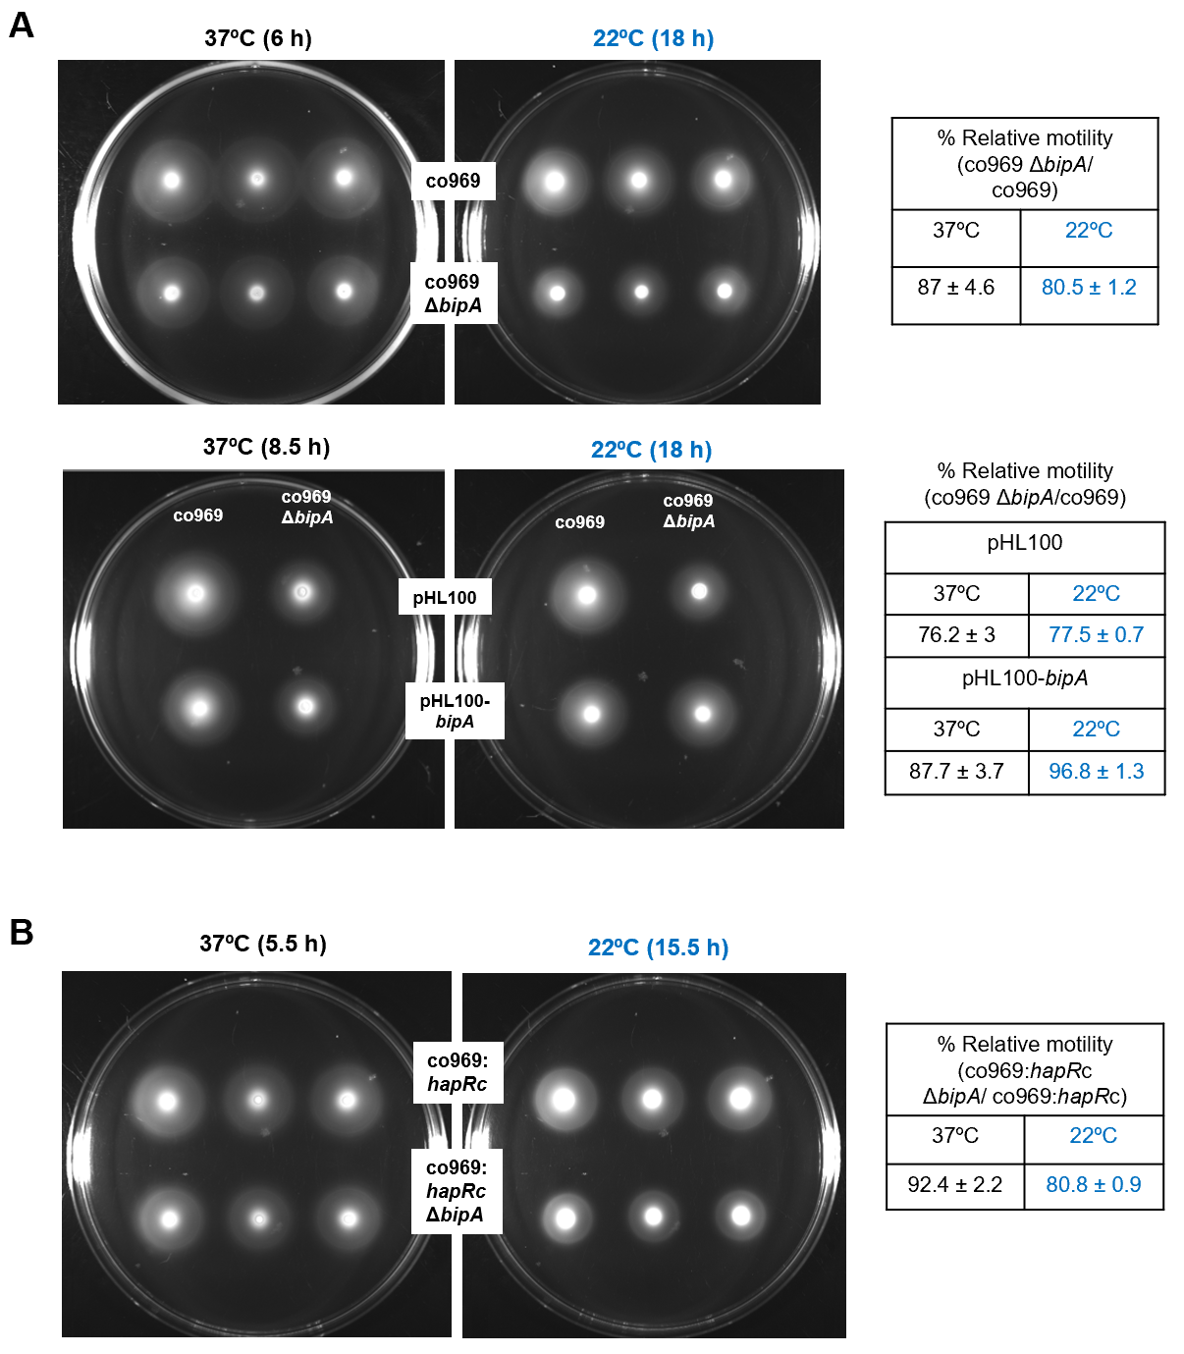
Supplementary Figure 6. Effect of BipA on motility.
A. Upper panel: motility of co969 and co969 ΔbipA on 0.3% agar plates at 37ºC (left) and 22ºC (right) after the indicated times. The relative motility between co969 ΔbipA and co969 (in %) at 37ºC or 22ºC is indicated on the right. Lower panel: motility of co969 and co969 ΔbipA either carrying pHL100-bipA, for overexpression of bipA from the IPTG-inducible P_{lac} promoter, or the empty plasmid pHL100 on 0.3% agar plates with Km (50 µg/ml) and IPTG (isopropyl-β-d-thiogalactosidase, 1 mM) at 37ºC (left) and 22ºC (right) after the indicated times. The relative motility between co969 ΔbipA and co969 (in %), either carrying pHL100-bipA or pHL100, at 37ºC or 22ºC is indicated on the right. B. Motility of co969:hapRc and co969:hapRc ΔbipA, with a chromosomal exchange of the mutant hapR from co969 for the active hapR of C6706, on 0.3% agar plates at 37ºC (left) and 22ºC (right) after the indicated times. The relative motility between co969:hapRc ΔbipA and co969:hapRc (in %) at 37ºC or 22ºC is indicated to the right. Relative motility values are the average of 2 independent experiments each containing at least 3 biological replicates ± standard deviation.

