NMR SPECTRA

¹H NMR
500 MHz
CDCl₃
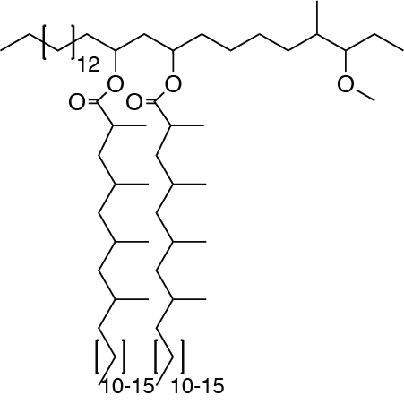
PDIM

¹³C NMR
126 MHz
CDCl₃

¹H NMR
500 MHz
CDCl₃
Azido-DIM

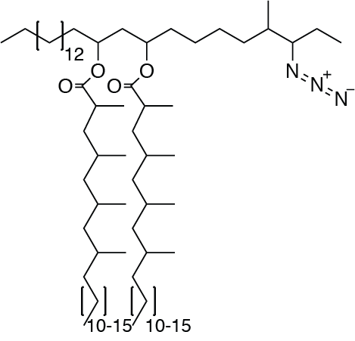

¹³C NMR
126 MHz
CDCl₃

¹H NMR
500 MHz
CDCl₃
PDIF
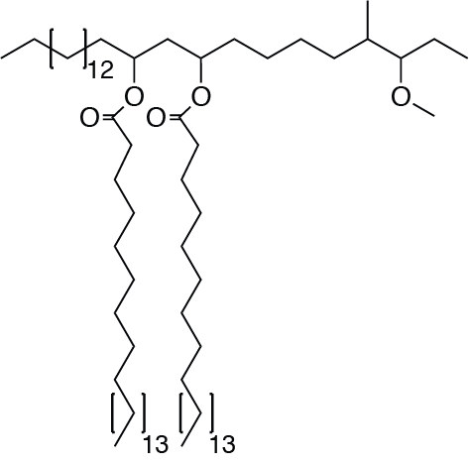

¹³C NMR
126 MHz
CDCl₃

¹H NMR
500 MHz
CDCl₃
Azido-DIF
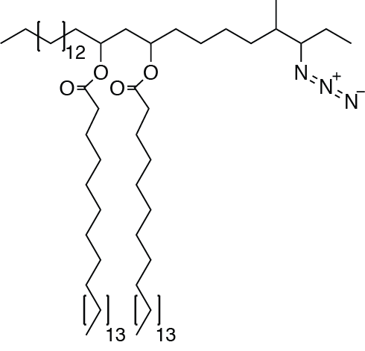

¹³C NMR
126 MHz
CDCl₃

¹H NMR
500 MHz
CDCl₃
Control bacteria - petroleum ether extract

¹H NMR
500 MHz
CDCl₃
Recoated bacteria – petroleum ether extract

