Supplementary Table 1:

Estimated pressures within SC lumen as a function of clamped IOP levels using two-series resistor model of conventional outflow pathway described previously.
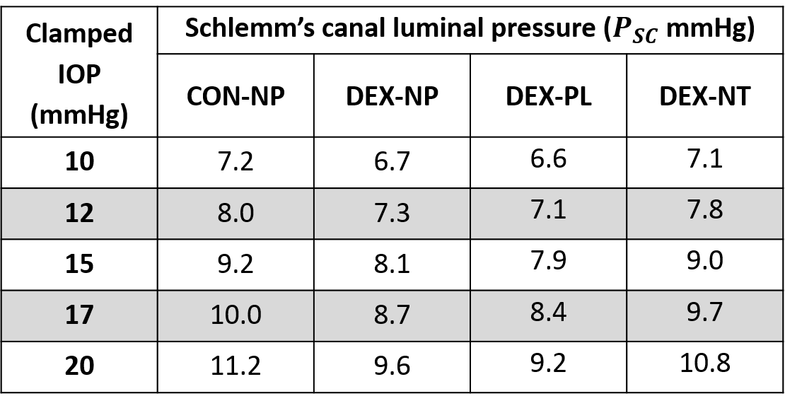
IOP: intraocular pressure, PL: placebo, NT: netarsudil, DEX: dexamethasone

