SUPPLEMENTARY FILE 1

Coordinated crosstalk between microtubules and actin by a spectraplakin regulates lumen formation and branching

Delia Ricolo^{1,2} and Sofia J. Araújo^{1,2*}
¹Department of Genetics, Microbiology and Statistics, School of Biology, University of Barcelona, 08028 Barcelona, Spain
²Institute of Biomedicine University of Barcelona (IBUB), Barcelona, Spain
*Corresponding author. email: S. J. Araújo sofiajaraujo@ub.edu,

Supplementary Table 1. DSRF-specific sequences in upstream and downstream regions of the shot gene. Sequences are shown within 2000 bp of the TSS with more than 70% similarity to the specific DSRF binding sequences, indicating their score and the chain of chromosome 2 in which they were found.
The DSRF-binding sequences identified, overlap with regions P1, P2, and P3. In the case of the P1 promoter, we found the sequences in the table spanning 13,926,470-13,927,188; in the case of P2, the first three DSRF binding sequences of the table are located within this region, which include 13,943,065-13,329; and in the case of P3, we found DSRF binding sequences within 13,912,773-13,912,789.

Chr | Start | End | Length | Score | Chain | Sequence
chr2R | 13,943,313 | 13,943,329 | 16 | 0.75 | + | TTTCCAAATGGGGTCA
chr2R | 13,943,313 | 13,943,329 | 16 | 0.75 | - | TGACCCCATTTGGAAA
chr2R | 13,943,065 | 13,943,081 | 16 | 0.74 | + | TCCCGATCTGTGGTCA
chr2R | 13,927,172 | 13,927,188 | 16 | 0.78 | + | TACTCATTTATGGACA
chr2R | 13,927,172 | 13,927,188 | 16 | 0.76 | - | TGTCCATAAATGAGTA
chr2R | 13,926,681 | 13,926,697 | 16 | 0.74 | + | TGTCGATCTGTGGTCT
chr2R | 13,926,470 | 13,926,486 | 16 | 0.79 | + | TGACCAAATATGAGGA
chr2R | 13,926,470 | 13,926,486 | 16 | 0.80 | - | TCCTCATATTTGGTCA
chr2R | 13,912,773 | 13,912,789 | 16 | 0.76 | + | ACTCCATATAGGGCAA
chr2R | 13,912,260 | 13,912,276 | 16 | 0.73 | + | TTAACATAAGTGGTCA
chr2R | 13,912,260 | 13,912,276 | 16 | 0.74 | - | TGACCACTTATGTTAA
chr2R | 13,912,773 | 13,912,789 | 16 | 0.78 | - | TTGCCCTATATGGAGT

Supplementary Table 2. DSRF positional weight matrix (PWM)
Specific DSRF-binding sequences known in vertebrates (Khan et al., 2018).
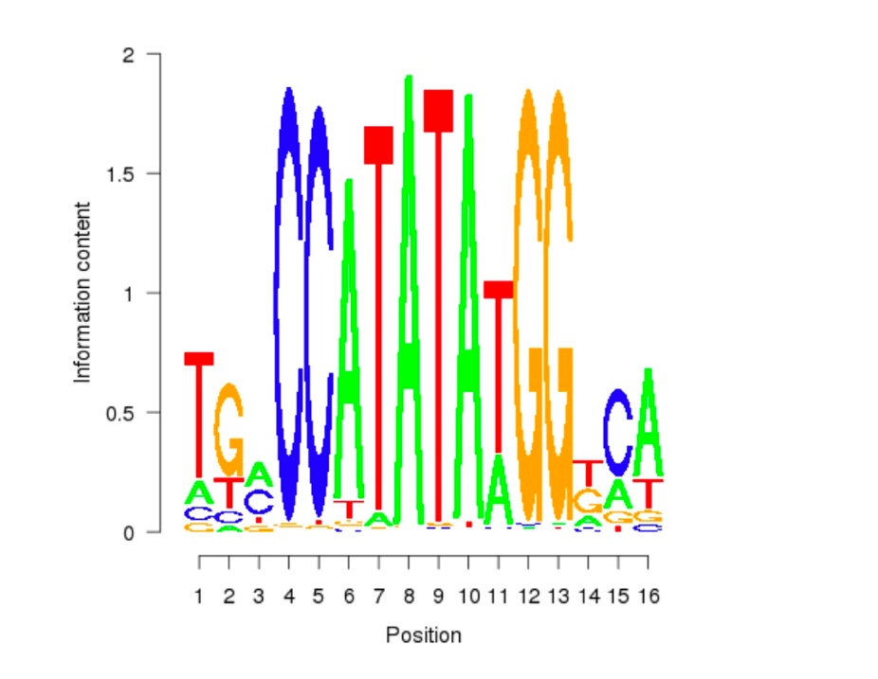

Quantification of the number of bifurcations (GB TCs) per embryo of the indicated genotype in Figure 3.
In the graph (panel I) embryos with 0 bifurcations are represented by grey columns, embryos with 1 bifurcation columns in light blue, 2 bifurcations columns in blue, 3/more bifurcations columns in dark blue. To better quantify the phenotypes, we subdivided Rca1 and ShotOE embryos in groups characterized by 1, 2, “3/or more” branched TC lumina. 80% of Rca1 mutant embryos had TCs with supernumerary lumina (n=40); in particular, 24% of embryos had 1 bifurcation, 30% of embryos had 2 bifurcations and 28% of embryos had 3 or more bifurcations. In ShotOE embryos, 57,5 % of embryos had TCs affected; 25% with one bifurcation, 22.5% with two bifurcations and 10% with three or more bifurcations (n= 40). We then analysed the phenotype in Rca1, ShotOE embryos (n=28). These embryos had bifurcation phenotypes in 96,3 % of the cases; 11,1% with 1 bifurcation 29,6% with 2 bifurcations and 55,6% with 3 or more bifurcations. So, in Rca1, ShotOE embryos, we observed a higher number of embryos with 2 or 3/more bifurcations and a lower number of embryos with 0 or 1 bifurcations in relation to Rca1, suggesting that the effect of Rca1 LOF and ShotOE was additive in producing 2 or 3/more bifurcations.

References
Khan, A., O. Fornes, and M.G. Arnaud Stigliani, Jaime A Castro-Mondragon, Robin van der Lee, Adrien Bessy, Jeanne Chèneby, Shubhada R Kulkarni, Ge Tan, Damir Baranasic, David J Arenillas, Albin Sandelin, Klaas Vandepoele, Boris Lenhard, Benoît Ballester, Wyeth W Wasserman, François Parcy, Anthony Mathelier 2018. JASPAR 2018: update of the open-access database of transcription factor binding profiles and its web framework. Nucleic Acids Res. 46:D260-D266.

