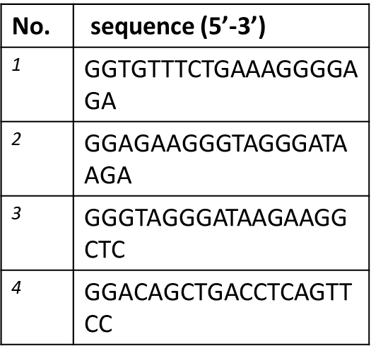

Supplementary Table 2. crRNA sequence for zebrafish *ccm2*